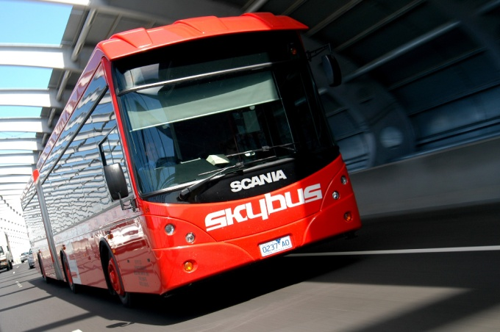
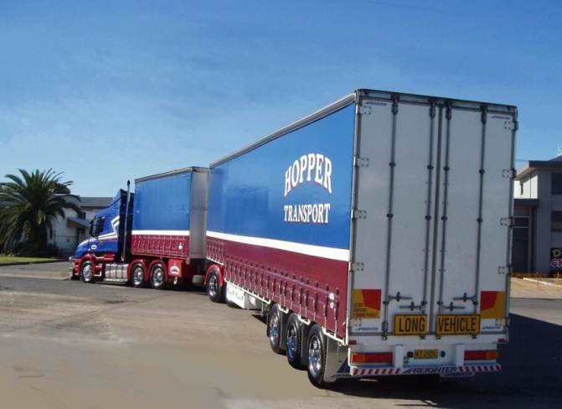
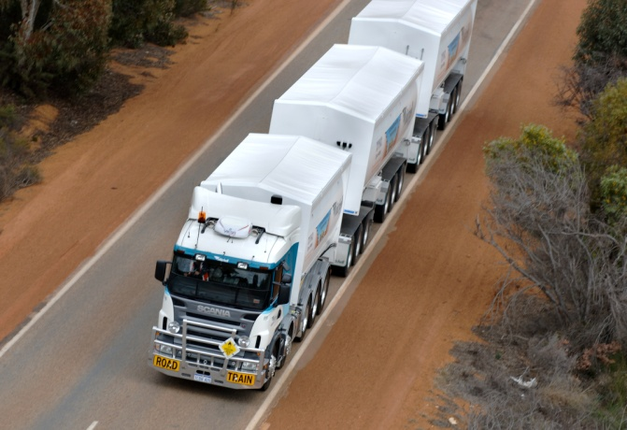
Australian Structured Finance group
ScanLease
Growing your business? We’ve taken small private clients from SME’s with under $2.00 million turnover to over $250.00 million turnover by providing funding to support growth; equipment and business acquisition. We’ve funded every item on this brochure – from mining fleets to single trucks and buses and we’ve stood by our customers through every business cycle the economy has seen since the early 1980’s
ASF and our staff are Australia’s leading experts in this field.
Operating Lease/ Rental
Finance Lease
Hire Purchase
Equipment Loan

2 Barrack Street
Sydney NSW 2000
TEL 02 9299 4711 FAX 02 9299 4780
joshua@structuredfinance.com.au

Our Products:
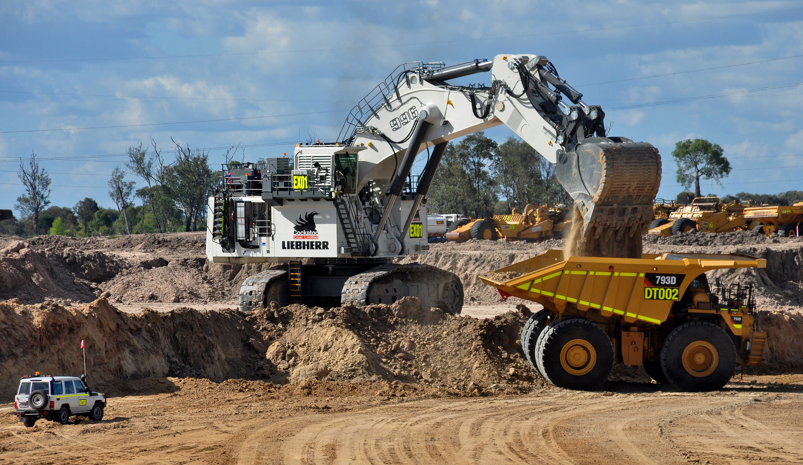
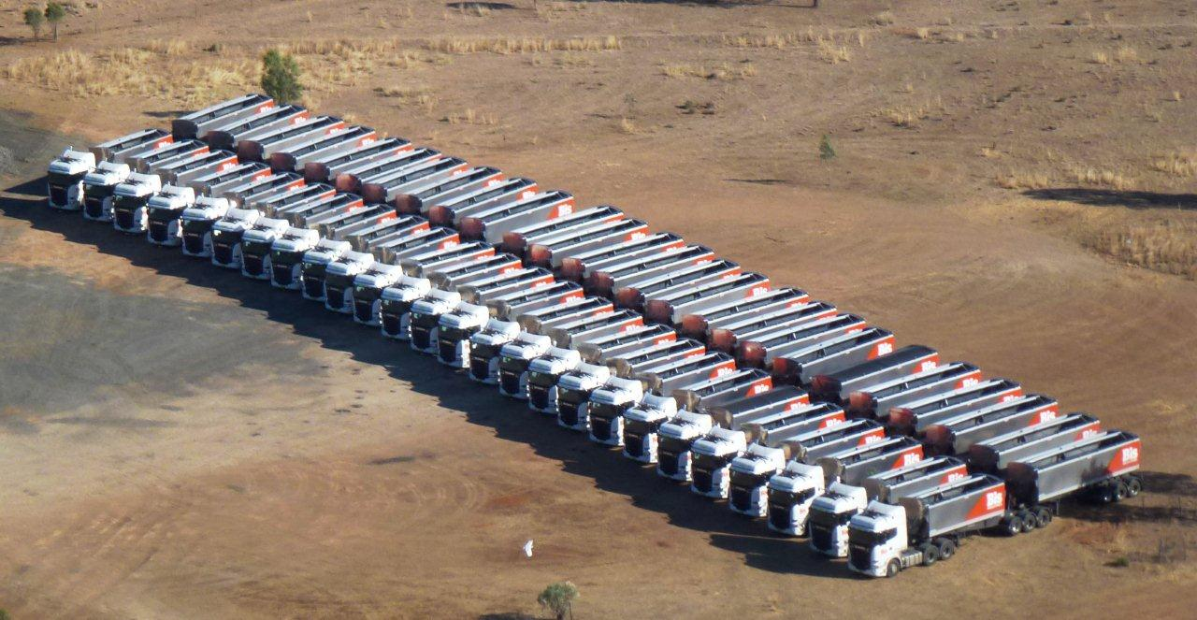
Out with the old; in with the older…… www.structuredfinance.com.au

After 20 years and over $350 million in vehicle financing; Scanlease P/L is changing its name and stepping aside as Scania Finance launch their own dedicated in-house financing arm to support Scania product in March 2016. It was a great couple of decades……

Did you know Scanlease was run and owned by the Australian Structured Finance group – established in 1984 and the leading vehicle and equipment finance business in Australia for over 32 years with over $5 Billion in vehicle and equipment financed to date!

As ASF, we are not limited to Scania product so please consider us as an alternative to your existing bank or Broker – competitive rates; competitive terms and a group of finance professionals that has outlasted every competitor we have in the “large ticket” equipment finance space based on our ability to deliver results over the last 32 years!

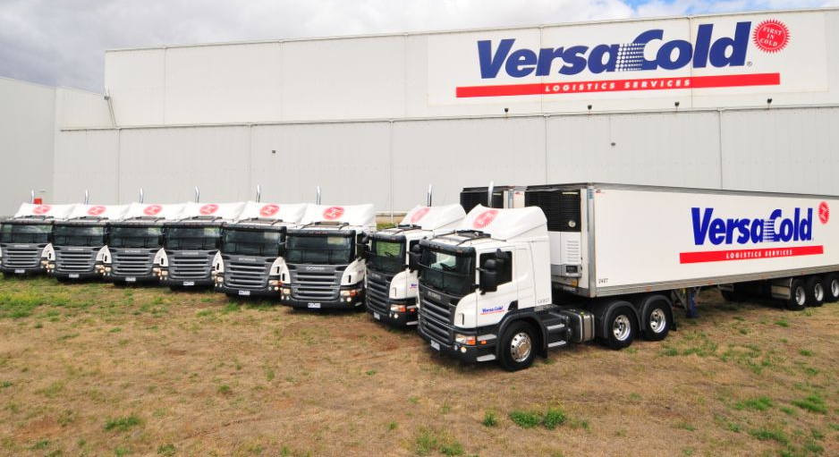
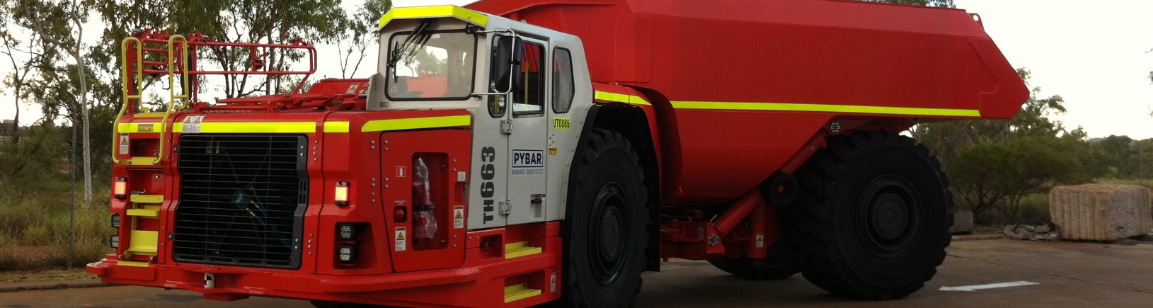
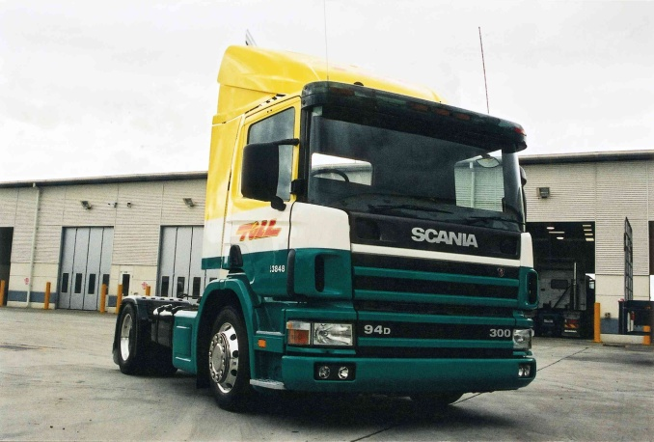
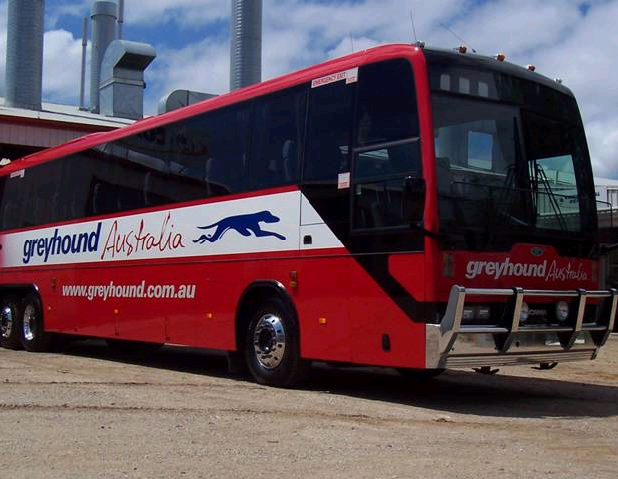
The ASF Difference
Your lifelong partners in Finance
ASF has a 32 year history of funding transport and logistics customers – independently as well as running vendor finance companies for both Mercedes-Benz Australia and Scania Australia – from the largest truck & bus fleet operators to single vehicle, owner-drivers!
We aim to develop long-term funding relationships and will work with you to understand your business – to support your growth and expansion by making available highly competitive, flexible funding solutions.
We offer financial stability and an unmatched depth of financial experience and advice in these economic times.
Australian Structured Finance – your partners in business
Each of our finance executives has worked for up to 35 years in the Banking and Finance industry at senior levels. We are long term players who have experienced both boom and bust - experts in financing transport and logistics across every industry sector.
Our customers include Federal, State and Local Government; the largest, most demanding Distribution and Logistics Fleet operators in the Country right down to owner-driver’s buying their very first truck, bus or coach – new or used.
We are a “stand-alone” line of credit provider - relying on the vehicle or equipment as security. We’re an alternative to your Bank and help you to preserve your borrowing capacity with them.
Yes. We will consider financing your entire vehicle, plant and equipment needs as part of our service to you.
Can I also fund other plant and equipment with you?
QA
My Bank is proving difficult with extra conditions, fees and charges on my facilities.
QA
Yes. For over 32 years we have had our own funding base as well as access to very competitive syndication lines enabling us to provide larger, more flexible credit facilities.
Is ASF competitive compared to my existing bank or broker relationships?
QA
FREQUENTLY ASKED QUESTIONS

