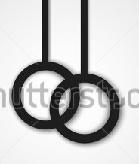
illuminate
A T H L E T I C S

