MELO YELO
A social enterprise initiative of EVolocity.

Background
In the Netherlands, electric bike sales grew from 41,480 in 2012 to 265,000 in 2015, meaning that 1.56% of the Netherlands population purchased electric bikes in 2015. Sales at this level in NZ would equate to 62,350 per year.
Another frame of reference is that ebikes have a 25% share of the overall bike market in the Netherlands. Cycle imports to NZ have grown from 157,000 in 2000 to 230,000 in 2012. Approximately 50% of the 1.5 million households have 1 bike, while 17% of households have 3 or more bikes. If ebikes had a 25% share of bike imports that would equate to 57,500 in annual sales. According to industry sources, only around 3000 ebikes sold in NZ in 2015. Growth over 2014 was 20-25%.
Why the chasm between the Netherlands & NZ? Here are a few key reasons:
- Netherlands has much more advanced cycleways infrastructure. However, NZ cycleways are developing quickly with the government spending $330 million on 41 new cycleways around NZ. http://www.stuff.co.nz/national/69712345/Government-to-spend-330m-on-41-new-cycleways-across-the-country
- In NZ, ebikes are mostly being sold through traditional bike retailers who lack the knowledge, passion & commitment to effectively sell ebikes
- Those promoting ebikes in NZ are mostly technical people, not sales & marketing people
- Current distribution channels and market awareness programmes are not reaching key niche markets, such as the 60+ age group.
The average distance travelled on an ebike in the Netherlands is 31.3kms/week (versus 18km/week on a conventional bike). 18% of the trips taken on an ebike were previously taken by car. Extrapolating these figures tells us that on average, an ebike user travels 1628kms/year. If 18% of those kms were previously travelled by car, then the average ebike user avoids 293kms/year in car travel. If there were 57,500 ebike users in NZ, they would cumulatively avoid approximately 17 million kms of car travel per year, reducing traffic congestion and improving personal health.
Taking the first step towards an electric transport future.
Currently in New Zealand, there are no government policies supporting adoption of electric cars, despite the fact that New Zealand is one of the most ideal countries in the world for electric vehicles because 80% of our electricity is generated from clean, renewable sources. As a result, the range of new electric car models available in New Zealand is small, and most of the models available are $60K+.
On the other hand, factory-new electric bikes are affordable, the range of makes and models is growing, and converting an existing bike to an electric bike is relatively easy. So what is required to give electric bike sales a turbo boost in NZ? And how will we keep those who show interest in electric bikes informed of the growing range of electric transport options coming over the next 5-10 years?
Giving electric bike sales a turbo boost requires:
- Market education
- Fun, dynamic branding & marketing
- Outreach. If a bike shop is the only place you can buy an electric bike, and if few 55+ year olds visit bike shops, then how are they going to discover electric bikes?
Those who show an interest in electric bikes via our outreach programme will be encouraged to join our mailing list. Over the next 3 years, we will build NZ’s largest database of EV interested people. And we will turn this database into revenue by – for example – producing and distributing NZ’s electric transport e-magazine, complete with advertising. We will also be able to sell research projects to industry, tapping into our database to encourage subscribers to participate in surveys.
Branding, Market Education and Outreach
Current brands in the electric bike market are very dull and boring. The Electric Bike Hub. Electricbikes.co.nz. A2Be-cycle. Volto. Techbikes. These are not brands that engage emotionally with shoppers.
Our brand is colourful, unique and emotionally engaging: MELO YELO – an anacronym for My Electric Love. Your Electric Love.
Our plan is to find an old caravan or covered display trailer, renovate it for use as a mobile education centre, brand it (obviously it will be bright yellow), apply sponsor logos to it, and get out amongst the public. Here’s an example of the caravan:

The caravan will make appearances at:
- Events
- Menz Sheds
- Lifestyle & retirement villages
- Environment centres
- Universities, polytechs and schools (those participating in EVolocity)
- EVolocity build camps & regional events
We will:
- Offer free educational workshops
- Show video case studies
- Distribute information
- Demonstrate the process of converting existing bikes to electric
- Sell electric bike conversion kits and connect the buyer to a local conversion expert if they need help
- Distribute a discount voucher from our sponsoring electric bike retailer/retailers
- Distribute an offer from our sponsoring electricity retailer – e.g. “Join Mercury Energy on a 2 year contract and get $500 off your electric bike.”
- Encourage people to join our email list (we will never provide our list to third parties, we will however allow third parties to make relevant offers to our subscribers)
- Sell MELO YELO merchandise, such as tee shirts and caps.
- Gather user stories and capture video clips of people having fun on electric bikes to leverage in our online communications
A big part of our story is that MELO YELO is an initiative of EVolocity, a charitable organisation which delivers an electric vehicle project based learning programme in high schools around NZ. Funds raised by MELO YELO are deployed to advance EVolocity’s educational programmes.
In addition to the community outreach, MELO YELO will have a web site. This web site will be THE resource for learning about electric transport options in NZ, seeing videos and case studies, learning about batteries, charging, end of life battery disposal and more. The illustration below shows the content areas of the web site:

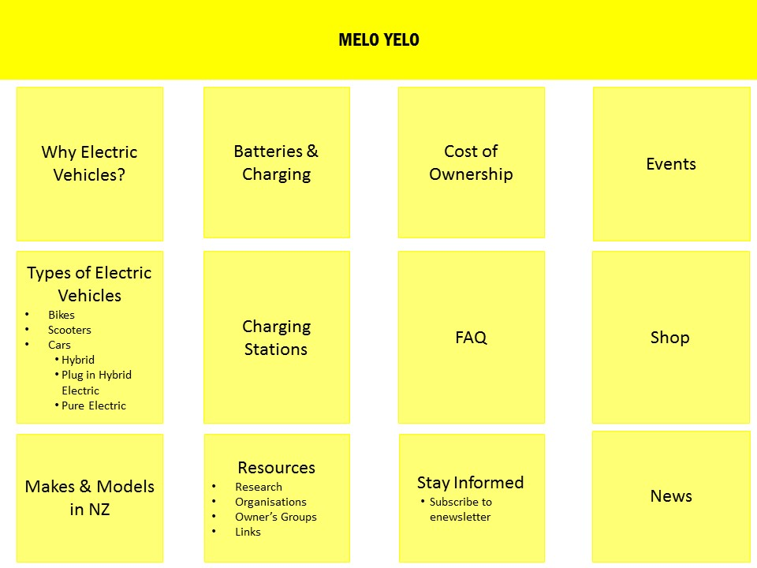

Traffic will be driven to this web site via:
- A prominent link on the EVolocity home page
- Google Adwords (we have $US10K/month in FREE Google Adwords)
- PR
- Social media
- Cards, literature and merchandise distributed through our community outreach
- Links from electricity company web sites, city council web sites, Environment Centre web sites, etc.

Regional Pilot
During 2016 we will test, validate and refine the community outreach within the Waikato and Bay of Plenty regions. We will attend a broad range of events and venues, keeping data on each including:
- Number of conversion kits sold
- Number of new ebike discount vouchers distributed
- Number of email subscribers generated
- Age and gender demographics
We will code the discount vouchers so that when they are redeemed, they are trackable back to the event that generated them. All data will be analysed to help us fine-tune the outreach programme over time.
National Rollout
Assuming the regional pilot is successful, we will begin a national rollout of the outreach programme in 2017. We will look for people with relevant skills and interests in the regions to become regional franchisees. Each franchisee will get:
- An exclusive territory
- A Melo Yelo caravan/trailer
- Training
- Educational and marketing materials
- Marketing support
Why have we chosen this method?
At present, most importers of electric bikes are selling through traditional retail outlets. As has been proven in the electric car market, often the salespeople in these traditional channels lack the passion, patience and knowledge necessary to sell an electric vehicle. There are a few outlets such as Wellington Electric Bikes and TechBikes in Christchurch who have retail outlets dedicated to electric bikes. And some of the importer/distributors exhibit at trade shows as a means of raising community awareness and interest.
None of the other market players have access to free Google Adwords. But because of our charitable status, we can access up to $US10K/month of free Adwords.
None of the other market players have access to grants from community trusts, gaming trusts and philanthropy trusts to underwrite the costs of acquiring capital items such as branded trailers, mobile workbenches and demonstration bikes.
Because of their for profit status, none of the other market players have the feel good factor that will sway organisations like Environment Centres, schools, Menz Shed and Age Concern to partner with us in reaching out to their communities.
In our observation and experience, most of those involved in the import and distribution of electric bikes are technology focused and lack the sales & marketing skills that we can bring to the table.
Key Target Markets
Target | Media | Key Messages
65+ | Community events & workshops. Age Concern. Bulletin boards. Lions. Rotary. MenzShed. | An easy and fun way to maintain an active lifestyle.
Commuters | Community events & workshops. Google Adwords & other online programs. | Get to work faster and without raising a sweat. Get your workout on the way home. Save money on gas. No need to pay for parking.
Women | Find existing female owners. Incentivise them to hold Tupperware-type parties to extol the virtues of their bikes. Case studies. Google Adwords. Facebook. Environment Centres. Community groups. | Experience the joys of riding with less effort. Go riding with the kids and grandkids with no fear of getting left behind. Enjoy the social interaction of riding bikes with friends.
Campers | Camping & motorhome associations & clubs. Trade shows. Online. | Have greater freedom & flexibility to explore the environs when you’re out on the road or camping in new places.

Value Proposition
For: The target markets listed above
Who need: <Insert niche specific messages here>
We provide: A convenient way to learn about and experience electric transport options, financing options to help get you started on you electric transport journey, a trusted network of technicians, and a promise that by doing business through us, proceeds are being deployed to further our educational work in the electric transport sector, including our project-based learning programme in schools.
Why are we the organisation that should do the work?
- Executive Director Rob McEwen was one of the first participants on the NZ EV scene, being the founder of the Association for the Promotion of Electric Vehicles in 2011. Rob has a particularly strong background in marketing and is well networked in NZ EV circles.
- EVolocity is expanding its national reach and networks through its schools programme.
- We are a charitable company, meaning we can access grants and communication channels not available to other organisations.
How will we know that we’ve accomplished what we set out to accomplish?
- We will track all transactions consummated through our programme
- We will maintain a database not only of customers, but of people who have attended our events and shown interest in electric transport solutions
- We will quantify the impacts of our programme through annual customer surveys as well as case studies
Potential partners & allies
- Environment Centres (12) throughout NZ
- Enviroschools (already a partner)
- World Wildlife Fund
- Greenpeace
- Oxfam
- Age Concern (promoting healthy living & active aging)
- Grey Power
- Participating schools
- Go Green Expos
- OOOBY
- Local & regional councils
- Smart Energy Solutions (have insulated 30,000 homes)
- EECA
- Menz Shed
Sponsor Targets
- A national chain of bike shops
- An electricity company
- A bank
Revenue Model
- Sponsorship income
- Sale of conversion kits
- Margin on conversion labour
- Sale of merchandise
- Advertising income (leveraging our database)

