Size US Letter- 8.5x11

Cover Page

Must Have - BubbleLife Logo
2016 Media Kit

BubbleLife is the only modern newspaper read and shaped by the community

Each of our 250 communities is its own “bubble” of neighbors, businesses and organizations connecting together to find, share and contribute to their local news.

Letter from Saffie

As local news coverage declines in traditional media and local conversations get split among text messages, Facebook feeds and Twitter posts, our communities are in danger of losing their cohesiveness and connectivity.

BubbleLife provides the only digital community newspaper that is read and shape by the local community. BubbleLife is different and innovative. We work to connect communities together with hyperlocal news that is all inclusive — derived from community contributions, thousands of online local resources and our innovative search engine technology. Our news delivery is conveniently mobile and accessible 24/7 online and daily by email.

Local newspapers have been an integral part of local life. As the founder of Bubblelife, I am proud to bridge the gap between the past and the future to give local communities a sense of identity, purpose and participation.

Sincerely,

Saffie Leedy Farris
Founder and Managing Partner

Graphics: Headshot of Saffie Farris (left side of letter)

BubbleLife Delivers an Advertiser’s Most Sought-After Audience

Having local communities identify with your brand is a tremendous strategic advantage. BubbleLife provides advertisers the ability to build mindshare with consistent visibility that reaches far into local communities.

Our unique approach of combining local news, online digital display advertising and mobile advertising by email provides a level and quality of digital exposure that other locally focused newspapers, magazines, websites and media can’t provide. BubbleLife Advertising reaches customers no matter where they spend their digital time.

Our circulation is built around the movers and shakers in our individual communities. We strategically introduce our social news and communication approach to community leaders, civic groups, school boards, city officials, volunteers, PTA presidents, and local businesses and engage them by encouraging community news contributions. We generate participation by providing somewhere they can connect locally in a single place — to not only find their local news, but to also share it.

Demographically, our readers align with many advertisers’ most sought-after audiences: female (62%), with children (50%), age 35-55 (48%), income of $100,000+ (40%), college educated (52%), and postgraduate educated (20%).

Graphics: What our audience looks like. Moms, Dads, Families, Etc.

BubbleLife Provides Intense Local Visibility

BubbleLife has fewer advertisers to compete with than larger media players, giving our advertisers better opportunity for conversions. Our ads are much more local and can be segmented to a specific audience.

BubbleLife provides online and email exposure to thousands of people daily by leveraging the popularity of local news and our unique Hyperlocal News Platform.

BubbleLife’s daily email newsletters, online news websites and native ad opportunities, showcased alongside local news, give advertisers a community focused strategic advantage to build mindshare in high-quality local audiences.

The BubbleLife DFW Network – 64 digital editions

Each of our 64 communities has an email newsletter, which serves as a daily digest of new articles published from your last 24-hour news cycle.
- 79,000 readers subscribe to daily email
- 2,367,842 daily email newsletters sent in Dec. 2015
Each of our 64 communities has a news website, which provides a communication hub for the community to contribute and find their news in real time.
- 2,300,000 Website Visits for 2015
- 757,515 Readers for 2015
- 33.4% New Readers
- 66.6% Returning Readers
- 98,100 Unique Visitors for Jan. 2016
BubbleLife Advertising
Every package includes native text ads that are emailed out daily in your area’s email newsletter and online banner ads that are displayed on your area’s news website.
- Sponsorships
- Advertising Plans
- Pop Up Advertising Plan
- BubbleLife Community Directory

Rates
Site Sponsorships start at $1,000 per month per neighborhood
Advertising Plans start at $500 per month per neighborhood
Pop Up Advertising Plans start at $1,000 per month per neighborhood

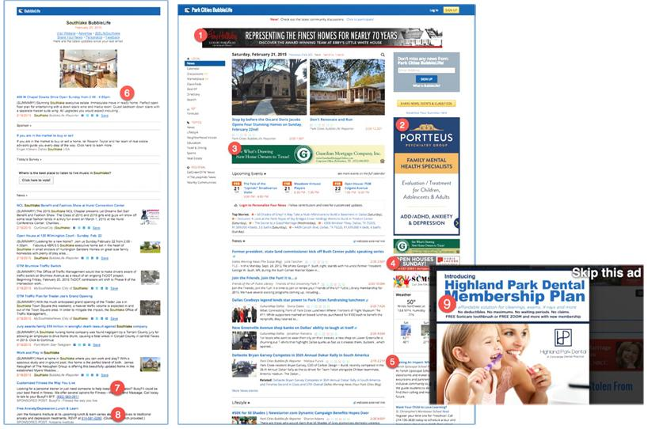

- Sponsorship ad (1) appears at the top of every website page and at the top of every newsletter (6).
- Wide banner ad (3) and tower ad (2) rotate with other advertisers on website front page and interior pages.
- Small banner ad (4) appears on the website front page and rotates on interior page.
- Text ads (7) (8) rotate in the newsletter in native display style and rotate on the website.
- Popup ad (9) appears once per day per user on the website and requires click to close.

Specifications

Site Sponsorship – 1092 pixels wide x 90 pixels high.
Wide Banner Ad – 768 pixels wide x 90 pixels high.
Small Banner – 336 pixels wide x 90 pixels high.
Tower Ad – 336 pixels wide x 600 pixels high.
Pop Up Ad - 1024 pixels wide x 1024 pixels high.
Text Ad – Composed of a headline, body text and a destination link. The headline should be fewer than 60 characters. The body text should be fewer than 140 characters.

Multiple versions of all ads may be submitted for A/B testing at no extra charge.

Content

Whether it’s words or images, content is the way you relate to customers, search engines and other players in the digital ecosystem. Advertisers are invited to submit content via BubbleLife Connect to our editors for consideration for distribution.

BubbleLife Connect is a full content management system with a direct link into BubbleLife.com.

Did You Know?

BubbleLife is one of the 5 largest national networks of local news sites.

If ranked nationally, BubbleLife would rank in the top 20 in digital newspaper delivery.

Online news consumption rose sharply the last two years, following the rapid spread of digital platforms. In fact, online was the only category of news that showed growth in Pew Research Center’s 2012 News Media Consumption survey.

In 2012, 39% of respondents got news online or from a mobile device “yesterday,” up from 34% in 2010.

The top 25 news sites in the U.S. grew 7.2% from the prior year. BubbleLife grew more than 120%.

Local digital ads grew 22% in 2012 to $19.9 billion, according to Borrell Associates.

Source: Pew’s State of the Media 2013

About Us

Overview

BubbleLife.com, a hyperlocal news and communications platform, is Dallas’s largest provider of neighborhood news both online and by email. In January 2015, BubbleLife expanded into Houston, and in September 2015, BubbleLife completed a roll out into 25 major cities to complete expansion into 250 communities in the United States. At the end of 2014, our targeted email newsletters reached more than 79,000 unique people daily while our news websites generated millions of quarterly impression opportunities.

BubbleLife.com’s unique approach to neighborhood news brings together content from our own editors, more than 2,000 neighborhood contributors and from 3rd party sources, creating an innovative and comprehensive approach to local reporting. Plus, our ability to deliver content through the latest content platforms such Twitter, Facebook, Flipboard, Feedly and more give us an ever-increasing local reach.

Management Team
BubbleLife’s entrepreneurial management is innovating new ways to gather and deliver news to better connect neighborhoods together while at the same time delivering sophisticated marketing technology to advertisers so they can better understand their neighborhood audience.
Jeff Farris – President & CEO
Jeff has always been a technology entrepreneur, with past endeavors including founding and leading one company that ranked 26th on Inc. Magazine’s list of Fastest Growing Private Companies, which held an IPO and sold to McAfee.
Saffie Leedy Farris – Publisher
Saffie is the founder of BubbleLife and previously served as the Operations Director of both iThink, Inc. and Webcode.com playing an instrumental role in the sale of these companies to Volaris Communications.

Contact Us
BubbleLife Media LLC
6611 Hillcrest Ave., #405
Dallas, TX 75205
(214) 233-0740
www.bubblelife.com
For More Information:
Saffie Leedy Farris
(214) 616-0977 (mobile)
saffie@bubblelife.com

