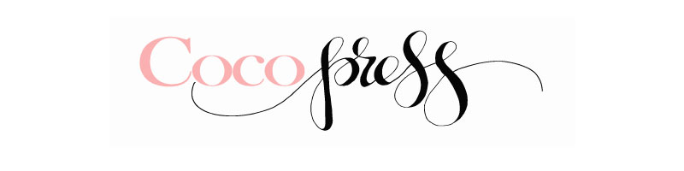
emma@cocopressdesign.com www.cocopressdesign.com
18 Fremont Cres, Secret Harbour, WA 6173 0414 897 533
Coco Press Letterpress* 2016 Order Sheet
Contact___________________________
Phone____________________________
Email_____________________________
Website___________________________
Ship to___________________________
_________________________________
_________________________________
_________________________________
Bill to _____________________________
__________________________________
__________________________________
__________________________________
SKU | Description | Cost | Qty | Total |  | SKU | Description | Cost | Qty | Total
 | New Baby Cards |  |  |  |  |  | Wedding Engagement Card
A001 | Twins Geo Heart | 3.55 |  |  |  | D001 | Mr & Mrs | 3.55
A002 | Giraffe baby Card | 3.55 |  |  |  | D002 | Mr & Mr | 3.55
A005 | Oh Baby Pink | 3.55 |  |  |  | D003 | Oh Happy Day | 3.55
A003 | Oh Baby Blue | 3.55 |  |  |  | D004 | Love, laughter
A004 | Baby Geo Heart Pink | 3.55
A005 | Baby Geo Heart Lilac |  |  |  |  |  | Love/Valentines Day
 | Kids Birthday Cards |  |  |  |  | E001 | Wunderkind | 3.55
B001 | 1st Birthday | 3.55 |  |  |  | E002 | Batty for You | 3.55
B002 | 2nd Birthday | 3.55 |  |  |  | E003 | I Love You pink | 3.55
B003 | 3rd Birthday | 3.55 |  |  |  | E004 | I Love You black | 3.55
B004 | Dancing Bear | 3.55
 |  |  |  |  |  |  | General Cards
 | Birthday Cards |  |  |  |  | F001 | Vintage Caravan | 3.55
C001 | Happy Birthday Pink Burst | 3.55 |  |  |  | F002 | Congratulations (coming end of Feb) | 3.55
C002 | Happy Birthday Green Burst | 3.55 |  |  |  | F003 | Sympathy (coming end of Feb) | 3.55
C003 | Strongman | 3.55
C004 | Happy Birthday Geo Heart | 3.55 |  |  |  |  | Mothers Day Cards
 |  |  |  |  |  | G001 | Marvellous Mum purple | 3.55
 | Fathers Day |  |  |  |  | G002 | Super Mum | 3.55
I001 | Rad Dad | 3.55 |  |  |  | G003 | Happy Mothers Day (flower) | 3.55
I002 | Happy Fathers Day (end of Feb) | 3.55

