Hi,
We thought a summary of what caught our eyes while trawling the internet for ideas may be helpful but we’re very open (and excited) to fresh and new interpretations of the design brief.
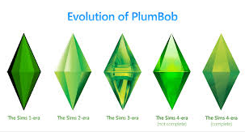
Plumbobs are the ultimate, iconic symbol of The Sims games.
We would like the plumbob shape to be the ultimate focus of our logo.
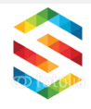

We like the idea of the S creating the plumbob shape.

We also like the idea of having the S within the plumbob shape (I couldn’t find an exact examples of S’ in a plumbob shape) We’re unsure if this would could be integrated as part of the ‘Similarish’ name or needs to be on its own, as a logo?
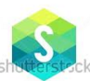



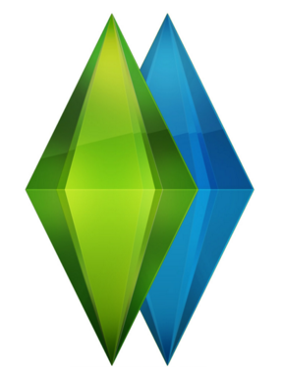
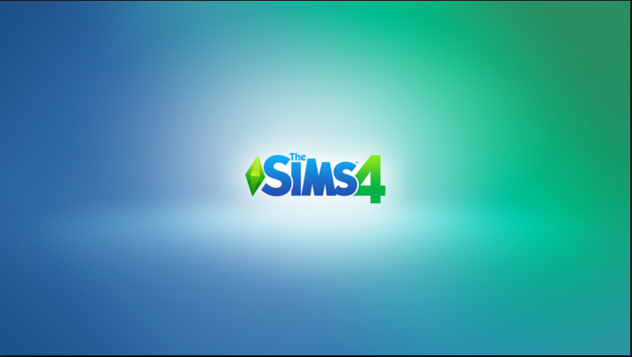
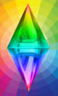
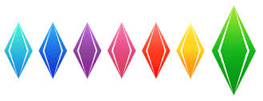
We liked the reflective quality of this logo. A shadow or reflection could represent how we are taking inspiration from the official Sims creations (I know, we think too much!), however, we don’t want to over-confuse/complicate the end design.

These green and blue colours are associated with The Sim games.
We are happy to use any choice of colours, colour schemes or multi-colours.
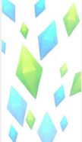

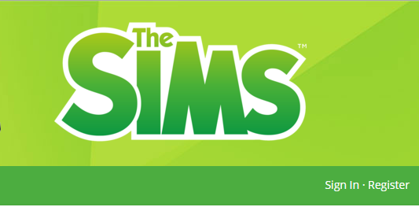
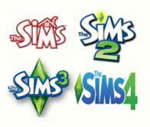
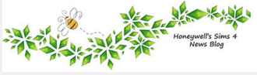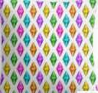

Because our name is long, we feel it may be better to use simple, lower case fonts, so the name stays clear and easy to read.

Just a random selection of what other people are doing with the plumbob.


As you can see from these pages, our design skills leave a lot be desired!
We will need help from designers with many different aspects of our business, not only marketing but packaging and many products that we will be creating too.
If you’d like us to email you with the brief’s of upcoming projects and product designs, please email Jenny at similarish@gmail.com. You can then quote us direct with a price for your work. Thank you :)

