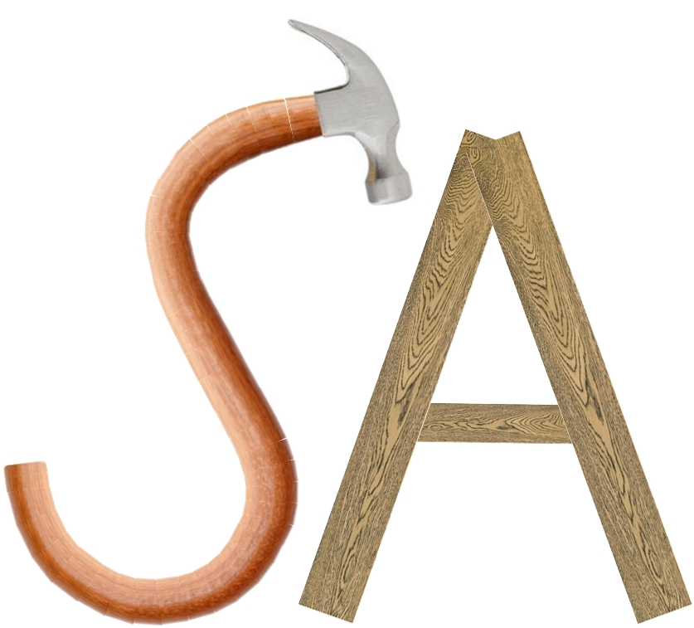
Stephen Anthony Construction LLC

