
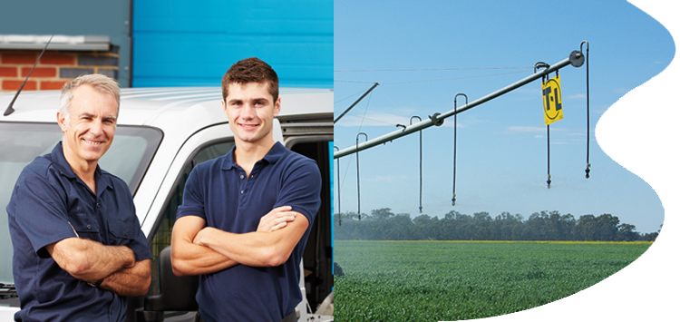

Call today to speak with one of our irrigation specialists and find out how we can optimise water use on your property.
Water Dynamics offer a range of agricultural irrigation solutions that will help you boost yields, while using less water. Whether you run a large scale commercial farm or small hobby venture, grow broad-acre or horticultural crops or rear livestock, we will customise an irrigation solution that is finely tuned to your needs and budget.
Our irrigation experts will take into account your topography, available water resources, crop/livestock type, growing media and climatic conditions to optimise your system for water efficiency.
DRIP IRRIGATION – reduce your water usage by delivering water and nutrients directly to the root-zone, minimise evaporation and improve efficiency.
BROADACRE IRRIGATION – whether it is centre pivots, linear or hose irrigators, get the right broad-acre irrigation system based on your unique topography and soil conditions.
STOCK WATERING – conserve water and spread grazing pressure with an irrigation system that combines effective storage, reticulation and pumping.
AGRICULTURAL SPRINKLERS – maximise the benefits of sprinkler irrigation while reducing water waste.
MICRO IRRIGATION – precisely water plants in greenhouses, nurseries and orchards.
Our team can help you with every stage of your irrigation planning and implementation. We'll conduct a detailed site audit, supply the right equipment to meet your needs, install your equipment according to exacting standards to ensure performance and longevity, train your staff and look after your maintenance needs into the future.

VITicultural Sprinklers
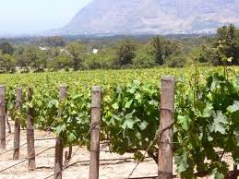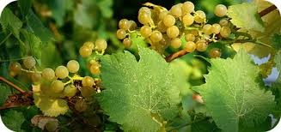

Getting the most out of sprinkler irrigation
Your local Water Dynamics team will help you maximise the benefits of sprinkler irrigation, helping increase crop yields while minimising water waste.
Our range of sprinkler systems includes:
- Pivot and Lateral move irrigators
- Travelling Irrigator sprinkler systems
- Solid set sprinkler systems
- Moveable sprinkler systems
- Micro sprinkler systems
- Landscape systems
- Sporting fields
- Fertigation systems
- Humidifying systems
- Frost control systems
- Dust suppression systems
- Leaching systems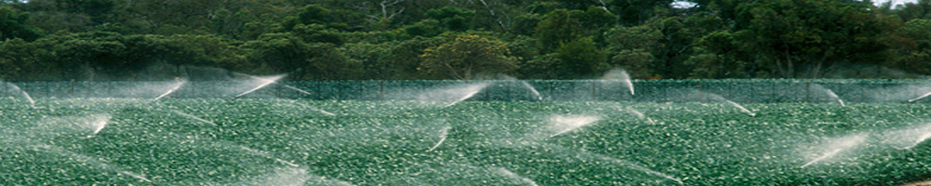
Drip Products:
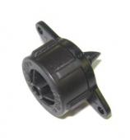 | 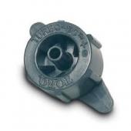 | 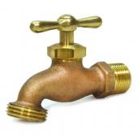
Part #: | Part#: | Part#:
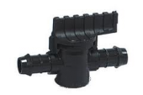  Part#:  Part#: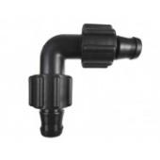 | Part#:  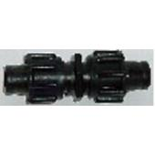 | 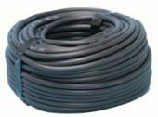  Part#:  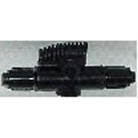
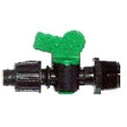 | 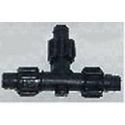 | 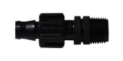

Micro Sprinklers

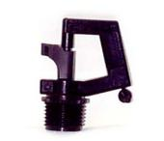 | - 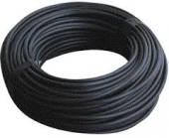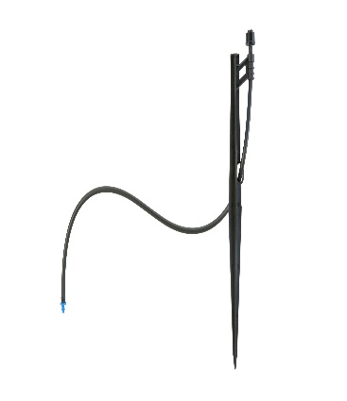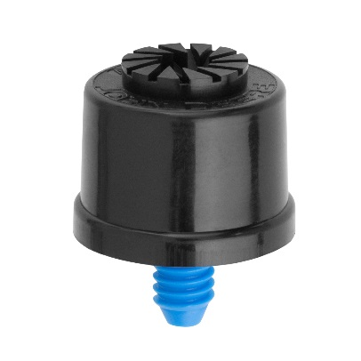  Part#:
 | - 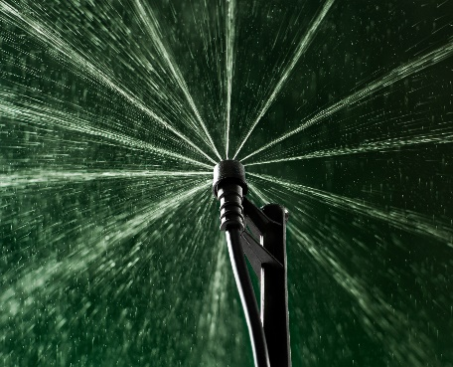

Installation, Service & Repairs
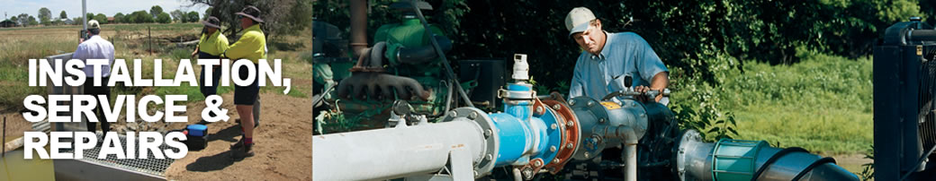

Whether it's hands-on training of a new piece of equipment, routine maintenance or emergency field repairs....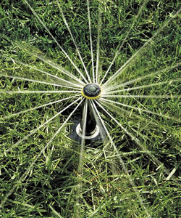

Our qualified technicians are always available to keep your system operating the way it should.

Installation
It is critical that your irrigation system is installed correctly by skilled installers in accordance with various standards. This will ensure the system performs optimally and in part determines the expected life of the system.
Planning is important to the installation program. It is essential that the installation is scheduled to be completed on time and well before the system is required to be used. The installation must follow the irrigation design and ensure that installation best practice is followed.
System flushing, pre-commissioning, system start up and training are key to a successful installation.
Water Dynamics have a history of successful installations from small domestic applications to large corporate operations.
Service & repairs
Water Dynamics know how important it is to keep your irrigation systems up and running. That's why we offer you a complete repair and service facility.
So regardless of the make or model of your equipment, any one of our many locations has the service capability to help you. We can supply the spare parts to keep your system running smoothly, year after year.
We recommend the right irrigation equipment & control systems - then install and commission the project.

