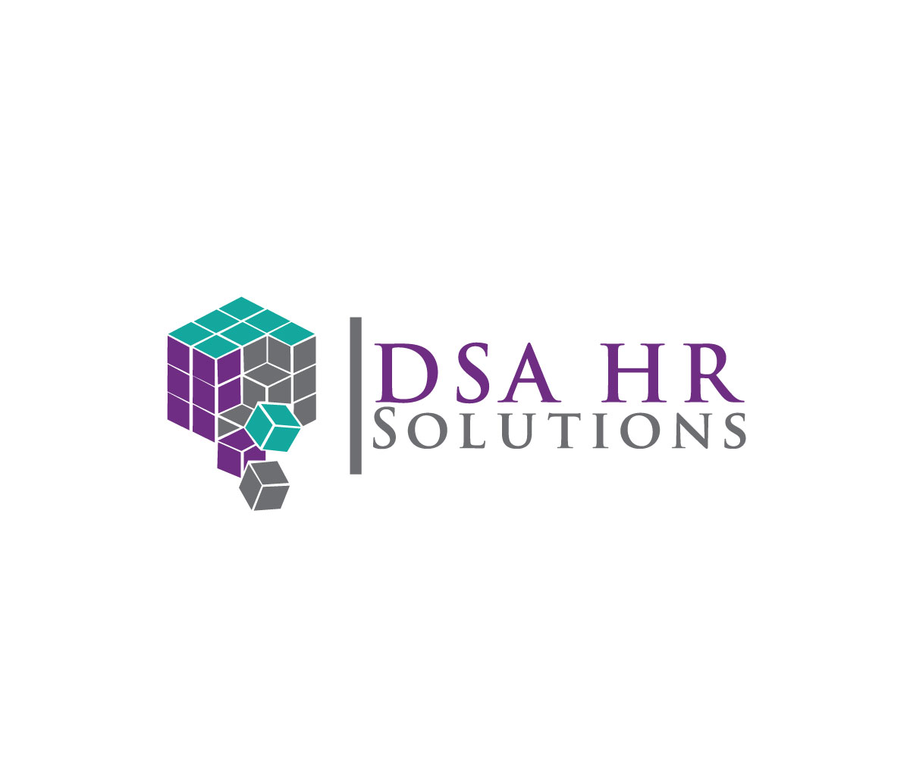

After conducting your complimentary HR Assessment, we work with you to bring your company into full compliance. For clients requiring ongoing HR support, we offer three service levels to choose from for a low monthly fee.

Premier

This is our highest level of service providing your company's complete HR Department. We will handle Benefit Administration, Employee Relations and other HR functions. Your HR professional will come on site two days per week to handle all HR duties, meet with employees and partner with Management on strategic planning and organization development.

Elite

Deluxe

With this level of service your HR professional will come on site one day per week to handle all HR duties with most tasks being completed off‐site. We will provide you with the tools and off‐site support necessary to run an effective HR Department.

With this level of service your HR professional will come on site once per month and provide virtual HR support with most tasks and support being provided off‐site. This level of service is ideal for companies who do not require an on-site presence and just need a back office and trusted partner to ensure they remain compliant.

HR Functions Provided

BENEFITS
Benefits Administration
COBRA Administration
Worker’s Comp Administration
Affordable Care Act Compliance Leave of Absence Management

∗ Additional fees apply
HUMAN RESOURCES
Employee Onboarding
Terminations/Separation Agreements
Recruiting
Performance Management
Employee Relations
Conflict Resolution
Investigations
Strategy and Development

∗TRAINING
Harassment Prevention
From Buddy to Boss for New Supervisors
Providing Effective Performance Reviews
Various Safety Trainings
CPR and First Aid
Progressive Discipline

