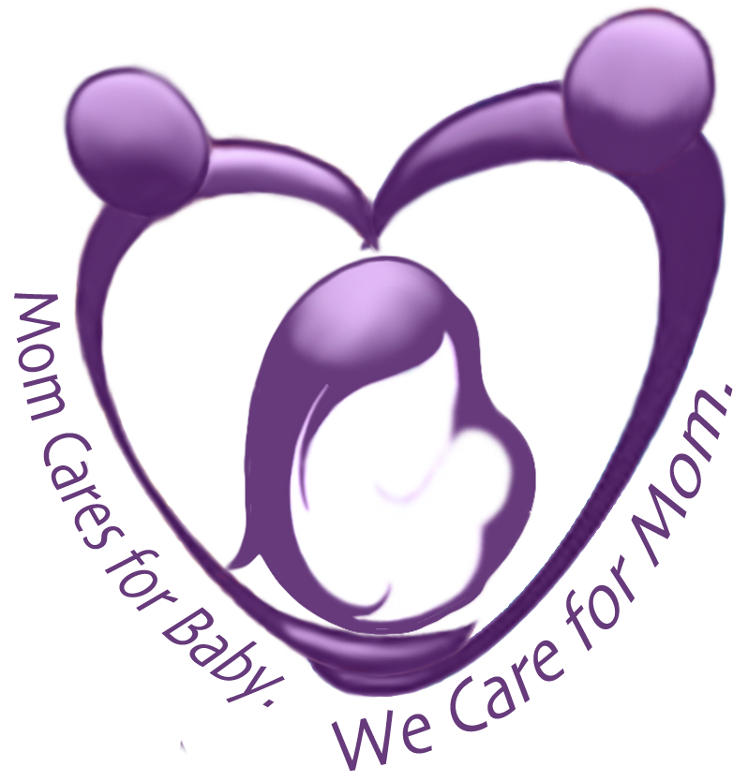
Postpartum Society of Florida

Education + Preparation + Support

What is the PPSF Mission?
Our mission is to ease the transition from pregnancy to parenthood.

What are the PPSF goals?
1. Postpartum Adjustment education for parents and providers
2. Postpartum Adjustment preparation and planning for expectant parents
3. Postpartum Adjustment social support for all area new mothers

What is PPSF actively doing to achieve these goals?
Education:
1. Planning “Providers and Postpartum Adjustment” Q&A at libraries
2. Compiling a provider resource list
3. Offering all providers opportunity for Postpartum Adjustment In-Service
4. Joining local Perinatal Service Networks and Coalitions
5. Speaking at Childbirth Education classes about Postpartum Adjustment

Preparation:
1. Conducting Personality and Postpartum Adjustment Project to examine potential relationship between personality and risk factors for PMAD
2. Collaborating with local Childbirth and Parenting Educators to create free "Postpartum Prep" Class for expectant and pre-expectant parents

Support:
1. Conducting peer support volunteer training Dec thru Jan
2. Developing materials to be distributed to new mothers at local hospitals
3. Creating SISTER, a pre-arranged telephone peer support program where a volunteer/mom contacts mom at “touchpoint” times in her recovery
5. Establishing biweekly Postpartum Adjustment Support Groups at LRMC
6. Giving “Mom and Baby Talks” at local moms groups to break the silence
7. Collaborating with area Pediatricians to distribute PPD Flyer at 2 mo appt.
8. Collaborating with area Obstetricians to distribute PPD Flyer at 6 wk appt.

Funding and More:
1. Pursuing 501(c)(3) status (application pending)
2. Researching and preparing grant applications and fundraising ideas
3. Seeking volunteers

Thank you! We look forward to working with you for healthy families!

