Perinatal Mood
Disorders Program
Office: (317) 962-8191
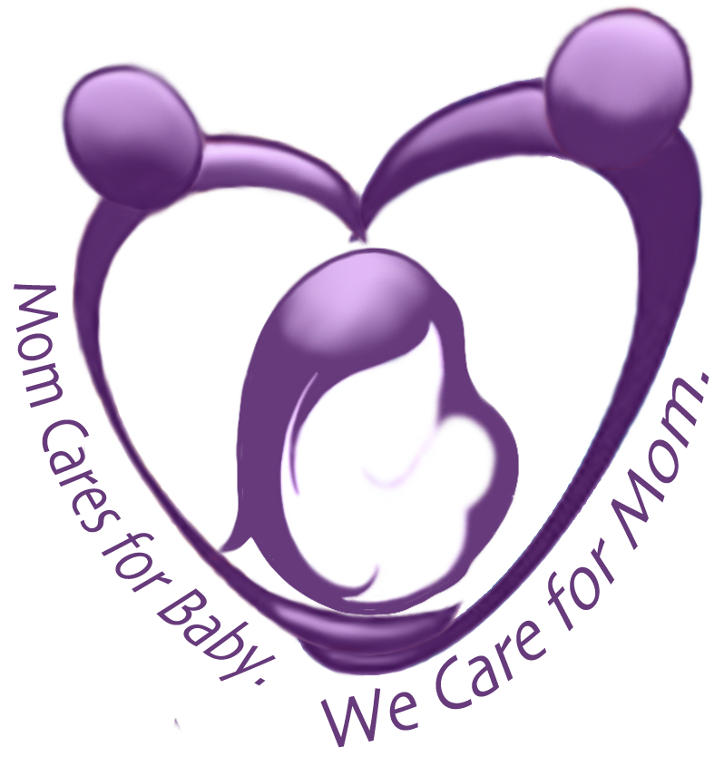
Postpartum Society of Florida
FACTS AND FEELINGS
Perinatal Mood
Disorders Program
Office: (317) 962-8191
- As many as 1 out of every 3 women will go through some form of postpartum depression sometime during the first year after giving birth: that translates to 400,000 Americas annually.
- Women at high risk are 50% to 80% more likely to have PPD than those that are NOT high risk. High risk women reduce their chances to 10% if they get treatment during their pregnancy
- It affects ANY women regardless of age, race, or financial situation and has nothing to do with whether the pregnancy was planned!
The Risk Factors
- Family OR personal history of mood illness (i.e. addiction, depression, panic attacks, anxiety)
- Stressful life events around the time of birth
- Poor system of support
- Relationship/Marital problems
- Women with severe PMS symptoms
- Mood changes while taking birth control or fertility drugs
- A prior episode of PPD, depressive and/or anxiety symptoms during pregnancy
The Warning Signs (after 3rd week postpartum)
- Sad mood that does not shift
- Irritability, angers easily
- Expresses hopelessness
- Expresses feelings of inadequacy “I am not a good mother” “You deserve a better wife than me”
- Sleep problems—too much or too little
- Fear of being alone
- Discomfort around the baby or lack of connection to the baby
- Loss of interest or pleasure in things she once enjoyed
What to do when you recognize some of the warning signs:
- Call your doctor. Tell them what you are experiencing.
- Talk, talk, talk to anyone you trust that will listen and not judge you.
- Enlist the help of a professional (therapist, counselor, social worker or psychologist) for emotional support and ways to cope.
- Ask for help from people close to you to help care for the baby and other children in the home until you get the care YOU need.
- Get time away from the home for yourself—even if it is only 10 minutes a day to go for a walk, or just to the mailbox.

If you are not getting better and need the support of other moms who have had these same feelings, call PPSF at 941.301.8819 or email sarahpostpartumfl@gmail.com, or go to postpartumflorida.org

