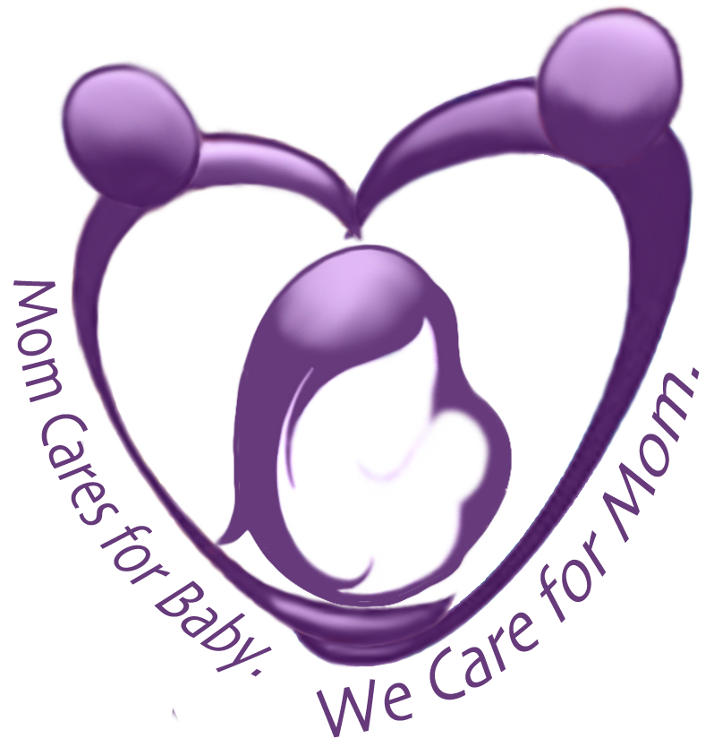
Postpartum Society of Florida
Is it Postpartum Distress?

Have you been feeling or thinking any of the things listed below?

I feel...
- Scared
- Angry
- out of control
- like I'm never going to feel like myself again
- like each day is a hundred hours long
- like no one understands
- like my relationship cannot survive this
- like I'm a bad mother
- like I should never have had this baby
- like every little thing gets on my nerves
- like if I could only get a good night's sleep, everything would be better
- like I have no patience for anything anymore
- like I'm going crazy
- like I will always feel like this

If you have any of the feelings described above it’s not just you! The fact is Depression/Anxiety is the top complication of childbirth.
If you are concerned about your thoughts and feelings, visit www.postpartumflorida.org, call the PPSF Warmline at 941.301.8819, email sarahpostpartumfl@gmail.com, find us on Facebook, or come to our…
MOTHERS OF LITTLE ONES SUPPORT GROUP
THURSDAYS, 9:30 am – 11 am
Lakewood Ranch Hospital Women’s Center, First Floor Classroom
8330 Lakewood Ranch Blvd., Lakewood Ranch, FL
You are not alone, Mama! We are moms and we’re here for you!

