Flip those TURNDOWNS into CLOSE DEALS in 2016!
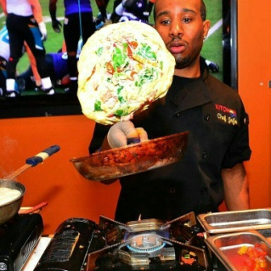
Let us host your next branch meeting
That’s right brunch is on us…featuring Chef Jo Jo
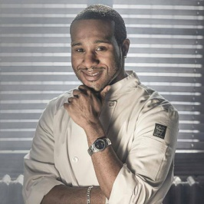
We pick up where other lenders fall short………..
- 500 Scores up to 70% LTV
- FHA Purchase Loans with FICO as low as 530
- FHA up to 96.5% with FICO as low as 580
- Bank Statement Only for Self Employed
- Stated Investor Rehab Loans
- Conventional Loans up to 97% w/ no Mortgage Insurance
Call to reserve your brunch appointment today. Just have the Turn Downs ready for us!
Call Jonathan Harris at (800) 583-3178 x 17
1st Step Financial Services, Inc.
218 E Lexington Street, Suite 504, Baltimore, MD 21202 * Email jharris@1ststeponline.com

