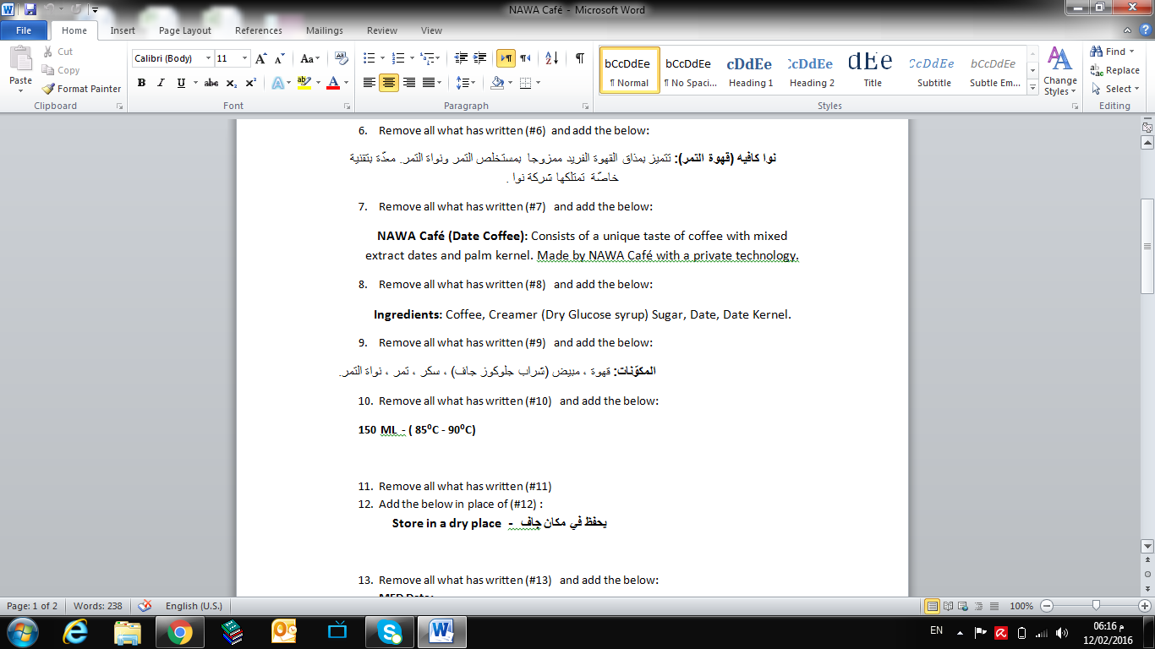
- Font need to be change (Arabic) with attractive font (please provide me more than 5 font so I can easy chose one) (#1).
- Remove the whole one (#2)
- Remove the whole one (#3)
- Remove the whole one (#4)
- Font need to be change (English) with attractive font (please provide me more than 5 font so I can easy chose one) (#5).
- Remove all what has written (#6) and add the below:
نوا كافيه (قهوة التمر): تتميز بمذاق القهوة الفريد ممزوجا بمستخلص التمر ونواة التمر. معدّة بتقنية خاصّة تمتلكها شركة نوا .
- Remove all what has written (#7) and add the below:
NAWA Café (Date Coffee): Consists of a unique taste of coffee with mixed extract dates and palm kernel. Made by NAWA Café with a private technology.
- Remove all what has written (#8) and add the below:
Ingredients: Coffee, Creamer (Dry Glucose syrup) Sugar, Date, Date Kernel.
- Remove all what has written (#9) and add the below:
المكوّنات: قهوة , مبيض (شراب جلوكوز جاف) , سكر , تمر , نواة التمر.
- Remove all what has written (#10) and add the below:
150 ML - ( 85ºC - 90ºC)

- Remove all what has written (#11)
- Add the below in place of (#12) :
Store in a dry placeيحفظ في مكان جاف -

- Remove all what has written (#13) and add the below:
MFD Date:
Exp. Date:

