WEBSITE SITE MAP
- Home
- Services
- Investment Approach
- Missions and Values
- Contact

BACKGROUND
We require a website designed for a private equity firm with offices based in Hong Kong, Singapore, London and Paris. Our focus is investments in property development projects, corporate ventures and loans.
You will have to select relevant images from the likes of iStockPhoto or other stock photo libraries. The website must have a clean modern feel and must portray stability and professionalism.
We will need a design done for a PC based website and the designer selected with the favored design will also need to produce some concepts for a responsive website.
NOTE: The logo design has been done however the logo colors can be changed to suit the website.
WEBSITE IDEAS
The following website is very good and we would be happy to have a custom design based on this idea. The main image could be that of a London skyline.
http://www.couno.co.uk/
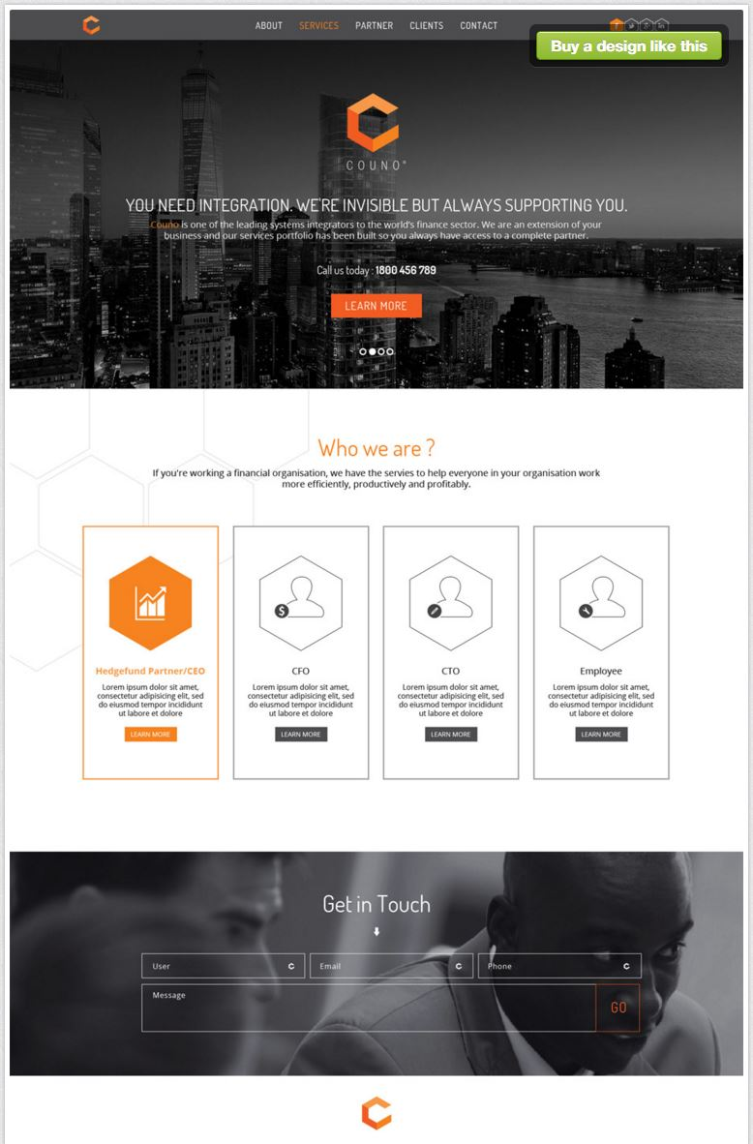 | 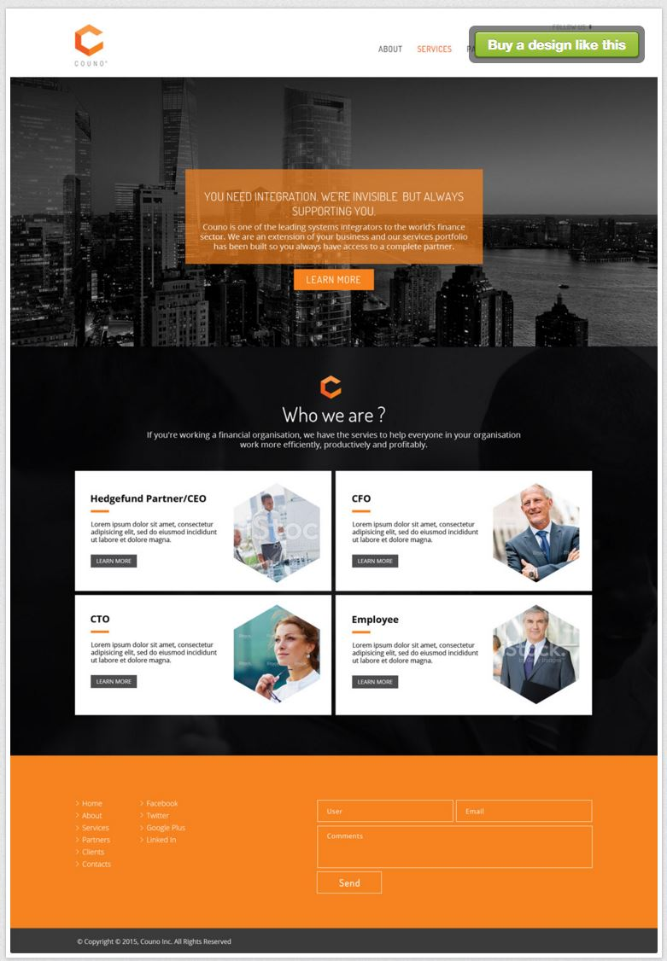

These website are also good and might provide some additional ideas:
http://aconinvestments.com/
http://www.metropolitanequity.com/
http://www.summerstreetcapital.com/
http://www.brockwaymoran.com/
http://www.agm.com/Home.aspx
https://www.fortress.com/Default.aspx
http://www.matlinpatterson.com/
https://www.dcadvisory.com/en/
http://corpadvisorysolutions.com/
http://www.789group.com
http://www.kwc.com.au
http://milestoneadvisors.com.au
http://inglobo.com.au
http://dequitypartners.com.au

HOME - PAGE
Orpheus Investments is a is a boutique independent investment group that specializes in direct investments along with the provision of consulting and fund raising services to both established and emerging private companies. We are attracted to challenging assignments.
With significant years of combined industry experience and international presence, we continually build upon our trusted relationships with principal partners to create successful and enduring investment partnerships. We trust, respect and like the people with whom we choose to work.
Our marketing efforts embrace:
- Our own funds
- Institutional investors
- Advisors and consultants
- Strategic corporate investors
- High net-worth individuals

SERVICES – PAGE (Use icons from http://laycon.com.au/services.html)
Orpheus Investments provides independent corporate advisory services in raising capital (equity and debt), strategic merger, acquisition or business sales transactions, implementing management buy-out/buy-in (MBO/MBI) transactions and growth focused advisory services.
We have established an impressive track record in the following areas:
- Angle Investment
- Capital Raisings
- Mergers, Acquisitions and Divestments
- Capital and Corporate Restructure
- Strategic Business Planning
- Financial and Operational Reviews
- Financial Modelling and Forecasting
- Business Turnaround Advice
- Litigation Funding [Note: Need to obtain icon for this]
- Loans and General Funding [Note: Need to obtain icon for this]
Our success is directly related to the calibre of its people who hold a wealth of both national and international experience with a diverse combination of strategic, operational and financial skills.
INVESTMENT APPROACH – PAGE
Our investment strategy is focused on growth. We pursue investment opportunities where our team can add value through our knowledge, skills and capabilities in co-operation with the company’s management team. Our value creating involvement includes:
- Focus on Strategy - Successful strategies implemented by Orpheus Investments include roll-up industry consolidation strategies, roll-outs of successful business models to provide wider geographic coverage and large-step operating improvements.
- Hands-on operating approach - Orpheus Investments brings a first-rate skill set to mid-market companies. We have a large and experienced investment team with significant experience in a wide variety of sectors.
- Partner with experienced owners and management - Orpheus Investments partners with experienced owners and management. We adopt a true partnership approach and ensure that incentives are aligned to a successful exit in keeping with a target return.
- Deal structuring creativity and tailored solutions - Orpheus Investments has developed distinctive capabilities in negotiating and structuring transactions in the mid-market. We specialize in difficult or complex deals and often seeks creative and tailored solutions.
- Providing capital for growth - Orpheus Investments is well regarded by financial institutions in the countries in which we have presence. We work with these institutions to provide capital to implement the growth strategies of our companies.
Orpheus Investments believes in building sustainable businesses by adopting ESG (Environmental, Social and Governance) standards in all our investments.
MISSIONS AND VALUES – PAGE
Mission
Our mission is to provide investors with a strong foundation of core business investments that foster solid growth.
Core Values
Guiding our day-to-day as well as strategic thoughts, decisions and actions are the following core values:
Discipline: we are systematic and disciplined in setting and achieving high standards of performance and expect the same from those we do business with
Assurance: we are confident in our abilities and can be relied upon for the quality and innovativeness of our work, and we have confidence of the same from those we do business with
Perseverance: we face challenges and obstacles proactively and with patience and tenacity, and we consistently deliver on all of our commitments
Care: we aim to be a leader in corporate, social and environmental stewardship both within the organization and in the broader communities in which we operate
Loyalty: we commit fully, for the long-term, and for mutual benefit, to each other and to those we do business with in spite of any challenges or obstacles
Fairness: we engage with and treat each other and those we do business with fairly, equitably and with integrity
Humility: we are humble, kind, collaborative and temperate and value the same in those we do business with
Cooperation: we appreciate, respect and encourage each other and those we do business with
Enjoyment: we celebrate our personal and professional successes, and the successes of those we do business with
Through these core values we find strength, purpose and significance in what we do and how we do it.
CONTACT US - PAGE
HONG KONG  No. 5, 17/F Bonham Trade Centre,  50 Bonham Strand, Sheung Wan, Hong Kong  Telephone | LONDON  TBC | SINGAPORE  Telephone +65 9041 1961 | PARIS  TBC

DISCLAIMER - PAGE (to be included down the bottom of website and not on menu at top)
Nothing in this website constitutes an invitation or an offer for the purchase, subscription for or sale of any securities. The contents of this website have been prepared to provide general information only and may not necessarily be, and no warranty is given that it is, accurate, complete or current. No person should act or fail to act on the basis of anything contained on this website. Orpheus Investments reserves all copyright, trademark, patent, intellectual and other property rights in the information contained in this website. Any unauthorized use or reproduction is strictly prohibited without the consent of Orpheus Investments.
To the maximum extent permitted by law Orpheus Investments and their officers and employees disclaim any liability to any person arising out of any action or failure to act by that person, in accessing, downloading, using or relying on any materials from this website.
This site may contain hypertext links, frames and other references to other parties and their websites. We cannot control the contents of those other sites, and make no warranty about the accuracy, currency or suitability of the material located on those sites.
The internet and the worldwide web are unsecured, public networks. There is a risk that information sent to or from this site may be intercepted, corrupted or modified by third parties and that files obtained from or through this site may contain viruses or other defects. In using this web site and material from it, you assume these risks and responsibility for any loss or damage caused, directly or indirectly, by these risks.

PRIVACY - PAGE (to be included down the bottom of website and not on menu at top)
Introduction
This Privacy Policy aims to help you understand how we handle personal information that we may collect when you use our website.
By using this website, you agree to our collection, use and disclosure of your personal information in accordance with this Privacy Policy.
What personal information do we collect?
When you use our website, we collect personal information which you voluntarily provide to us, such as your name and contact details when you register for talks and seminars which we organize, or your employment details if you send us your curriculum vitae in connection with employment opportunities with us.
How do we use the personal information?
If you do provide personal information to us, we may use the personal information for the following purposes:
- administering and managing our relationship with you, including dealing with any requests or inquiries which you may have and providing services to you;
- conducting our recruitment and selection process;
- contacting you regarding any updates, events or publications which may be of interest to you;
- managing our business and website;
- meeting any legal, governmental or regulatory requirements; and
- such other purposes as permitted by applicable law or with your consent.
All personal information provided to us will be kept confidential. However, we may be required to share your personal information with our offices, third party service providers, agents and/or our affiliates or related corporations, and/or other third parties to carry out the purposes set out above. Before sharing your personal data, we will take appropriate steps to ensure that the recipient will keep your personal information confidential and secure.
Cookies
Cookies are pieces of information which are issued to your computer or mobile device when you visit a website, and which store and track information about your use of the website. We use cookies to store and track certain anonymous statistical information when you browse our website. We use this information to improve our website and to learn which parts of our website are most popular with users.
Third Party Links
Our website may contain links to third party websites whose data protection practices may differ from ours. We are not responsible for the content and privacy policies of these third party websites and we encourage you to consult their privacy policies before using the third party websites.
Changes
We reserve the right to change this Privacy Policy from time to time. Any changes to this Privacy Policy will be posted on our website.

