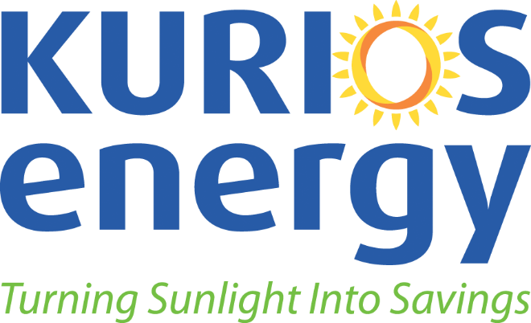
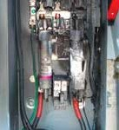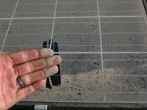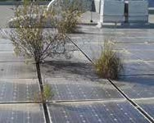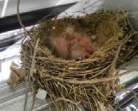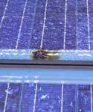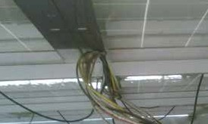

The Renewable Energy O&M Solution

Did You Know?

• A well maintained solar PV system can perform up to 30% better than one which is not?

• Components within your solar PV system could be void of all warranties if routine maintenance is not performed?

• Without third party verification of your system, poorly installed components could forever go unnoticed?

The Truth

Similar to conventional electrical power generation assets, solar PV systems encounter operational hurdles that will disrupt performance and hurt annual revenues. Even with proper manufacturing and installation, solar PV systems encounter extreme weather events, module soiling, communication errors, series losses due to loose terminations, gird events, shading, rodent infestation, intermittent ground faults, vandalism, heat expansion and contraction, and structural vibrations that can damage
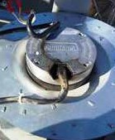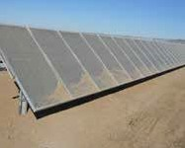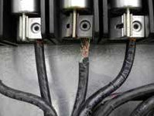or destroy equipment.

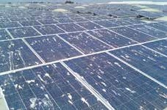
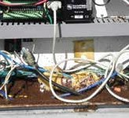
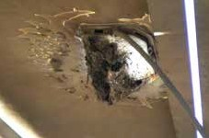

The Solution

Kurios Energy’s solar service plans are designed to shield and protect solar PV investments from unavoidable degradation. We understand the fiscal importance of keeping your solar PV system operating at optimal performance. Our cost-effective and proactive approach to solar O&M goes beyond the standard ‘when it breaks, we will fix it’ approach.

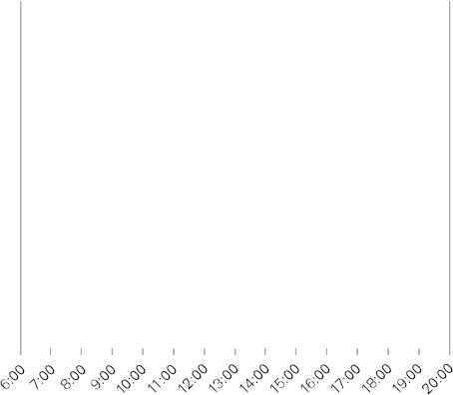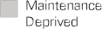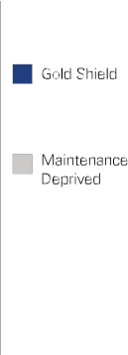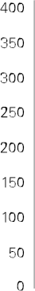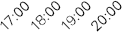

2011

2010

2011

2010

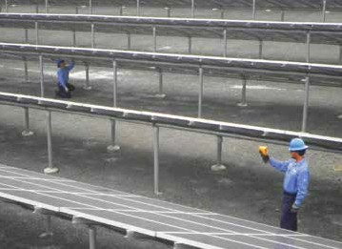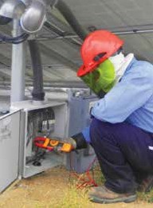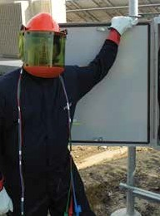

Shield & Protect Your Solar Power Investments

Bronze Shield: At the heart of your solar PV system is the Inverter. Our in-house factory trained and certified electrical solar technicians will conduct inverter preventative maintenance, plus visual inspections of the arrays and BOS such as: combiner boxes, disconnects and Data Acquisition Systems. With Bronze, you’re given access to our 24/7 Customer Support hotline. You will also receive a maintenance report after each site visit, as well as an annual maintenance summary report.

Silver Shield: Preventing degradation to your system’s performance is key. The most cost effective method is to include proactive performance monitoring within your annual O&M schedule. With Kurios Energy’s Silver Shield, you receive the added benefits of real-time performance monitoring and alarm triage, thermal image scans on all electrical DC wiring, inverters, E-Houses, pad mount transformers and other electrical equipment, and biannual performance reports.
Gold Shield: Kurios Energy’s Gold Shield is the industry standard for proactive maintenance. In addition to having all the benefits of Bronze and Silver, Gold Shield introduces annual performance testing and verification (Imp & Voc on all strings), DAS preventative maintenance & calibration, emergency response and/or dispatch within 24 hours or less, warranty compliance, and spare parts inventory management.

Annual Solar Service Plans BRONZE SILVER GOLD

Inverter Preventative Maintenance | ✓ | ✓ | ✓
Visual Inspection of Arrays | ✓ | ✓ | ✓
Visual Inspection of Balance of Systems | ✓ | ✓ | ✓
Visual Inspection of DAS | ✓ | ✓ | ✓
Removal of Debris and Materials | ✓ | ✓ | ✓
24/7 Customer Support | ✓ | ✓ | ✓
Maintenance Report within Five Business Days | ✓ | ✓ | ✓
Comprehensive Inspection of Array Racking |  | ✓ | ✓
Comprehensive Inspection of Exposed Array Wiring |  | ✓ | ✓
Real-time Performance Monitoring & Alert Triage |  | ✓ | ✓
Thermography Scans |  | ✓ | ✓
System Performance Test & Verification |  |  | ✓
DAS Preventative Maintenance |  |  | ✓
Emergency Response* within 24 Hr. or Less |  |  | ✓
Warranty Compliance |  |  | ✓
Up To Two Panel Cleanings Per Year Using Reverse Osmosis |  |  | ✓

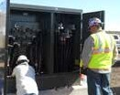ADDITIONAL SERVICES:

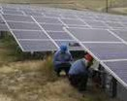Commissioning. The person who installed your system is the last person to point out anything wrong with the project. Therefore, we recommend our third party Commissioning service to verify quality in workmanship, materials, design criteria and performance.
Pre-Grid Load Verification. Our test allows for the verification of performance during construction, in advance of a substation or the rights to interconnect to the grid. It helps avoid repetitive workmanship errors, accelerates construction and allows solar assets to begin generating revenue ahead of schedule.

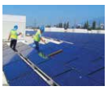

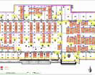Engineering.
Due to our technical re- sources, experienced personnel, access to operational PV performance data, and our leadership within industry bodies such as NREL, EPRI & Sandia, KURIOS ENERGY is a solid partner for engineering projects.

Owner’s Representative QA/QC. KURIOS ENERGY will provide onsite observer and reporting services and use all necessary documents and construction management protocols to oversee construction routines, schedules, and activities, will perform spot checks and random sample performance testing, and on a weekly basis take logs and create comprehensive reports of all activities.
Solar Array Cleaning. Critical for solar PV systems in locations prone to: heavy pollution, dust storms, construction kick-up, bird droppings, forest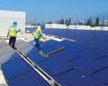 fire ash, chemical and manufacturing residue.

Asset Management. Kurios Energy manages millions of dollars in solar assets to bring a fully comprehensive and integrated approach to the delivery of technical, operational, and financial results for owners of solar
PV systems.

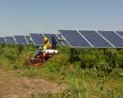Weed & Vegetation Control. Weeds and other vegetation can cause massive disruptions in power production when overgrowth creates shading on the module surfaces.
OEM Service & Repair.
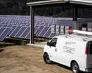Kurios Energy’s electrical solar technicians are trained and certified by the manufacturers. We also manage spare parts inventory in our warehouses and service vans in order to deliver and complete same
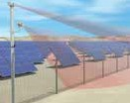Day service requests.

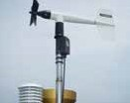DAS Installation. Monitoring your system’s performance is critical to achieving your ROI. KURIOS ENERGY will install a dedicated weather system to ensure your system operates optimally in all conditions of the environment.

Security. Protecting solar PV assets from theft, vandalism or trespassing is vital to the long-term operability of the power plant. It is also critical that all incoming and outgoing traffic such as shipments and visitors be managed thru a professional service.

