THE KURIOS ENERGY ADVANTAGE

ENERGY PORTFOLIO MANAGEMENT (EPM)
STRATEGY: ENERGY INDEPENDENCE STRATEGIC ANALYSIS
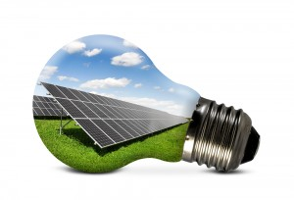
What we do.
We maximize your investment through careful energy independence planning and management.
Our analysis includes the following:
- Consumption Pattern Analysis
- Demand Pattern Analysis
- Rate Structure Analysis
- Time of Use Pattern Analysis
- Facility Efficiency Analysis
- Rebate Analysis
This comprehensive approach allows us to create and present an efficient, money-saving recommendation so that you can begin managing and producing your own energy, while savings thousands per year on electricity.

OPERATING PLAN: VALUE ENGINEERING

Kurios Energy designs the size and type of solar energy system based on the ability to offset most of your current cost for electricity, which the solar industry refers to as avoided cost.
The high value solar kWh produced in the peak summer time period helps offset the high usage activity during the fall processing months by maximizing the solar production during summer peak and summer off-peak time periods.
Kurios Energy will also look at other energy independence needs, such as whether a multi-meter system is necessary for your business, potential infrastructure upgrades, and utility needs to maximize your system.
This value engineering package will not only allow you to be energy independent, but will execute your renewable energy solution in the most cost-effective way.

EXECUTION AND INSTALLATION
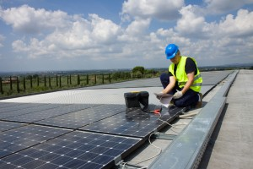
Kurios Energy will handle the execution and installation efficiently so that you don’t have to worry about interrupting your commercial activities while in process.
Kurios Energy’s innovative, turnkey solar electric solutions are offered through a comprehensive process that takes the customer’s system purchase from concept to completion.
There is no faster, easier way to obtain a cost-saving, environmentally friendly solar electric system for your facility.
The major activities included in our end-to-end process include:
- Perform site feasibility studies and rate analysis
- Engineer a comprehensive, optimized design
- Manage the project implementation
- Construct and install a quality system
- Install real-time, web-based monitoring
- Provide on-going operations and maintenance support

KURIOS SOLAR ENERGY SYSTEM PERFORMANCE GUARANTEE
When we engineer your system, we don’t just predict system production, we guarantee it! Solar is all about savings and savings are all about production. We guarantee production to guarantee savings. In addition we provide a 10 year bumper to bumper Operations and Maintenance program to ensure your system produces at optimum levels for years to come.

FULL-SERVICE COMMERCIAL SOLAR
Kurios Energy is a full-service commercial and industrial solar panel installation service provider, from expert in-house design, permitting, and installation to utility interconnection and rebate paperwork. We will work with you and for you, from Concept to Completion of your project.
QUALITY PROCESS
Kurios Energy only uses the highest quality components installed by NABCEP guidelines and using NABCEP certified installers. We ensure that high quality components meet high quality construction in order to produce reliability and longevity of your solar power plant.

COMPETITIVELY PRICED SYSTEMS
Kurios Energy works hard to make sure your system and process is managed efficiently to ensure the most cost effective energy independence package for you.
We won’t just give you an expensive installation quote, we’ll give you a comprehensive money-saving approach with a structure that works for your budget. We also have developed strong relationships with our suppliers, so that we can pass along volume discounts to our valued customers.

