GoHPT Company Description
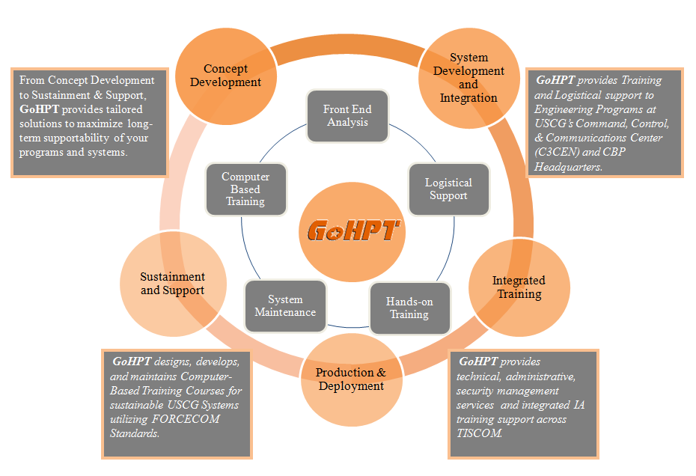
Goal-Oriented Human Performance Technologies, LLC (DBA GoHPT) is a Native American owned company capable of strategically designing practical, flexible, and robust solutions for planning, training, and maintaining systems designed specifically to protect the Homeland.

GoHPT People
Our professionals bring with them seasoned experience with a proven past performance record. GoHPT employees possess the following experience, training, and education:

- LEAN
- Six Sigma
- Human Performance
Technology model (HPT)
Project Management
- CISSP
- CISM
- CRISC
- WiMAX RF Network Engineer
- ITIL V3 Foundations

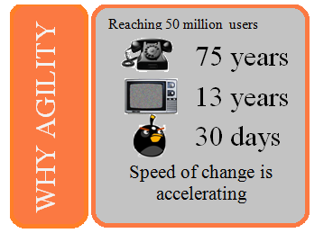
Business agility is the ability to respond quickly to market conditions.
IT agility is the ability for IT systems to quickly accommodate business changes.
While the distinction between the business and IT agility is fairly subtle, GoHPT believes that the shift in perspective is significant.

PROCESS IMPROVEMENT
Instructional Design
The time to design and develop a Computer Based Training (CBT) from scratch is typically 18 – 24 months. By providing the designer with a template, the time to design and develop a CBT can be reduced to 4-6 months.
Information Systems
A customer recently remarked, “If the mission need changes from X¹ to X², we can no longer afford (cost or time) to radically change (“swap out”) the supporting IT system from A to B; instead, we need to be capable of changing the IT system from A1 to A2, quickly and efficiently.

Finding a better way
GoHPT Professionals are encouraged to be better stewards of the resources they have been entrusted.
GoHPT Professionals are trained to identify processes, encourage streamlining, and calculate the risks of completing tasks using a variety of methods.
The end goal of every task assigned to a GoHPT Professional is to: eliminate waste and reduce variation in a cost-effective and efficient manner.

8(a) Mentor Protégé
GoHPT is a protégé of ISHPI Technologies, LLC. ISHPI has the capability to provide experienced people, proven processes, technology, advice and leadership to enable a full spectrum Cyber capability that transcends humanistic, metaphysical, and geopolitical factors if defense of the Homeland.

NAICS Codes - 541511, 541512, 541513, 541519, & 541611
PSC Codes – AD24, AD23, AD25
CAGE CODE – 7CE50

