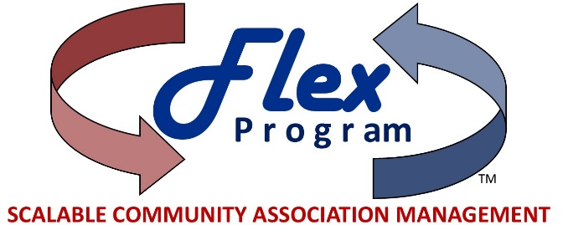
Now Introducing

Simple.
Efficient.
Flexible!

With the MMI Flex Program, our Boards have choices:
- Self-management
- Financial management, with support
- Flex Core: pay only for services needed at the time
- Flex Enhanced: Full service with minimal additional costs

A flexible Management Agreement allows services to be added or deleted without terminating the entire program, giving Boards greater control over the management budget.

