Post card Front Side

INDIVIDUAL & COUPLES COUNSELING FOR NEW YORKERS.
Urban life places many stresses on us, making it difficult to find true connection, balance and joy. I work with clients to explore how relationships with partners, family, friends, coworkers, and society in general are often the source of our greatest growth and the root of our biggest challenges.
Areas I specialize in are :
Couples Therapy
Engagement & Pre Marital Counseling
Sex Therapy- helping couples connect emotionally and achieve their desired level of intimacy
Living Together
Substance Abuse, alcoholism or addictions
Trauma—recent or past
Abuse (physical, emotional, sexual)
Work Related Stress (newly employed, laid off, under-employed, office politics)
Grief and Loss
Separation & Divorce
To start this process, I offer a complimentary 20-minute phone consultation where we can discuss why you're considering therapy, and explore how therapy could be helpful.

Post Card BACK SIDE

If you're looking for extra support and guidance through a challenging situation
Or you want to move in a new direction in your life,
I look forward to working with you to achieve your goals.
In New York City I am conveniently located in Union Square and Astoria.
I offer daytime and evening appointments Monday through Friday.

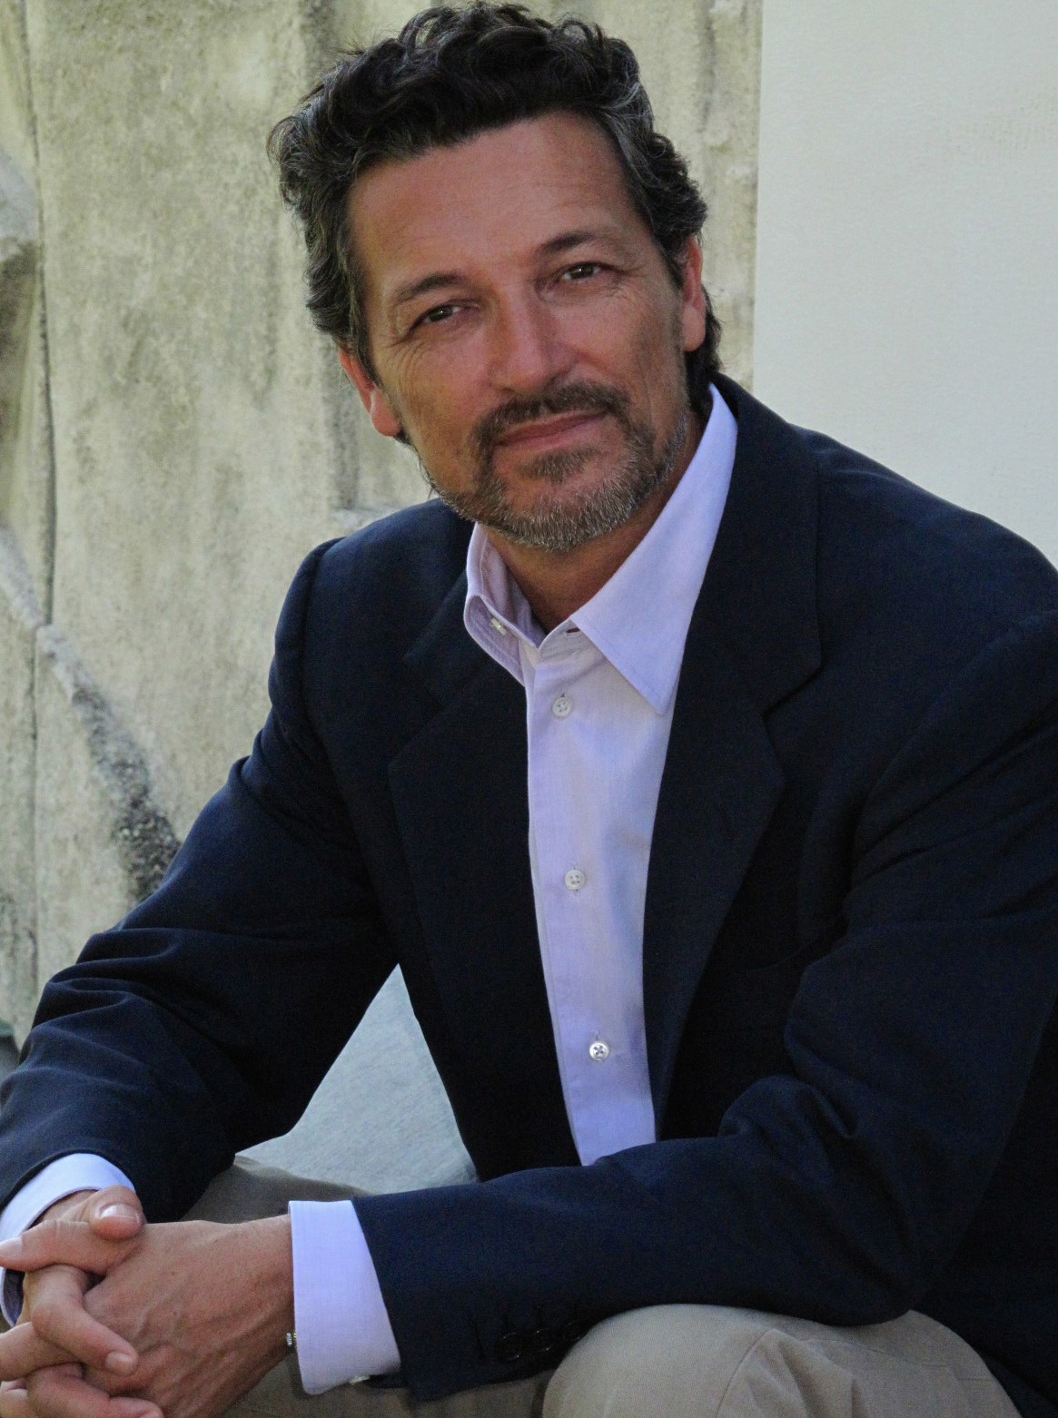
Carlo A. Borea / Psycho Therapist
NYS License #006161
Tel. : 917-756-4209
info@boreatherapynyc.com
41 Union Square West - Suite 1328 New York, NY 10003
3051 36th St. Astoria, NY 11103

