DM Overview
Audience
There are two main audiences and the message may need to be different for the two –
- HR & Training and development people
- Analytical team managers
What I want ideally is for companies to take the ‘Making Analysis Work For Business’ workshop (2 days for p to 8 analysts) and privately host it rather than necessarily just have them attend the public workshops. With some companies the workshop has become part of their standard programme of training for analysts so every 12,18,24 months they come back to me and say we’ve now got a bunch of new analysts we want to put through the workshop and that’s ideally what I want to happen in the long term.
About ‘Making Analysis Work For Business’
This is my flagship 2 day workshop- if I get to speak to Analytical managers it’s usually a reasonably easy sell – it gives the analysts a number of practical steps and expected behaviours they can follow to ensure they deliver good analytical service whilst also improving their impact and increasing productivity by reducing re-work. Ultimately for any level of analyst it provides a template of standards to work to that will naturally help build credibility and trust with customers and enable them to work more proactively.at the end of the workshop they get checklist of behaviours and actions as an aide memoir – a few businesses have gone on to integrate this into their personal development review processes. There are a number of common issues/challenges analytical teams face and experience. These are:=
- They have (or rather take on) too much work (usually because they don’t plan effectively or they avoid negotiating deadlines ad say yes to everything).
- They work reactively and find no time to add value
- Their customers don’t involve them in the wider process and so they don’t feel they get the full picture and don’t get involved until last minute.
- They feel their customers don’t articulate themselves very well and are prone to changing their minds so they do lots of re-work.
- Their customers think that everything is just a press of a button whilst in reality it’s a lot more work than that.
- They struggle to get heard and suffer from a low profile within the business.
- They feel as though they spend a lot of time just turning the cog to spew out data.
The workshop addresses all these challenges through sections dedicated to communication, planning and presenting data.
I have lots of testimonials for the workshop and it’s now CPD accredited which is another reason why it’s a good lead product. I guess for the two audiences there are two hooks…
Training/HR – CPD accredited soft skills training specifically developed for data analysts, data scientists, Management Information and Business Intelligence professionals.
Analytical Managers – Complementary soft skills training to help the analysts to become more proactive and customer orientated/consultative.
I’ve developed a skills based triangle as a way of capturing the importance of soft skills to an analysts development (something totally lost on a significant portion of more technical orientated analysts)….
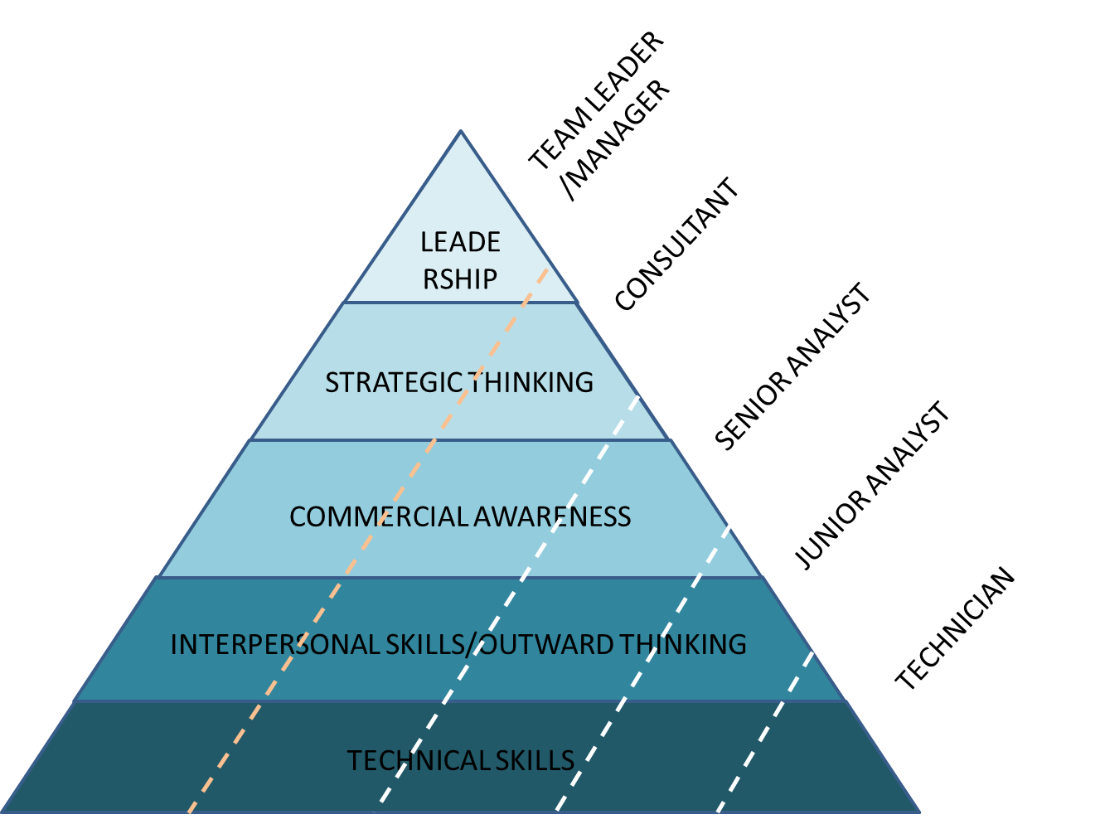

Previous Marketing
This year I started to differentiate my marketing into prospects and customers whereas previously I sent everyone the same thing. So customers get updates and offers generally – prospects get a salesy email here are a few and their open/click rates.

