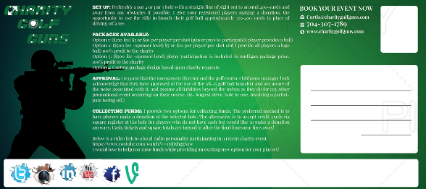
Can you remove the darker green shaded “box” above and keep everything else just overlay everything else on the original green background ?. If you look back at the first version above the background is the same all the way across the entire width.
I love the text below on the left, it is perfect, don’t change it but can you extend the white all the way across the entire width like the original above and place an asterisk before
* (TCG available in select markets only)

Final change!
On the target photo on the left, please crop a little of the top of the photo out and drop the orange/white triangle down slightly so the top of it is perfectly in line with the top of the orange/white triangle on the right. 


