PELLUCID Glass Sliding Walls
Admitting maximum passage of light without diffusion or distortion

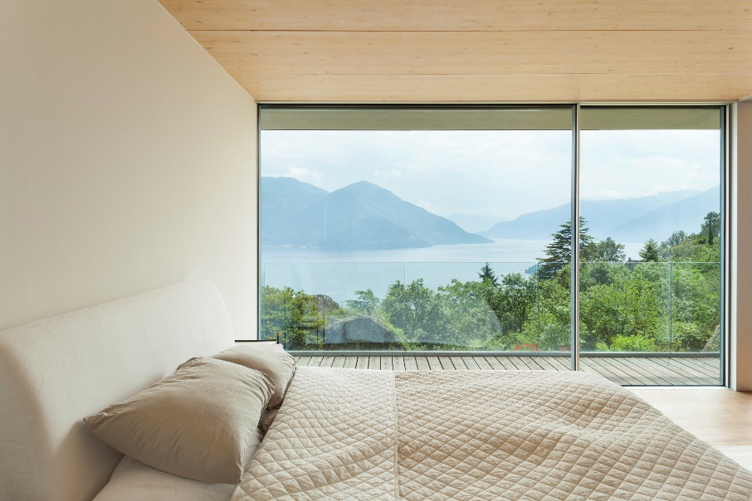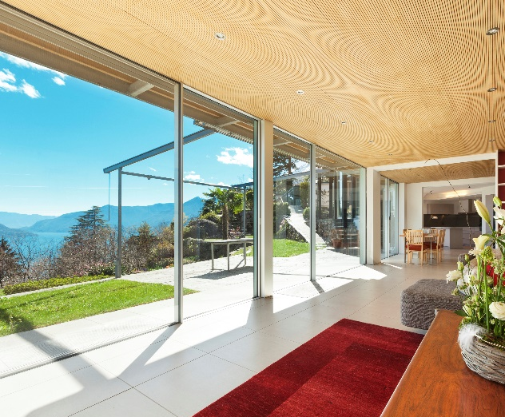

Our product is an aluminium framed, double glazed system with minimum frame exposure giving greater glass area. We can now supply this high end product for the cost of standard range systems.

What we do
We are manufactures of, & specialize in, thermal insulated aluminium framing systems for large double glazed, fixed & sliding glass panels.

We can achieve thermal U ratings as low as U 0.75

Energy Saving like no other, compare our thermal U rating with other systems
Style & Strength of aluminium with modern design architects look for.

Our service
Full manufacture– Complete manufacture ready for site installation
Semi manufactured – Sell full length profiles partly manufactured
In house powder coating facility

