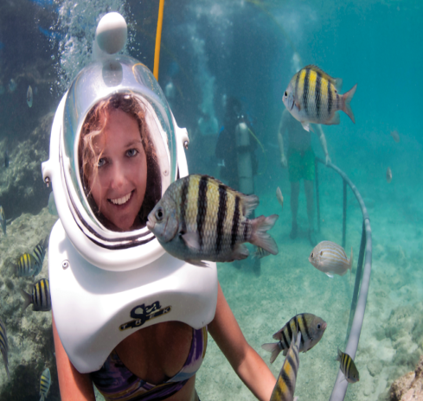
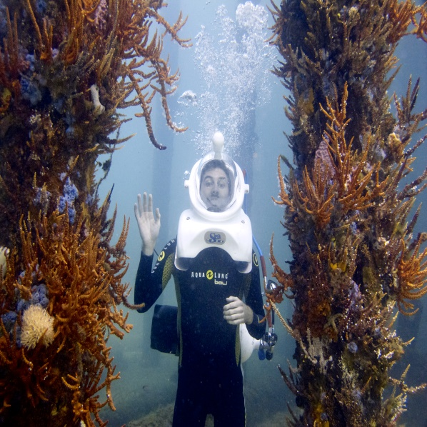
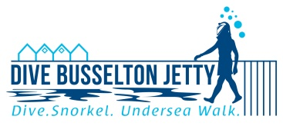
How to book onto today’s tours: Book online at www.underseawalks.com Or book by phone on 1 800 994 210
Go Below!
You can walk under the sea today!
◊ Very safe and easy to do
◊ For (nearly) everyone 12+
See the underwater wonderland beneath the Jetty for yourself!

