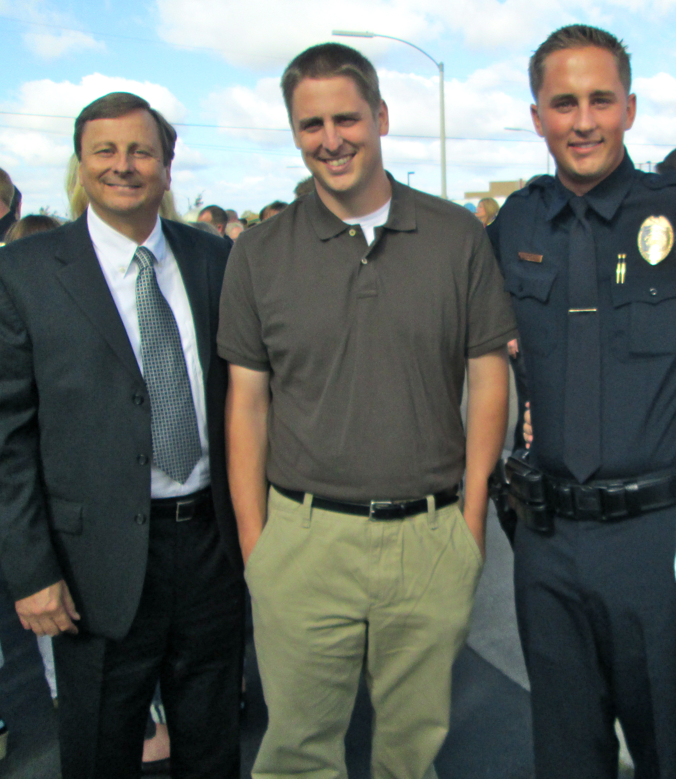

“You cannot rely on anyone but yourself to save your life…”
Lt. Jim Byler Brandon Byler Brett Byler

Jim’s Story

“And then I heard it. The unmistakable sound of a shotgun being racked. And then another one. I was hit with near-blinding light from police flashlights, but was still able to make out the silhouettes of officers taking cover behind their patrol car doors... All weapons pointed directly at me…”

Brandon’s Story

“Brandon stood over him, holding the shotgun in his left hand and his now empty handgun in his right. He stood there in stunned disbelief at how a routine call had escalated into a violent confrontation in a matter of seconds. The stench emanating from the house, mixed with the smell of gunpowder and blood, was almost overwhelming.”

Brett’s Story

“Brett desperately wanted to stay with Jeff, but the danger still presented by Bogard was paramount. As Brett rushed towards the suspended vehicle, the door suddenly opened. Bogard climbed out and dropped to the ground. He stood and faced Brett like a raging bull. If the bull charged, Brett was prepared to shoot again…”

