
VIP Invite

Kronos South East Asia is delighted to invite you to an executive luncheon at

The China Club
Singapore

February 18th from 12-2:30pm
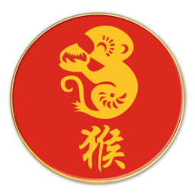
Join us for a delicious Chinese New Year celebration in an elegant, members-only club, atop the 52nd floor, The Capital Tower.
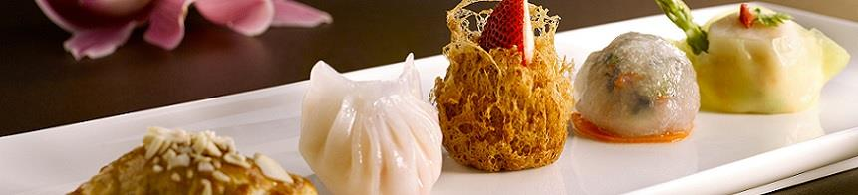
RSVP to deane.hornsby@kronos.com before 18th January

