Here are some links that will give you the "look" of a few Main Streets in small and mid-size US town that I think are good examples:
See http://www.travelandleisure.com/slideshows/americas-greatest-main-streets The best ones are Ann Arbor MI (except it’s a night view), Staunton VA (except it doesn't show enough), and Hoboken NJ (especially if you can get a Google streetview around 416 Washington St). Others either have buildings that are too low or too much in the style of just a small region.
There is one problem with the images I mentioned above: they are almost certainly copyrighted. I wouldn’t want to violate anyone’s copyright. They are fine for preliminary designs but not good for a final design that will be publicly used on Twitter.

So I got the views below from Google Streetview. I think we can use them without violating any copyrights. I’ve never seen a copyright © symbol on Streetviews. Feel free to crop and modify them too, in any way you wish.

361 Main St., Ridgefield CT USA (A little dark/gray to use as-is, but a good example of typical Main Street buildings).
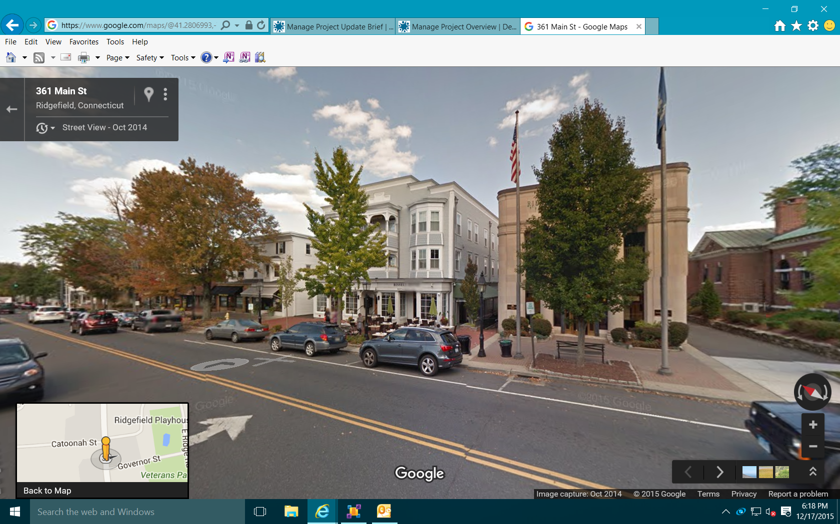

Main St & 70th St, Queens NYC, NY USA
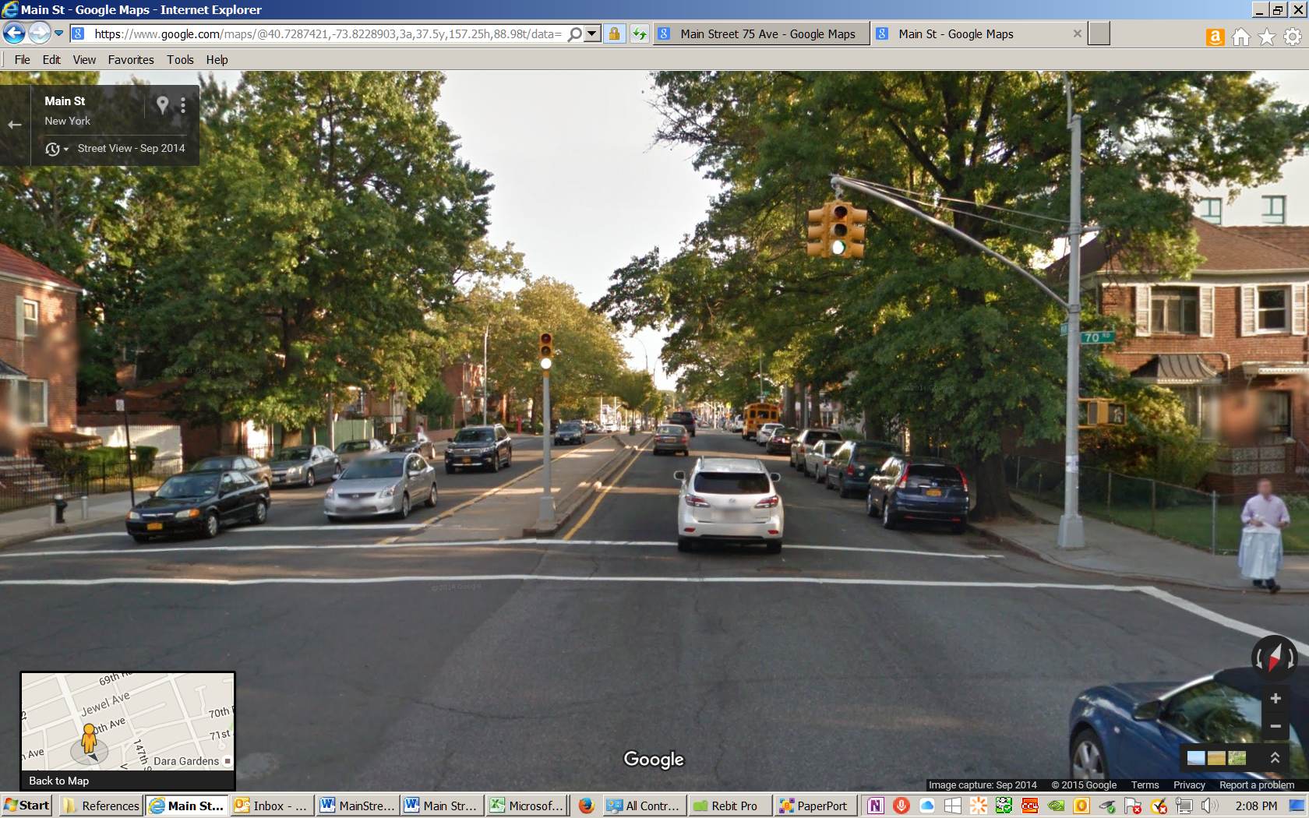
32 Main St., Stockbridge MA USA (A little too dark/gray to use as-is, needs adjusting, but a good example of typical Main Street buildings).
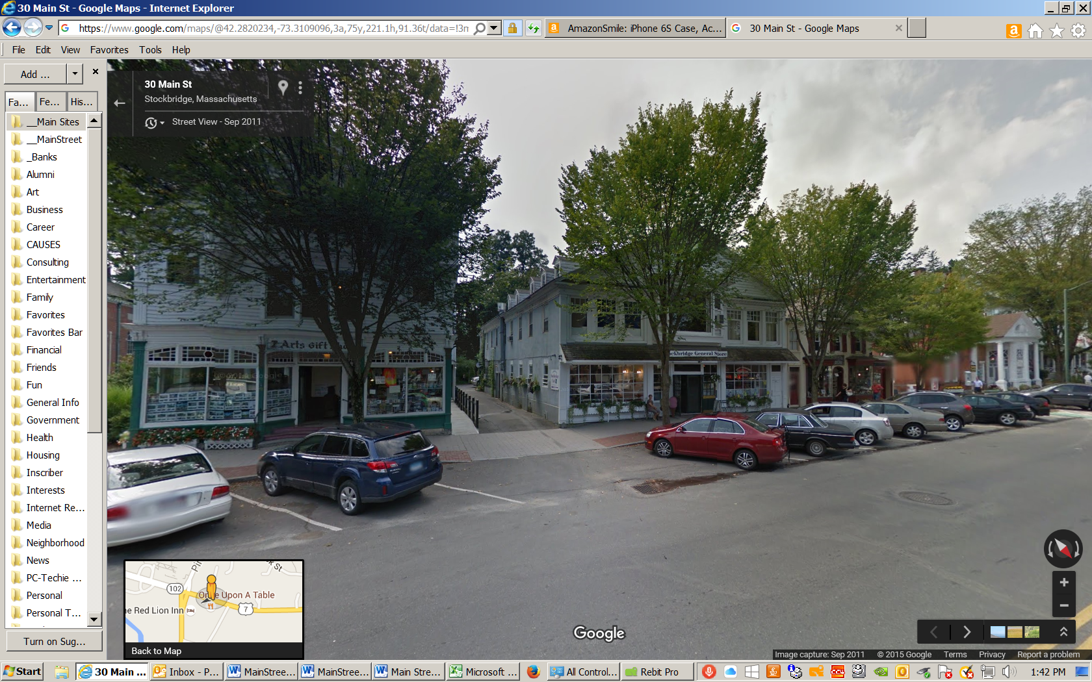

Cazenovia NY USA (A little too dark/gray to use as-is, needs adjusting, but a good example of typical Main Street buildings).
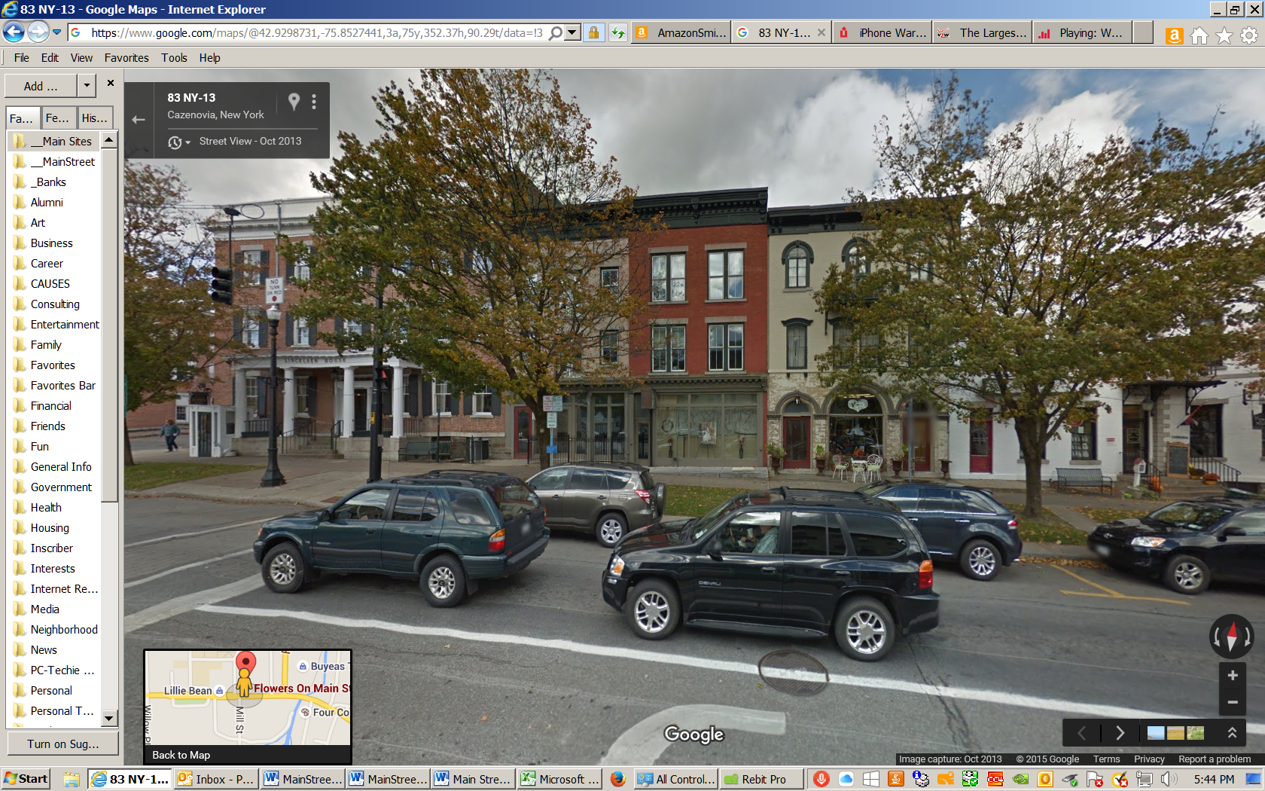
Cazenovia NY USA
