  About Mike  Your life changes. As your State Farm Agent, Mike Holland helps you manage your changing needs, from starting a family, to buying a home, to planning your retirement. Mike designs strategies to protect you today, while planning for tomorrow, and managing the everyday risk in between. He also oversees the day to day operations of his agency. Mike started the agency in 2011 after more than a decade of success in the corporate sector and after 14 years as a small business owner. He is a graduate of NC A&T State University where he earned his bachelors in engineering. When he’s not helping his clients, he’s spending time with his wife Tisha and his two boys, Michael (7) and Miles (4).      Team Members    Our agency has 7 team members in addition to Mike. There are 3 Account Representatives, 2 Customer Service Representatives, and 2 business marketing college interns. Our team will arrange to meet you anywhere, anytime to accomplish your plan. Your needs will determine our path. Shared values will guide us. |  |  |   Our Mission  State Farm’s mission is to help manage the risks of everyday life, recover from the unexpected, and realize their dreams.  remarkable  Every Customer | Every Interaction | Every Day
  Intern & Co-op Program
  Holland Insurance Agency, Inc.
    - Spring 2016 Internship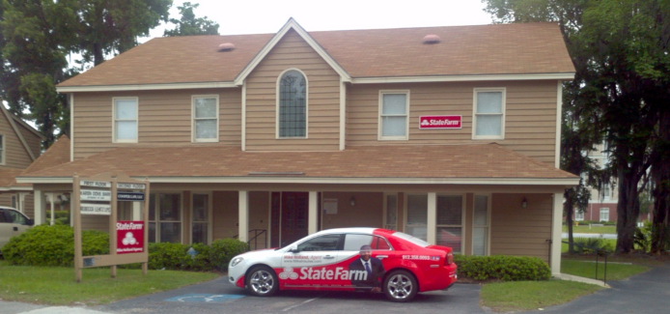
  Auto | Home | Life | Health | Business
  www.MikeInsures.com
  5859 Abercorn Street, Bld 2 / Suite 4
  Savannah, Ga 31405
  
  Facts about State Farm  - Insures more cars and homes than any other insurer in the U.S  - Has more agent locations than McDonald’s, Starbucks, and Walmart stores  - Has 82.1M policies in force in the U.S.  - Is ranked No. 41¹ on the Fortune 500 list of largest companies  - Has more than 65,000 employees  - Has 18,000 agents  Are You Looking To Intern With Us??   |  |  |  | Key Position  Responsibilities  - Market research to strengthen our sales efforts  - Implements marketing and advertising campaigns  - Working with and through team members to accomplish goals and promotions  - Supporting agency sales efforts  - Obtaining referrals for agency growth and your personal growth  - Consistent training in and out the office  - Having a great time with a winning attitude! |  |  | Apply Online Now  (Please no calls)  www.mikeholland.sfagentjobs.com  Intern & Co-op Opportunities  Spring Semester  Summer  Fall Semester  Minimum of 15hrs/ week  College Majors  Business Management  Business Marketing  Entrepreneurship  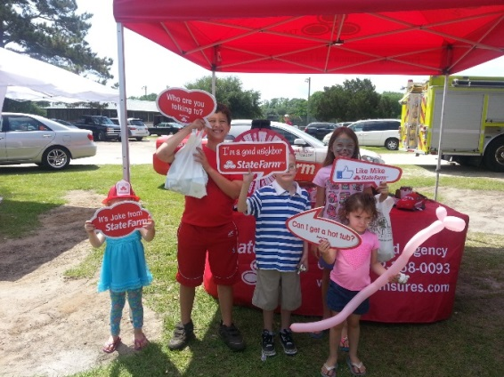  *Will write a letter of recommendation upon successful completion

