
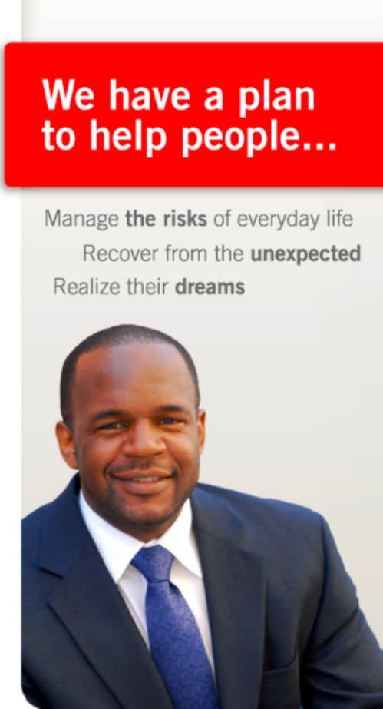
Holland Insurance Agency, Inc.

About Mike
Your life changes. As your State Farm Agent, Mike Holland helps you manage your changing needs, from starting a family, to buying a home, to planning your retirement. Mike designs strategies to protect you today, while planning for tomorrow, and managing the everyday risk in between. He also oversees the day to day operations of his agency. Mike started the agency in 2011 after more than a decade of success in the corporate sector and after 14 years as a small business owner. He is a graduate of NC A&T State University where he earned his bachelors in engineering. When he’s not helping his clients, he’s spending time with his wife Tisha and his two boys, Michael (7) and Miles (4).

Team Members
Our agency has 7 team members in addition to Mike. There are 3 Account Representatives, 2 Customer Service Representatives, and 2 business marketing college interns. Our team will arrange to meet you anywhere, anytime to accomplish your plan. Your needs will determine our path. Shared values will guide us

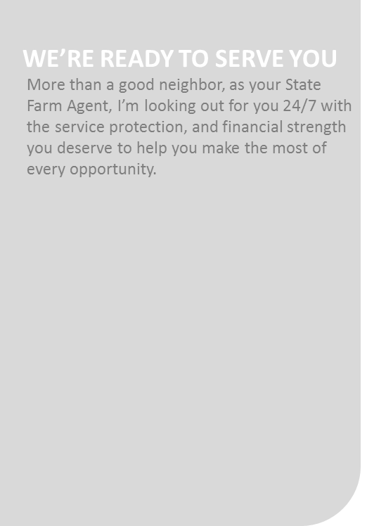


We’re ready to serve you
912.358.0093
Auto | Home | Life | Health | Business
www.MikeInsures.com

912.358.0093
5859 Abercorn Street, Bld 2 / Suite 4
Savannah, Ga 31405

