YTK
Ya’s Thai Kitchen

YA’S THAI
KITCHEN

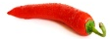aaaa