Front:

<Image of woman and company logo>
A personalized approach to skin care.
Results you can see. Care you can feel.

Let us create a custom skin care regimen that best fits your medical and personal needs.

We pride ourselves on providing premium skin care, to patients of all ages, with an honest and attentive approach. We’re also proud to be leaders in skin cancer surveillance and specialize in the diagnosis and treatment of skin cancer.

Inside:

Medical services
We’re leaders in the diagnosis of all skin conditions and autoimmune skin conditions, including:
- rashes
- acne
- warts
- skin tags
- rosacea
- psoriasis
We’re also involved in ongoing research for the treatment of psoriasis.

Skin cancer surveillance and treatment
Skin cancer can form anywhere on the skin (even where the sun doesn’t shine), so it’s vital that a full body exam is done at least once a year.

We pride ourselves on thorough surveillance and commitment to your overall health.

Alternative care
Your commitment to your health is the same as our commitment to you. We provide non-antibiotic acne treatment including botanicals, blue light and a combination of supplements to fit your personal lifestyle.

Dermatologic surgery services
We have in-house surgeons for the removal of atypical moles and skin cancers, including margin control for melanoma. Our board-certified, in-house surgeons specialize in:
- Plastic surgery
- Mohs surgery (treatment includes transportation and care from your trusted healthcare team)

Cosmetic services
Your skin is unique, so we take pride in our ability to provide personalized consultations and skin care analysis to set you up with the right treatments and products.

- Chemical peels
- Photofacial
- Ultherapy
- Harmony
- IPL
- Injectables and fillers (Restylane, Juvederm, Belotero, Botox and Dysport)

Elite-grade cosmeceutical products
Including Vivier, Jan Marini, Image, Colorscience, Skin Scripts, Latisse and much more.
Eesthetic services
Facials, peels, microdermabrasion, body wraps, waxing, eyelash extensions, brow tinting
Nutrition and supplement support
Including gluten free, no filler multi-vitamins, immune boosters, hormone, sleep aid balancing products and B12 injections and the Skinny Shot.

Back:
480-704-7546
ahwatukeeskincare.com
Shop at 2loveyourskin.com

<This information in any layout:>

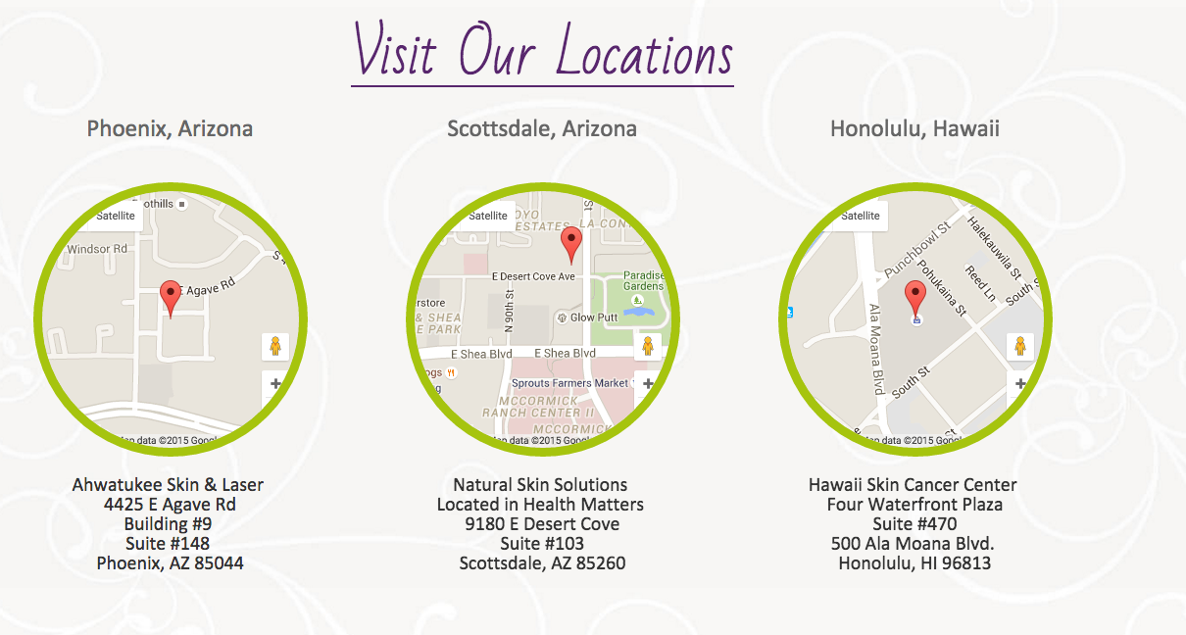

We accept most major insurances and offer affordable self-pay rates.

