Min´ka
Public infrastructure for money

Comment: good foto or illustration picturing community or network, or illustration of world map focused on Latin america
Min´ka – qechua Word for word for – work for the good of the community.

Money is only information about what we owe each other.

Min'ka is a platform that allows you to process that information.

2,5 billion people accross the world don’t have access to financial services.

Comment: diagram, this is my drawing sketch, idea is to provide an illustration.
No hardcoding of names, we will need to translate to Spanish.

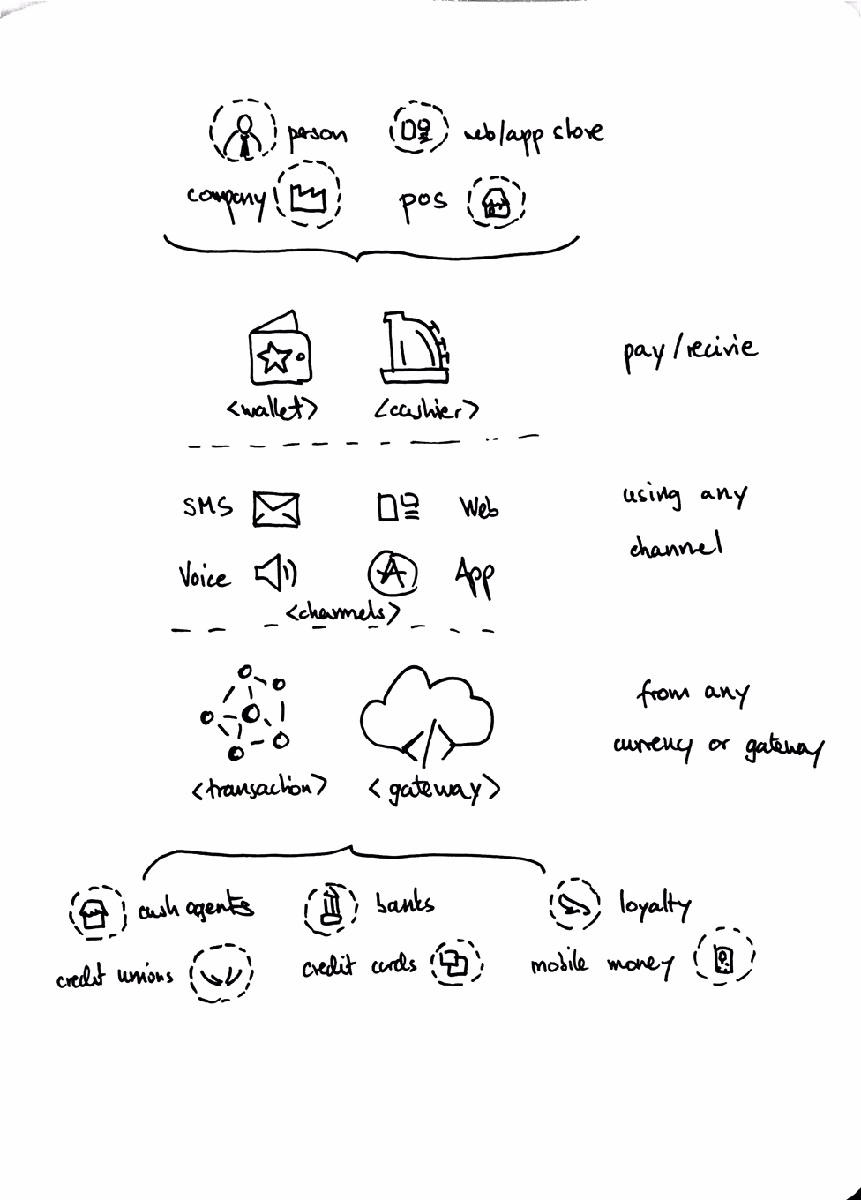

Bottom – two columns – short paragraph each, tbd. Lorem ipsum for now
Commment: add logos from the first page diagram, such as:


<Wallet>
Universal, omni-channel wallet that is accessible on any device. True one action payment making it as simple and accessible as cash.

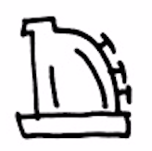
<Cahier>
Universal interface for accepting any form payments. Personalized information and benefits program provide a contexts to what otherwise would be only transactions.


<Channel>
Text message, voice call, ussd, web or app. Any channel you prefer to use.
Powered by Infobip - 4 billion transactions per month, 190 countries, 800+ operators.

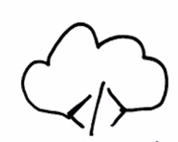
<Gateways>
Gateways are issuing entitites that that people trust to hold their deposit and issue credits into the network. Min’ka network connects the different gateways so they can interact and create money transactions.

<Transactions>
Min’ka uses a global ledger to keep track of all the balances and transactions for every single account on the network. Min’ka ensures that all transactions are valid and get applied successfully to the global ledger.

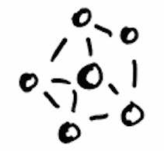
<Currency>
Min’ka can allow to send any currency between any address in the system trough its built-in exchange. Lukas is the universal, bridge currency used to settle dollars, yens, pesos, loytalty points, giftcards or bitcoins.

<Address>
Each unique Min’ka address can be referenced by something we all know – your phone number. Two factor authentication and global ledger ensure a secure, fraud free system.

