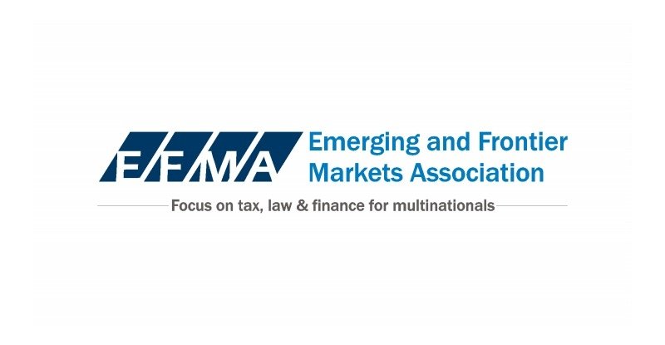
The logo above should be on either the front or back and should not be as large.

We could either have a graphic in the front, where I have typed graphic or in the back showing the Boston skyline. See for example, the Boston Harbor here though I don’t want to pay much for the graphic: http://www.dreamstime.com/stock-photo-boston-harbor-financial-district-boston-massachusetts-usa-image46273095)

Register Early and Save up to $300

Increasing Profits & Protecting (GRAPHIC)
Intellectual Property in Developing Growth Markets
Boston March 24 & 25, 2016

You are cordially invited to attend a comprehensive and practical day and a half conference to examine the tax and legal structuring strategies for increasing profits from Intellectual properties while protecting these important assets when doing business in fast growing developing markets. Intellectual property assets include some of the most important assets of most companies: their patents, trade marks, copyrights, brand names and licensing agreements.

Senior tax, legal and financial experts will provide a comprehensive analysis of the legal issues, recent tax & regulatory developments, skills and structuring strategies necessary to maximize profits from IP Migrating IP assets to low tax jurisdiction will also be covered along with dealing with issues of piracy, counterfeiting, infringement and other legal challenges to a company’s IP.

Topics to be covered include:

- Market trends in IP tax & legal structures
- Proposed US Tax changes and regulatory developments outside the US including European and OECD developments affecting IP, patent box, base erosion and profit splitting (BEPS)
- Overview of the IP landscape in key developing growth markets such as China, India, Brazil, Korea, South Africa, Mexico and other developing markets outside the US.
- Legal issues including litigation, arbitration and use of government assistance to protect IP values in key developing markets.
- Monetizing IP assets and rights in regard to divestitures, spin offs, split offs, M&A, transfers of ownership and securitizations in developing growth markets
- Special Tax Planning and Legal Considerations for IP in Particular Sectors such as Biopharmaceutical, International Sports Licensing, High Tech, Consumer Brands, and Manufacuring
- Restructuring and Migration of IP Assets to Tax Advantaged Jurisdictions

[page 2 either have the below logo here or on page 1 and have picture of boston skyline here]

Page 2 continued
Speakers

Biogen (speaker to be announced)

Kevin O’Brien and others (Baker & McKenzie)
Gilles .j.de.Vignemont, (PricewaterhouseCoopers)
Michael Hardgrove, Paulus Merks, and Niels Mulder (DLA Piper)
Richa Naujoks (Nixon Peabody)
James Ferguson (Mayer Brown)
Jay Darby (Sullivan & Worcester)
Karen Won (Cooley)
Lindsey Canning (Freshfields)
Others to be announced

Seating is limited, we invite you to REGISTER NOW!
We look forward to seeing you on Thursday, March 24 at the Boston office of Sullivan & Worcester, 1 Post Office Square, Boston, MA 02109
Register at http://www.globalpredict.com/products/ip-conference-attend
Or email gbrown@emerging-frontiermarkets.org or call 978-369-3536

[mailing address on right side of page 2 of postcard]
Emerging-FrontierMarkets.org
44 Saw Mill Rd.
Concord, MA 01742

[lower right]
Want more information on EFMA or other programs.
Send us an email to gbrown@emerging-frontiermarkets.org
Or send this back with your address

