HOMEPAGE
*It appears that File #’s in the CrowdSource Brief get renumbered. Please refer to the DROPBOX folder instead of the File numbers shown below. In DropBox, all of the Sliders have the relevant images. Please provide your email so I can invite you into Dropbox.

*Shall we use a short 10-15 second video clip of me (Ian) teaching yoga as a background for the website homepage? Maybe in black and white. Muted of course. Please advise.
1) Utilize Correct Logo (File #36 in brief) which has the text “Expert Guidance for a Healthier Life”:
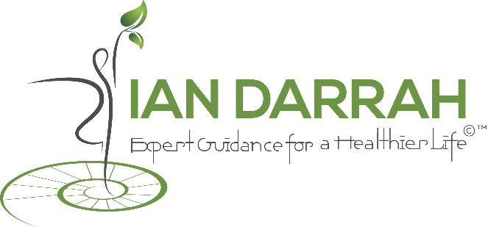

2) WEBSITE PURPOSE CLARIFICATION:

1. Show Ian (Face or headshot)
2. State Services:
*Expert Guidance for a Healthier Life
*Expert Leader of Yoga Teacher Training

NOTE: it is important that people can see what I do from top of the Homepage: 1) Teacher of Yoga 2) Personal Fitness Trainer
The purpose of the homepage and website: the objective is for people from different walks of life (different gender, age, physical/mental condition etc.) to feel like: “yes, Ian Darrah can help me with my health and wellness” It is important for the initial visual of the homepage to show me giving personal attention to someone. It is important for people to feel safe and cared for. Showing me in a fancy yoga pose DOES NOT serve this purpose (*note: most yoga teachers are trying to promote themselves showing themselves in fancy/advanced artistic yoga poses). This can scare a lot of people away. The emphasis should be on me helping/teaching/training students & clients. The target market will be people who appreciate more authentic and spiritual yoga (mental peace), wellness over having huge muscles like a body builder, sensitivity to ecology-nature-green-organic-healthy nutrition…
2) NAVIGATION: HOME
ABOUT IAN
SCHEDULE
SERVICES (drop down: personal fitness & yoga training, yoga classes, workshops & retreats, ayurveda/shamanic lifestyle teaching, diet & nutrition coaching, guided meditation, specialty senior classes and yoga teacher training programs
CLIENTS (drop down:CASE STUDY, TESTIMONIALS)
GALLERY
CONTACT
3) SLIDER: need to improve design (current www.iandarrah.com)
*Note: I don’t know how many sliders is best? I await your guidance on this! See Dropbox for the folders of Sliders with Images

Please advise regarding maximizing the design of this Image slider
4) STATE SERVICES:
YOGA, WELLNESS & FITNESS with IAN DARRAH The Natural Way
Ian Darrah's personal fitness & yoga training, yoga classes, workshops & retreats, ayurveda/shamanic lifestyle teaching, diet & nutrition coaching, guided meditation, specialty senior classes and yoga teacher training programs are offered with one purpose in mind: to help you live a better, happier and healthier life! Awaken your potential. Exercise, get a fitter body, learn yoga, calm your mind, relax & reduce stress and experience vitality & inner peace. Why wait? Begin practicing today. Start your new journey to true wellness now.

*Please note: I also have access to pro photos located at: http://anaisbenoudiz.smugmug.com/Other/Ian-Darrah/30117044_VcwSx9#!i=2589279589&k=S29pTV6

Please advise regarding any photos you feel are best for this website and I can purchase them without Watermark. Ideally the photos should not be the ones where I am NOT touching the students. But if there is a really good one where I am touching the student it is ok.
Thank you.
Regards,
Ian Darrah

SLIDERS & the text + NEW SLIDERS
Welcome
Are you at a decision point in your life, where wellness has become a priority and you are seeking additional support to reach your goals? Ian offers his unique experience to help inspire you to become healthier. He will guide you to wellness by working with you to create a custom tailored plan based on your needs and what you really want to achieve. Whether it is yoga you seek, improved nutrition, coaching, mindfulness & meditation or increased fitness, Ian has the experience, skills and personality to get you there. Please take a moment to read the fabulous testimonials (and see the video testimonials) Ian has received from so many of his yoga students and fitness clients.
Be the Healthiest Happiest You!
I practice a holistic approach to nutrition, which means that I look at how all areas of your life are connected. Does stress at your job or in your relationship cause you to overeat? Does lack of sleep or low energy prevent you from exercising? As we work together, we look at how all parts of your life affect the whole.
There is one thing in this life that everybody is searching for. It is priceless. And no amount of money can buy it. In fact, it has been called the ultimate spiritual treasure. It is the realization and experience of our inner peace. When our health suffers, so much energy and attention goes to the problem of disease (dis-ease). Poor health causes us to become less able to do things, to work, to be with children, to offer our energy and service in this life. When our health shines bright with vitality and function, it is much easier to feel at peace and see life as pure joy!
Benefits at any Age & for any Body Type
Ian’s special skill is that he is able to work with virtually all types of people and actually get his clients & students really excited about making the necessary lifestyle changes to achieve true wellness. Using his background in yoga, fitness, and a decade in the “corporate world”, Ian is able to communicate in a unique way that touches people’s hearts. Ian works with people from all walks of life: super athletes, the obese, handicapped, elderly (Seniors), kids & teenagers, yogis, meditators, triathletes, average Joe’s, people with diseases such as autism, parkinsons, osteoporosis, cancer and heart disease.
Ian understands the tightness and restricted range of motion in the hips, hamstrings and lower back faced by runners and bikers a`s well as the needs of middle aged and aging adults (lower back pain, decreased energy, balance and flexibility challenges, loss of lean muscle mass/strength, decreased cardio function etc.). Ian teaches the importance of proper breathing, postural alignment, balance, flexibility, bioenergetics, the vibrational power of mantra, and the mental skills of concentration, relaxation & meditation.
IAN DARRAH – FOUNDER & DIRECTOR of INSPIRED SENIOR LIVING
SENIOR CARE WELLNESS CARE – FALL PREVENTION PROGRAM
Brochure PDF
IAN DARRAH – CREATOR OF MEDICINE YOGI YOGA: RETREATS, WORKSHOPS, CLASSES
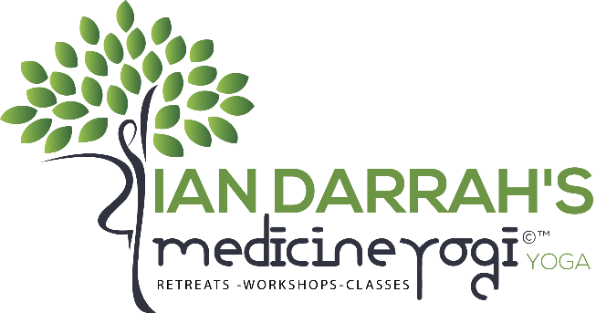
Diet & Nutrition Coaching – Ian’s Approach to Nutrition
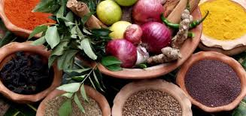
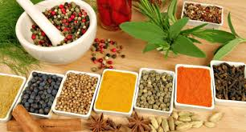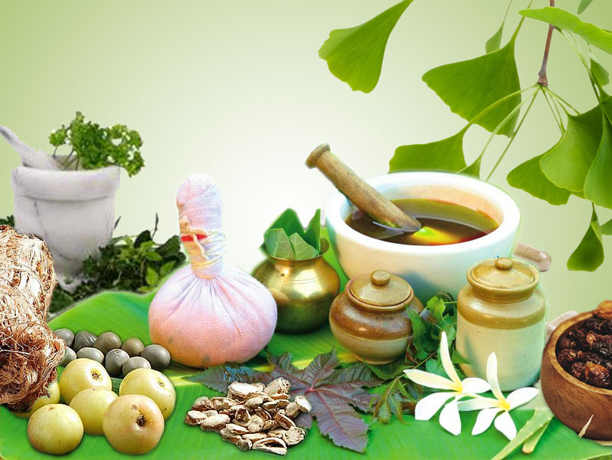
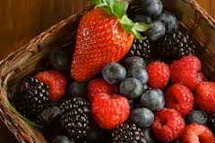
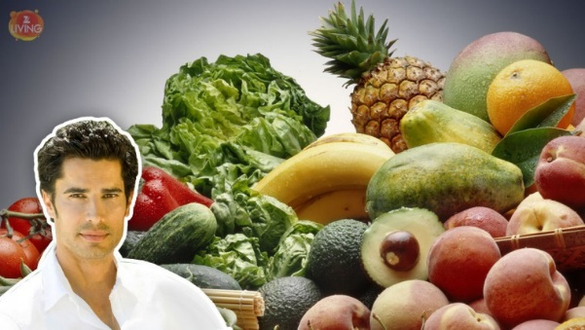
Everyone is “Bio-Unique”, therefore no one diet works for everyone
This is a very important concept that is often missed in the many modern diet fad crazes. Ayurveda (the world’s oldest preventative medical system) fully recognizes this truth and wellness consultations and course of action are based on a particular person’s physiological constitution as well as many other factors: age, gender, health, conditions, season, climate, geography, activity level, individual lifestyle, personal goals etc. One person’s healthy food can be another person’s toxic poison (like with food allergies). Thus, Ian carefully examines each individual person and their specific environment before making any recommendations regarding nutrition.
True nutrition is not just what we put into our mouths
What really nourishes you? Ian practices a holistic approach to nutrition. For example, according to the 7,000 year old tradition of Ayurveda, you can eat all the healthy food in the world but if your digestive “fire” (agni) is weak then you won’t properly, or optimally, absorb the nutrition from the food. Likewise, if you are not sleeping well (quality & quantity) then your ability to properly absorb nutrition is compromised. So, Ian will consider your relationships (are they healthy?), your career and marketplace lifestyle (is stress causing you to not eat proper meals or to routinely go for “comfort” foods like sugar?), your sleep patterns and help you understand how different aspects of your life affect your eating, nutrition and healthy GI tract (gastro-intestinal) function.
Finding balance
Ian recommends what Ayurveda teaches: eating a variety fresh organic plant-based whole foods, sitting down to have meals according to a regular consistent schedule, minimizing unnatural & processed “foods” as much as possible, choosing foods that work well with your own unique body-type, strategically using certain spices, herbs and teas to help build digestive strength, balancing the mix of foods to stimulate all of the 6 “tastes” to maximize digestive efficiency. And so much more…
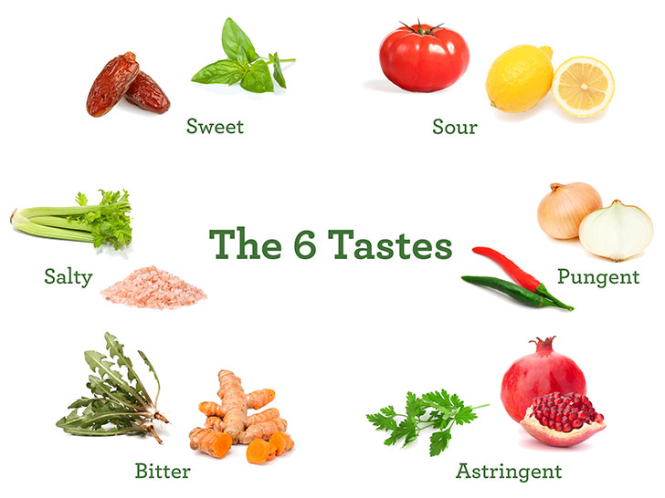
Getting Started. Personal Transformation & Growth The Natural Way

Have you ever wanted to change something about yourself, and found it difficult?
Are you…
- Someone wanting to get more satisfaction out of life?
- Ready for more energy, more happiness, more living?
- Finding it difficult to relax and calm the mind down?
- Having trouble sleeping enough and deeply?
- Interested in learning how to eat better?
- Someone who suffers from digestive difficulties?
- Tired of your doctor prescribing more & more pills?
- A busy mom or dad seeking wholesome easy meals
- Ready to begin your journey into better health?
Get started today!

NAVIGATION SECTIONS
ABOUT IAN
Ian Darrah brings his expertise and experience as a top Yoga Teacher, Yoga Teacher Trainer, and Personal Fitness Trainer to the Miami community. Ian is an E-RYT 500 (Experienced registered yoga teacher with the Yoga Alliance) and has spent time training under the most masterful Vinyasa, Ashtanga, Satyananda, and Sivananda teachers in the world. Having mentored thousands of students since his own teacher's training course, he is widely recognized as a knowledgeable and powerful carrier of the wisdom tradition. His strength as a teacher comes from decades as an impassioned student of health, longevity and human potential and daily dedication to personal development and the empowerment of others. In addition to leading yoga teacher training courses, teaching public, private and corporate classes, Ian offers private wellness services (personal fitness training, nutrition, meditation and ayurveda/shamanic education) to people of all walks of life. In addition to his numerous yoga certifications, Ian is certified with ACE (the American Council on Exercise) and NASM (the National Academy of Sports Medicine). He is also certified to perform certain Native American (indigenous) healing & purification ceremonies.
MORE
Ian Darrah began working privately with clients to share his expertise & love of health, fitness, yoga & nutrition to help people lead healthier lives. His clients come from all walks of life and range from baby boomers & seniors to children and teens, and from special needs populations to competitive runners and triathletes.
Ian is a native of Ohio and grew up competing in tennis tournaments and ski races. Endurance, however, proved to be his forte as became a nationally ranked amateur triathlete (swimming, cycling and running) before racing professionally for two years. While still in college at North Carolina State University, Ian founded a triathlon club where he trained student triathletes for the Collegiate National Championships where he himself placed 2nd overall. Ian went on to complete his Bachelor’s degree at NCSU (Raleigh, NC) in Foreign Languages and an International MBA at the nation’s top-ranked International Business program (USC – Columbia, South Carolina). After nearly 10 years working with corporations domestically and internationally (marketing) and developing a successful international travel business, Ian decided it was time to step away from the computer & office and get out to help people with their health & wellness. Ian’s mission & passion is to help people of all ages and condition to better their health, meet fitness goals and improve lifestyle/well-being.

Ian has extensive experience as a Personal Trainer (certified with the American Council on Exercise “ACE”) and Yoga teacher (Certified at the 200 and 500 hour levels) and brings his understanding of fitness, nutrition, anatomy and proper form/technique to properly guide his clients. For example, he understands the tightness issues (restricted range of motion in the hips, hamstrings and lower back) faced by runners, bikers and triathletes as well as the needs of middle aged and aging adults (lower back pain, decreased energy, balance and flexibility challenges, loss of lean muscle mass/strength, decreased cardio function etc.).

Coming to yoga in 2002, Ian discovered that yoga had the ability to relieve stress and rejuvenate his energy in a way that running, cycling and swimming did not. A year later, he immersed himself in the remote wilderness of Southern Brazil to participate in the Native American Vision Quest, an experience that inspired a parallel path of intensive retreats into nature. In addition to working with personal training clients, Ian now teaches a variety of classes throughout Miami: Sivananda, Vinyasa Flow, Beginners, Gentle Yoga and Meditation. He underwent Level I Vinyasa-based Yoga Teacher Training in 2008, and in 2013, completed the Sivananda Level I and Advanced Yoga Teacher Training courses in Val Morin, Canada. Ian leads Yoga Teacher Training programs at the 200 hour level, and his students have become inspiring and successful yoga teachers. Ian credits his yoga practice and teaching to world-renown Swami Brahmavidyananda, the Sivananda lineage teachings and Ashtanga Vinyasa system.
SCHEDULE
Public Yoga Classes

TUE
9-10:15am - Vinyasa “Medicine Yogi” Flow — Dharma Yoga Studio (Coconut Grove)
THRS
9-10:15am - Vinyasa “Medicine Yogi” Flow — Dharma Yoga Studio (Coconut Grove)

SUN
8:15 - 9:30am — Vinyasa “Medicine Yogi” Flow — Just OM (South Miami)
9:45-11:00am - - Meditation & Restorative “Medicine Yogi” — Just OM (South Miami)

Workshops & Master Classes
TBD

Retreats
TBD
Yoga Teacher Training Course
Miami, FL USA: January 19 - May 27, 2016
Sacred Valley PERU: July — August 2016

SERVICES

Yoga Teaching (Public classes, private instruction, Leader of Yoga Teacher Trainings)
Personal Fitness Training (private)
Wellness Coaching: Nutrition, Ayurveda, Meditation & more (private)

Shamanic Healing & Puja Ceremonies and Education (private)
CLIENTS (CASE STUDY, TESTIMONIALS)
*Need a really nice warm, friendly and convincing page here!
Have Video Testimonial Section as well as written.
1. Yoga training video
2. Yoga Thomas
3. Yoga Krista
4. Yoga Claudia
5. Training Azam
6. Example of training: John Trafford
7. Sally Snyder
8. Nadia
9. Pat ??

CLIENTS & TESTIMONIALS
Ian’s clients have ranged from youth to the elderly and from competitive athletes to special needs clients. Ian has specialized experience and enjoys working with Triathletes (runners, bikers and swimmers) and elderly people because he cares for and effectively addresses their unique individual needs such as balance & flexibility challenges, slowing the aging process, arthritis, loss of muscular strength & lean muscle mass, low back & knee pain, decreased cardio function, Insomnia, Spinal stenosis, Osteoporosis, Parkinsons, MS, Bariatric Bypass patients, obesity etc. Ian custom tailors fitness training and yoga teaching for it to be safe and effective so that his clients and students can reap maximum benefit and minimize risk of injury. He emphasizes the need for living in a natural and holistic way in order to create healthier sustainable ecological behaviors and to be aware of evidence based scientific research regarding health claims. Special attention is given to proper anatomical alignment and posture of the body along with mindful breathing techniques during physical activity/movements in order to correct imbalances and increase endurance and energy efficiency.
A CASE STUDY:
Meet Azam Malik:
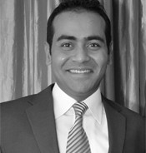
Azam is Owner and CEO of a software development company in Coral Gables called sdsol.com. He had spent nearly a decade devoting all his energy to building up his business and had let his health slide. He was not eating properly (often eating fast-food) and was not exercising enough. He had gained weight and was over 200 pounds. We started a fitness training plan meeting 2-3x per week in the residential gym focusing on general strength, flexibility and cardio-vascular conditioning. Our first meeting 4-22-09 Azam’s body fat % was 23.7% and Body Mass Index was 29.5 (considered severely overweight and nearly Grade 1 Obesity which starts at 30). Step by step Azam’s fitness improved and his weight dropped. 1 month later Azam’s weight was under 190 at about 187-188 pounds. Core strength in planks had increased from 45 seconds to multiple sets of nearly 1:30. 2 months into his training he was tested for cardio using the classic 3 minute YMCA step test. His post 1-minute recovery heart-rate was 104 beats per minute (an average score). 10 weeks later, Azam’s body fat was 16.4% (a drop of over 7%!) and BMI to 26.1 (still “overweight” classification). 3 months into our training, Ian began teaching Azam to swim. He was terrified of the water and had never swam in his life. He was unable to keep from sinking and could not even swim 1 stroke. After 6 months, Azam weighed 161 pounds and was swimming 40-60 laps in the pool. 8 months later cardiovascular fitness had improved significantly on the step test with a port 1 minute recovery of 79 beats per minute (down from the previous test of 104) This was an enormous improvement and considered “excellent” in the rating charts. Body fat had also dropped to 15.5% and BMI to 24.2 considered to be “fitness” level body fat and “normal range” for weight. Azam’s body weight over next 8 months would fluctuate in the 160’s depending on diet and training. With some travel and a few vacations he was not always on the plan. 16 months into the training Azam successfully completed his first Sprint Triathlon (1/4 mile swim, 10 mile bike, 3.1 mile run). At this time Azam’s body-weight was in the low 160’s with body fat around 15%. Cardiovascular step test performance had improved to 70 beats per minute post 1 minute recovery which was an additional improvement considered excellent. At some points over the next 2 years Azam’s training would slack off however weight gain, due to improved diet never surpassed 170 pounds. Azam did complete his second triathlon about a year after his first and did well except for some psychological fears of swimming in the open water unable to see the bottom. A stronger commitment was made to overcome this fear. Then, finally 3 years into the training Azam agreed to do a colon cleanse followed by a 4 day raw, plant based, organic reduced calorie fasting cleanse. Azam’s body responded with weight dropping under 160 pounds to 154 pounds. Azam claims that cleanse was the single most powerful thing he ever did for his health. Feeling lighter, leaner and more athletic, his run times plummeted immediately due to enhanced efficiency and he ran 5 miles in 41 minutes (8:12 mile pace). Azam is continuing to train, planning a second cleanse and, with greatly improved swimming (he now meets 1x per week for a coached masters Swim team workout up to 2000 yards) and is looking to compete at a much higher level in his 3rd triathlon and overcome the fear of open water swimming!
Meet John Trafford:
Meet Pat Crittendon:
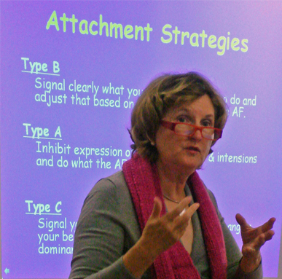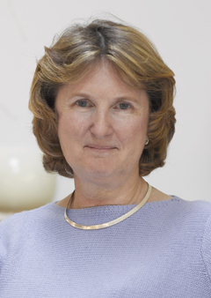
Pat was referred to Ian by a physical therapist who had been treating her frozen shoulder and back pain. Over the past (3) years under Ian’s care, her shoulder has continued to improve with nearly full range of motion. And her back pain has remained in remission. Pat’s busy schedule around the globe as an internationally acclaimed speaker/presenter is challenging to say the least. Before beginning with Ian, Pat also often had chronic and quite severe back pain. Ian developed an appropriate yoga & fitness program including: SMR (Soft Myofascia Release), Yoga asana sequencing to help remove tissue adhesions and create greater joint ROM (range of motion) especially in the spine, hips and shoulders. Notable improvement occurred in Pat’s ability to not only remain comfortable (hold) certain postures but to get into and out of postures such as: Warrior 1 pose, Lizard & Pigeon poses, ½ Spinal Twist pose and Shoulder Stand pose. Enormous improvement occurred in the flexibility of posterior lower body tissues such as the gluteals and the hamstrings. Spectacular gains occurred in Pat’s ability to balance: on 1 foot and leg, doing the same but lifting the knee up towards the stomach or straightening the leg back while lifting it, doing the same while closing the eyes etc. Ian also made recommendations for training plan Pat could incorporate during her travels. Additionally, Ian made helpful suggestions and recommendations to help with Pat’s chronic insomnia including dietary, lifestyle and yogic breathing exercises shown to help with sleep challenges.
Meet Marcia Simon:
Marcia is approaching 90 years old and has Parkinson’s disease. Her Doctor had recommended that she start an exercise program since exercise has been proven to reduce the symptoms and rate of onset of the disease. Ian has been working with Marcia since 2008 and has helped her feel inspired about doing exercises. The exercise prescription for Marcia includes modified yoga sequencing (like sun salutations) but from a safe seated position. Resistance (strength training) with tubing and light dumbells doing such exercises as: seated/standing rows, wings, bicep curls, marching, functional squats, lateral arm raises, trunk rotations, reverse wings (works the rotator cuff & rhomboid muscles) etc. proved effective at maintaining strength an minimizing unwanted symptoms of Parkinsons. Stepping excercises, marching and footwork drills help maintain leg strength, produce cardio benefit and help train the feet, legs and body for better balance. Ian especially emphasized proper breathing during the exercises to maintain steady blood pressure and oxygenation and to help relax and focus Marcia’s attention on body awareness.
Meet Thomas Taulbee:
Thomas was an injured runner who first came to Ian’s yoga classes to help the running injury. Little did he know that years later he would take and successfully complete Ian’s 200-Hour Professional Yoga Teacher Training Certification course (see testimonial below). And Now Thomas is a successful yoga teacher teaching over 10 classes per week.
Meet Carlos Tao:

TESTIMONIALS
“Ian, Thank you for all the care and concern you’ve shown for my father”
“Dear Ian, Working with you as your student has set up a solid foundation for what has become a practice with significance on many levels. Although I have enjoyed the benefits of exercise and yoga before, this time my practice has taken on a whole new dimension. Of course, these are things that I have tapped into that always were. But I do believe that having the right teacher is an important relationship.
There were many reasons I chose yoga. However, I was not expecting it to be as significant in other areas outside of physical & mental strength. You have been an amazing teacher. As a teacher, your authentic concern for the growth of your students goes above and beyond what I was expecting from my classes. I was able to feel safe in a non-judgmental environment with a teacher with very clear, professional boundaries, who at the same time expresses his sincere spiritual guidance. You bring much to the profession and I thank you. Namaste!”

“Hi! Ian,
Thanks a million for sharing, once again, such a beautiful teaching… Today, when you asked us to give thanks for something we felt grateful and to set out intention and offer our practice to someone or something, I gave thanks for the practice of yoga, and I offered my both of my practices to you, who helps us by delivering the right messages, the right practices, the right positions, the right movements and breathing techniques all at the right time… We are all grateful to have you in our lives. I say we because I see it on all of our faces. May God shower you always with many unknown blessings for always bringing light to others.
Love and Gratitude”

FROM YOGA TEACHER TRAINING CERTIFICATION COURSE
Dear Ian,
The decision to take the Green Monkey Teacher Training was one of the best I’ve ever made. As you know, my journey started about five years ago when I made some life changing personal decisions that would have an impact on the rest of my life. Those changes over time led me to find yoga and for that I’ll be forever grateful.
The teacher training with you provided me with so much more than just the fundamental of teaching a class. Yes, that’s important but understanding why we teach yoga is the real reason I was here. Yoga is thousands of years old and it’s very difficult to fit that into ten weeks but you managed to get most of it. Was it intense, yes but I am better for it and I hope to continue to learn.
The course outline was extremely detailed and matter of fact. We knew what each week would bring and our responsibilities. It was never a surprise when we walked into class. For me, a working professional that was wonderful. I knew exactly what I needed to prepare for and didn’t spend time studying topics that were not going to be covered. It made for a concise learning experience.
I also had the opportunity to meet a fantastic group of people. All from different walks of life which proved entertaining at times. We were all there for different reasons but one thing for sure, we love yoga. I consider each one of the yogi’s friends for life!
Thank you for dedicating your time and energy to this program! You certainly gave it your all and it showed. Now that we are finished, we come out as yoga teachers but for me, I’m a better person!
Namaste,
Thomas Taulbee

Hi Ian,
I just wanted to take a moment to share with you how much the TTC has meant to me. I did not know what to expect when I signed up but it has blown away any expectations I had. While I did expect to expand my knowledge as to the theory, history and practice of yoga and yoga anatomy as it applies to personal practice and especially teaching, I was not expecting the profound experience that it has been.
I am so amazed by how much information and application we were able to absorb in the short time we were together (which I’m sure has to do with how well put together our class packet was), but even more so by how moved I am by what a difference this time we all spent together has made to me. I am so excited and feel so prepared with all you have shared and given us, but most of all I feel extremely blessed to have had you as a teacher. Day after day you were not just imparting information, you were sharing your life and your love of yoga with us. Your excitement and personal practice were contagious and made coming to class so much fun that it didn’t seem like work. And I also wanted to thank you for your caring and how you made yourself available to all of us through the whole process. I know this was not a job for you, this was a complete giving of yourself.
Thank you from the bottom of my heart.
Carlos

Dear ian,
This teacher training has been a wonderful journey for me in many ways. The curriculum was very diverse, and it was planned with excellence, addressing every area a person who wants to walk a yogi path needs to be aware of. I loved that overall Yoga was not approached just as a physical exercise, but as a means of personal and spiritual transformation (or elevation) without compromising your own spiritual beliefs. The teachers were all experienced and knowledgeable in their subject; they were pleasant to learn from, and they all showed an obvious spiritual awakening in their own lives. Ian is a very intelligent man and he is obviously in a very noble spiritual path. The fact that he was the leader in this journey was a winning ticket for us from the beginning because he brought unity to our group, and this unity made it possible for us to move through it smoothly, with an energy that allowed for growth as we learned on different subjects. Even when we discussed risky philosophical or spiritual themes within the course, Ian was able to come back to the concept in a way that allowed for a general understanding. Going through these months of preparation has given me a lot of clarity, and it is definitely an important turning point in my life.
Thank you to all of you, my teachers and my classmates.
Namaste.
Marilyn Romero

Ian,
Thank you so much for everything.
That was definitely one of the best things I have done in my life! I wanted to take a Yoga Teacher Training so badly, but I was not quite sure where to go. I am glad that I trusted my judgment and went with you 
I have been practicing yoga quite long. I wanted something more than just practicing or teaching asanas. And I have been totally satisfied!
One of the best things about the TTC was that I was able to take lectures and workshops from some very interesting people (including Ian, of course). Meeting a yogini like Veronica was so inspiring. Joan’s guided visualization blew my mind! Everybody, everything was amazing!
The most inspiring thing for me was Marisa’s ashtanga workshop. When I was listening to Marisa’s talk, my heart was pounding really fast! I was so excited that I found something I’d like to do in my life!
Because of the TTC, I’ve got my new routine which is starting my day with pranayama and meditation practice. This was really good, too. This routine made a big difference! And I realized how powerful pranayama and meditation practice are! I’d like to keep going with this routine.
So many great things are in the TTC, but the best thing was meeting so many beautiful people
Since I moved to Miami, I was feeling so lonely, isolated, disconnected and rejected. I couldn’t believe in myself. But this experience made me more confident! Maybe I am more powerful and capable than I thought I was?! I am so happy to be able to feel this way
Today, I taught a community yoga class. I was so nervous that I couldn’t sleep well last night. I was unable to enjoy the party last night . But I got so much support and love. Marisa was there and gave me some advise and a hug. Carlos stopped by even though he could not take the class, Michael came to the class, Ashley was there… I had a very nice group of people taking my first class, too. They gave me very nice feedback. My first class went well. And I felt blessed. It was one of my happiest moments in my life.
I don’t know if I can actually become a yoga teacher after the TTC or not. But what I know is that I’ll be always a full time yogini!
Thanks again about everything. I was not such a good student. Thank you for your patience and love.
I am so glad that I met you! You’ve changed my life!
Coco

Yoga teacher training has touched my life as well the rest from the class in my vision. I began to reflect on this journey that we just took together and realize how much it has uplifted our spirit. I notice on everybody face. Everybody has a glow. When we began the training, we were strangers and look our regular self not knowing what to expect, at least in my part. However, we had this curiosity of expanding our wings to learn the true meaning of yoga through philosophies, asanas, history, mantra and much more. This training has allow us to grow as a yogi family and brought more awareness in our self. We all had a busy scheduled but manage to find time for this training. We all have a different reason why we came to this training but for me was to learn how to teach yoga to be healing. Yoga has thought me so many things such as healing myself and it still is. We all have that power with in to heal.
This training was really challenging because all the information we need it to inhale but I manage and enjoy it. I am more attune and connect even more with my heart and soul then i was before. The lesson I learn in this journey for me is teach from the heart.
Ian is an inspirational teacher and so passionate of yoga. One can see it in his yoga class and as a teacher trainer. I am so grateful to have been a student and to be part of this teacher training. His guidance was graceful and very supportive all the way of the training. Thank you Ian for sharing your light as a teacher. It has made a shift in our life. Aho!
Peace, Love, & Light to all,
Viviana Jaramillo

I am beyond blessed to have had the opportunity to take teacher training with the phenomenal Ian Darrah. To say the least, the 10-week course changed my life. Simply stated, I discovered a peace within myself I was not sure even existed and found a deep connection to my own inner wisdom, to those around me, and, ultimately, to the Universal wisdom.
Ian raised spiritual conversation in a way that allowed for all of our personal understanding. His gentle and accessible approach encouraged us to take our practice beyond the mat. Through his teachings and as well as those of guest speakers we learned a mind/body/spirit practice. Where other teacher trainings lack in some aspects such as philosophy, anatomy, and the history of yoga, this training certainly did not. Ian beautifully encompassed all aspects of a true yoga practice and thus helped each of us students to establish a solid foundation from which to teach our own future students. Our classes, discussions, and meditations were a place of growth and of turning inward to our own inner wisdom.
I began teacher training as a relative “newbie” to yoga, and now my life will never be the same. Yoga used to be something I just did; today, it’s something I live for.
All my love and many, many blessings, thank you, thank you, thank you!
Anna Gogos

In April 2010, my wife and I took a four-hour helicopter tour of Las Vegas and the Grand Canyon. The scenic views were mesmerizing and landing below the rim was an unforgettable experience. It is amazing to see the geological marks of the Grand Canyon or to look at the horizon and not see its end. Our pilot was a young guy, who understood his role as our guide and entertainer. Of the six passengers on our tour, four did not speak English and didn’t understand a word the pilot was saying. At one point, out of frustration, the pilot said, “What a tough crowd.” I explained to him the reason why. After that, he stopped the general flow of communication and engaged only the two people that could understand English.
Back in Miami, I was extremely curious about the Grand Canyon and wanted to learn more about it. Among other things, I learned that the helicopter tours from Las Vegas take people to the West Rim, which is not part of the Grand Canyon National Park. I discovered that the Grand Canyon is one of the seven natural wonders of the world and that we had seen a minute part of it. Next time, we’re going to the South Rim from where we’ll be able to see the Vishnu Temple and possibly, the Shiva Temple, Krishna Shrine, Brahma Temple, Deva Temple and Manu Temple. They are all situated in the Grand Canyon (I kid you not). To thoselike me that weren’t aware of this, you should also know that the Vishnu Group of the Grand Canyon consists of the Vishnu, the Brahma and the Rama schist.
Two years later, I found myself with what seemed to be a “tough crowd” (evidently, that includes me), starting a Yoga Teacher’s Training Program with a young guy named Ian Darrah. I’d been practicing Yoga for almost six years, but except for a few Restorative Yoga classes, I’d never attended Ian’s classes. It was a tough crowd because we were an incredibly heterogeneous group with the exception of a common love for Yoga. If I had to forecast back then what the result would be, the obvious parallel would be my helicopter tour to the Grand Canyon: mesmerizing and unforgettable but barely touching the surface due to the grandeur of the subject, with a limited approach due to the lack of the time. Boy, was I mistaken!
In addition to being an advanced practitioner, Ian is a patient and dedicated Yogi who fully practices Patanjali’s 8-Limb system. Thanks to his guidance, the “tough crowd” doesn’t seem that tough anymore, and the seeds of personal growth have been planted in all of us. In the short but very intense ten weeks, we learned what Yoga is by discussing: the Yamas and Nyamas, reading about Yoga’s History and Philosophy, in depth studying of Yoga Anatomy, practicing and learning the Asanas, doing Pranayamas, chanting, and meditation. Our knowledge was enhanced by the several visitors that kindly shared with us their experience as practitioners and teachers. We had an overview of all of the corners of Yoga, not only of its “West” side, and we were able to see a glimpse of the long and winding road that leads one to being a Yogi. Or, still paraphrasing, of how many roads must a Yogi walk down before you can call her a Yogi.
Many times, when teaching or in our daily lives, we’ll feel the same fear that Arjuna felt at Kurukshetra. When that happens in life, recall Patanjali’s Second Sutra. If it happens while teaching, keep up with your Ujjayi breath, remember of the basic sequence and move forward. If that doesn’t work, just tell your students to do one standard vinyasa and lead them into Addho Mukha Svanasana while you recover.
Thank you, Ian, for being a great instructor and a good friend!
Namaste,
Julio
GALLERY

CONTACT
Ian Darrah
2829 Bird Ave., Suite 5, #242
Coconut Grove, FL 33133
USA
ianinnerjourneys@gmail.com
786-443-9564

