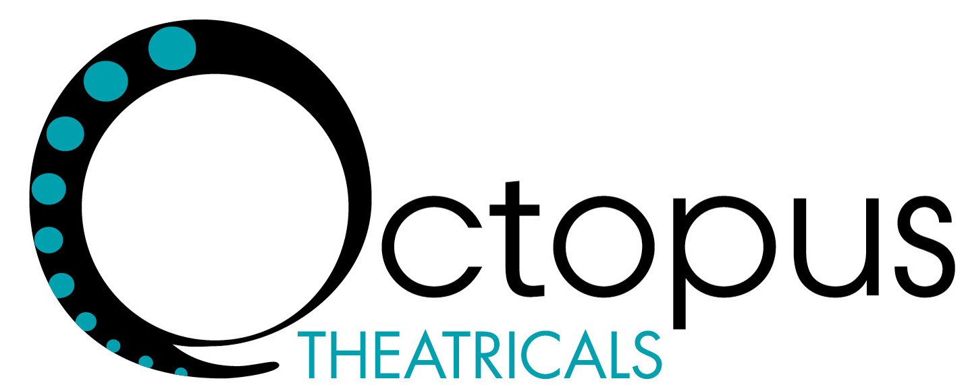

Octopus Theatricals LLC is a company dedicated to producing and consulting in the performing arts. From experimental to commercial, we collaborate with artists and organizations to foster an expansive range of compelling theatrical works for local, national and international audiences. We eschew boundaries—aesthetic, geopolitical, institutional—and thrive on a nimble and rigorous practice.
As producers we generate and develop our own innovative theatrical projects, serve as a creative producer for hire (by producing companies, independent artists and others) and provide other creative project-based services, including program development and dramaturgy.
As consultants we work with theater companies, presenters, performing arts centers, foundations and other non-profit or commercial entities to provide ongoing programming advice, research and development as well as broad policy, leadership and structural input and oversight.
Our model of producing and consulting varies project-by-project, organization-by-organization. Our projects reflect a broad spectrum of genre, scale and clients. We examine the individual elements and/or artists involved and shape producing strategy around their particular visions. By customizing an approach that capitalizes on the strengths of everyone involved and then identifying how to supplement those strengths we facilitate artistic excellence, while having a good time.
At its core, Octopus combines artistic values with an independent flexibility and financial structure that allow us to create a body of work that wouldn’t exist under any other auspice.
Octopus Theatricals LLC strives to be nimble, adaptive and clever, all qualities we share with the noble octopus.

