Logo Brief – Sparklean New

This is our inspiration:

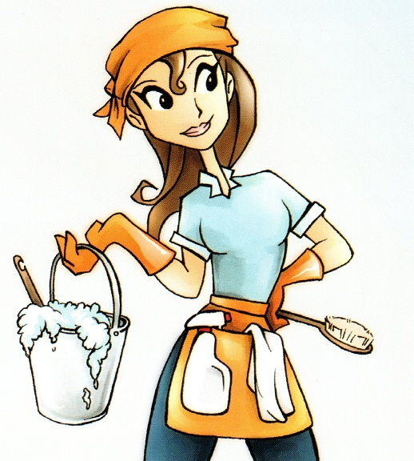


This is how we would like her to look:
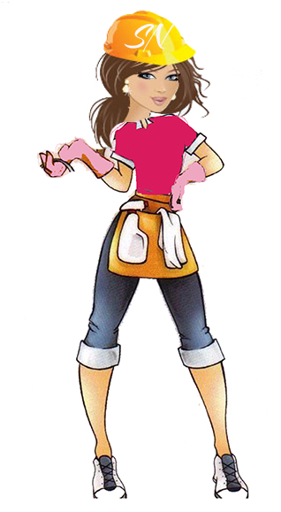

- The pink we like for her top is: CMYK: 0,95,0,0
- We would like the letters SN on the hard hat in the font “Arizonia” and in Pink
- We would like her to be holding a mop over her shoulder like in this image:

- 