Peoplebank - Our Value Proposition

Peoplebank at a glance
- 230 staff and over 25 years’ experience in the industry (Established in 1990)
- 590,000 quality IT & digital professionals in our talent pool
- Over 5000 candidates placed each year
- More than 6000 contractors on assignment across Australia at any given time
- Over 100 preferred supplier agreements in place
- Annual turnover of approx. $580m

Our vision
“We aspire to be the best recruitment company in Asia Pacific, the number 1 choice for our employees, clients and candidates.”

Our Promise
Our pledge to delight customers, be accountable for our performance and deliver consistently outstanding service to our clients, candidates and contractors across Australia.

How We Are Different

- Specialists, Not Generalists
Our consultants provide in-depth knowledge of the technical and behavioural skills required to excel in IT & digital roles.

- Industry Focus
When we receive a brief we assign a team that has a thorough understanding of the industry and the current market drivers.

- Find Candidates Faster
Our CRM has industry-leading applicant tracking capabilities with an automatic coding facility to update our candidate’s key skills, employment information and education history.

- Redeployment program
Industry first initiative available to our contractors who are actively looking for their next job.
Clients benefit from:
- Reduced time to hire
- Rapid onboarding
- Ability to pre-book candidates
- Proven, reference checked talent
- Ability to pre-book candidates

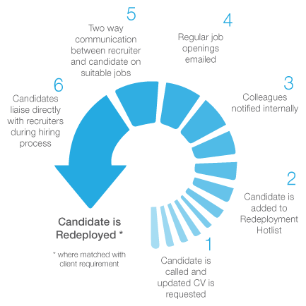

- Across Asia Pacific
Our strong presence in Singapore, Hong Kong and Malaysia means we’re in a prime position to support and service clients throughout the region.

- How do we find the best people?
- Database searches
- Social media
- News media sites
- Job boards
- Electronic direct mail
- Print
- Search engine marketing

- Reduced turnover
4 years = Peoplebank’s average length of service
2x recruitment industry’s average of 2.1 years

- Best candidate experience
Our consultants provide a highly professional experience to candidates, which will continue to become increasingly critical in a continually growing candidate short market.

Our key clients
Australia’s blue-chip organisations…
- Big 4 banks
- Top-tier financial services and insurance institutions
- Telecommunications, retail and travel companies
- #1 supplier to the Federal Government and State Governments

Our Awards

Aon Hewitt Best Employer Award
The only recruitment agency to be awarded Best Employer 4 years running from 2012 - 2015.

Engaged employees = engaged clients = engaged shareholders


Employer of Choice for Gender Equality
Peoplebank accredited in 2015 as an Employer of Choice for Gender Equality by the workplace for gender equality agency.
- Only recruitment organisation in Australia to be accredited
- 4 consecutive years of accreditation
- Creating an equal playing field for both genders
- One of only 90 organisations accredited in Australia


