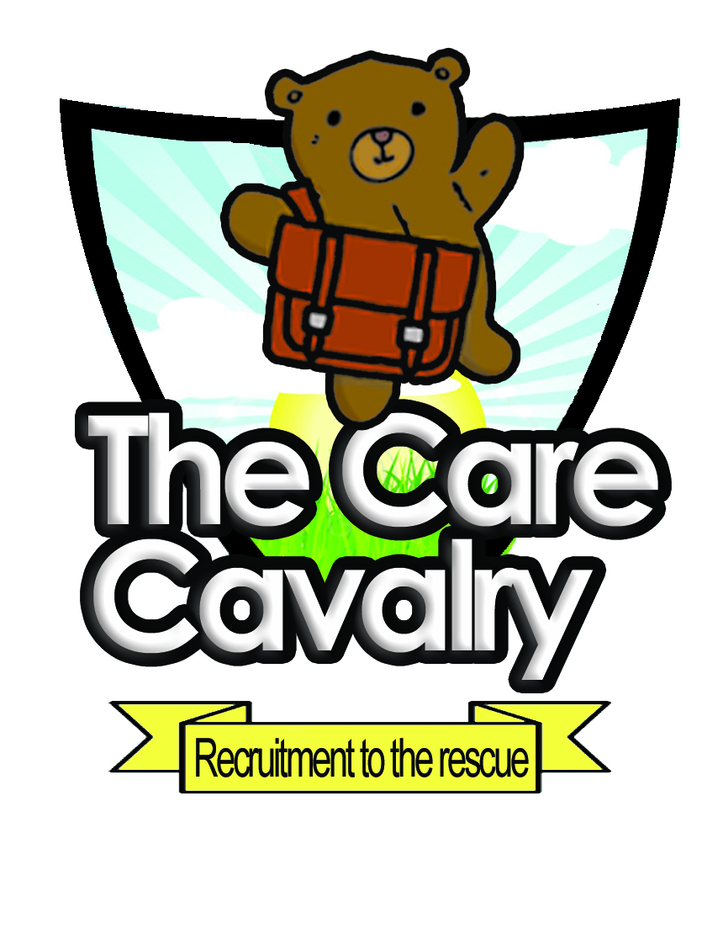
The Care Cavalry
Recruitment to the rescue!
Recruitment to the rescue!

Specialist recruitment for childcare and education

introduction
The Care Cavalry offer an affordable high quality recruitment service to childcare services including nurseries, pre-schools, play groups, holiday clubs and schools. We provide both qualified and unqualified child carers and teachers on a temporary or permanent basis to service all your recruitment shortfalls. Our applicants are recruited through strict safer recruitment procedures with current DBS checks and are trained to our high standards where we expect high delivery. Recruits hold Paediatric first aid, basic food hygiene and Safeguarding children certificates as part of their basic training. Our team of skilled consultants are child care qualified themselves and so will understand all your requirements and pride themselves in not just meeting your needs but exceeding them. We invite our clients to appraise and rate the staff we supply to them which means good staff can be recognised and be the popular choice. We look for our recruits to be accommodating, presentable in our uniform, friendly and helpful and confident. We know that when your team are down a member or two the last thing you need is someone less than dynamic and supportive so we send our recruits out with the skill and tools necessary to help save the day.
Our consultant team is dedicated to high standards and delivering value for money both for our customers using our service but to our recruits as well. We are a company that values sincerity, fairness and integrity and we are dedicated to giving the best service we can.
Our specialist Staff include:
Qualified NVQ2 and NVQ3 Nursery Nurses and assistants
Managers and Leadership staff with Foundation and Higher degrees
Room Leaders
Play/activity workers
After school and holiday workers
Sen specialists
Child support workers
Teachers
Teaching assistants
Nannies
Baby sitters
Weekend and event carers (weddings, parties etc)
For More Information Contact Hannah on mob 07949 115080 or
Dawn on tel: 01865 865381
Or enquiries to Hannah@thecarecavalry.co.uk
www.thecarecavalry.co.uk
Acacia Care and Education company NO:4148697 Address: the old post office, 19 banbury road, kidlington, oxford ox51aq

