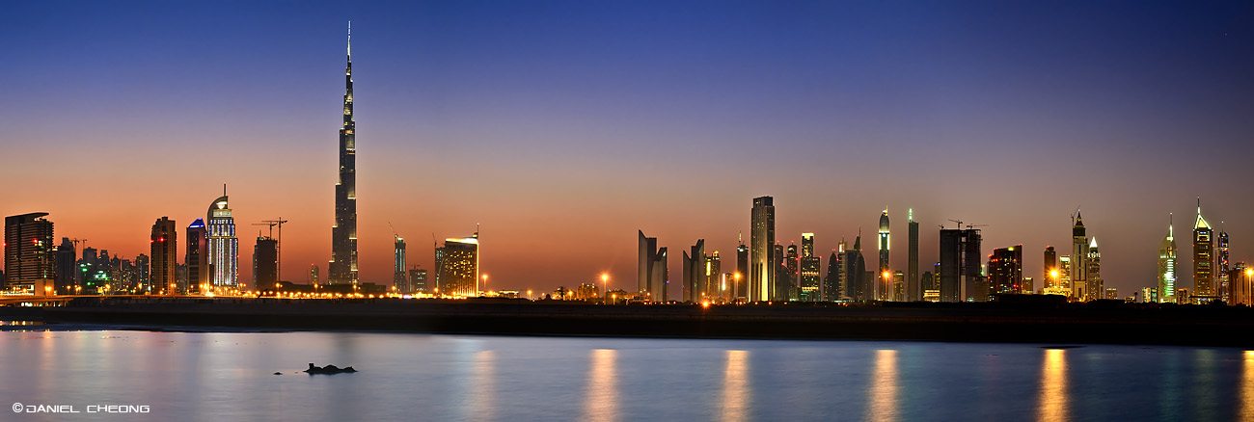


Your Business Our Connections
(add vicom logo)



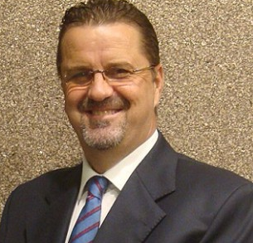
The Best Offer in the Industry
Grow Your Business Through Our Extensive Network
3000+ Business Connections | 570+ Decision Makers, MDs, CEO’s, Head of Purchasing
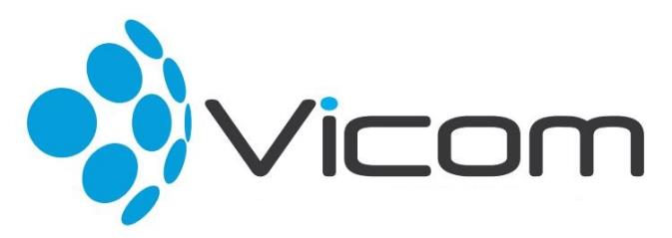
Call us NOW for a FREE consultancy on 04 373 5030
Located at the Burjuman Business Tower, 24th Floor Dubai, UAE
Sunday – Thursday: 9:00 am -18:00 pm
W: www.vicom.ae

Satisfaction GUARANTEED
100%
or your money back

Business Introductions
- Grow your business with our 3,000+ connections
- 570 Key Decision Makers, Managing Directors, CEO’s
- We book appointments with key hand picked customers
- Simple Revenue Sharing model

Sponsorship
- 50% off your current sponsorship fees
- Free sponsorship for 12 months
- Low monthly installments (starting at AED 1,500)
- We are your active sponsor or strategic partner if you are need us to be
Do you need help to increase your sales?
Grant Kirk, Managing Director, Vicom

As Low as
AED1,500
Easy Monthly Installments

