

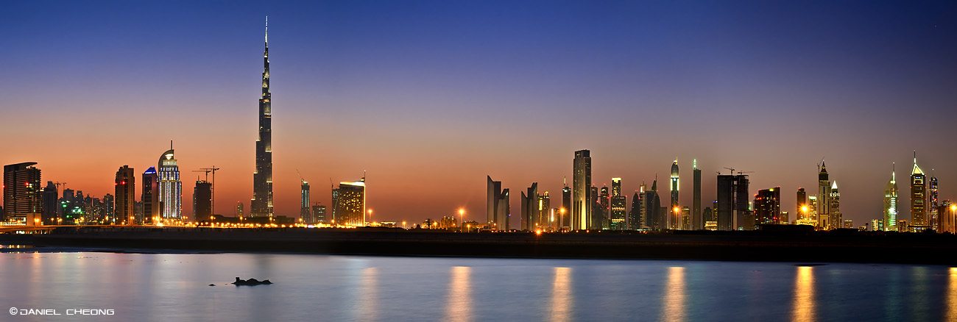
Your Business Our Connections
(add vicom logo)

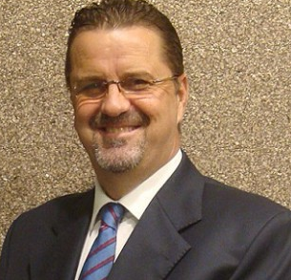
Satisfaction GUARANTEED
100%
or your money back
The Best Value-Add Offer in the Industry
Get an active sponsor who will help you with business development, VIP introduction, legal support, collections
Are you getting real value from your current sponsor?
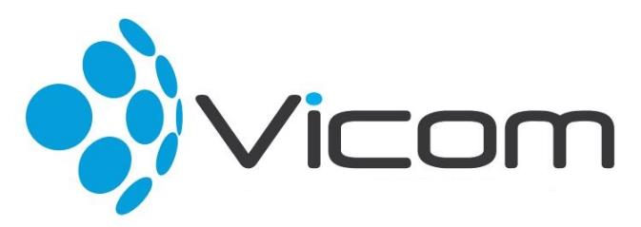

Business Introductions
- Grow your business with our 3,000+ connections
- 570 Key Decision Makers, Managing Directors, CEO’s
- We book appointments with key hand picked customers
- Simple Revenue Sharing model
Call us NOW for a FREE consultancy on 04 373 5030
Located at the Burjuman Business Tower, 24th Floor Dubai, UAE
Sunday – Thursday: 9:00 am -18:00 pm
W: www.vicom.ae

Sponsorship
- 50% off your current sponsorship fees
- Free sponsorship for 12 months
- Low monthly installments (starting at AED 1,500)
- We are your active sponsor or strategic partner if you are need us to be
Grant Kirk, Managing Director, Vicom

As Low as
AED1,500
Easy Monthly Installments

