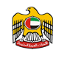

Keynote Speaker Profile

Hisham Al Gurg, CEO,

The Private Office of Sheikh Saeed Al Maktoum

With over 18 years of experience in business within the MENA region, Mr. Al Gurg is a pioneer for his visionary approach, high profile networking, and for concluding large regional projects and investments worth more than 1.06 billion USD.
He is also the Executive Counselor of Al Fajer Investments & Development, an investment division of Al Fajer Enterprises, a holding group of companies owned by His Highness Sheikh Hasher Al Maktoum.
Mr. Al Gurg is also a board member of Signature Group, an International Private Equity that focuses on emerging markets such as the Middle East, India, and Africa. Mr. Al Gurg is a Bachelor degree holder from Southwest Texas State University (San Marcos, Texas).
Speaking Themes:
- Business in the UAE • Entrepreneurship
- UAE Trade & Regulations • Networking
- Investment Management • Government & Private sector relations
Speaking Engagements:
- Positioning your Business in the ME- Understanding Regulations and Trade Opportunities of Locating in the UAE
- How to do Business with the Arabs in the GCC
- Leveraging the trade and investment opportunities in the U.A.E
- Tendering in Dubai – Winning high value deals and government contracts

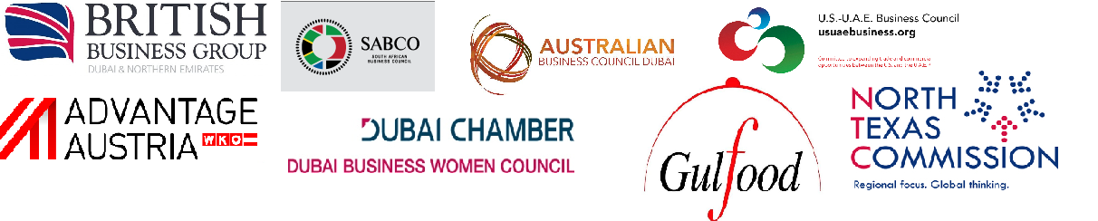
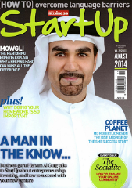





As Featured:
Media contact:
Zandile Mnguni
Events & Communications,
The Private Office
zandile@the-private-office.com

Keynotes and presentations for:

Arabian Business
Magazine
Businessman of
the Year 2015
--
Founded the SEED Entrepreneurship Center to train startups to become successful businesses.
“The UAE’s leading light when it comes to investment”. – Arabian Business Magazine

