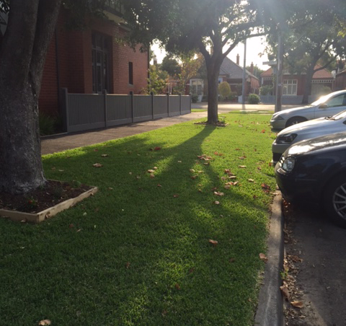
CUTTING KERBS
NATURE STIP LAWN MOWING
Please contact Will Bainbridge via Phone on 9696 9948 or on email at williambainbridge@caulfieldgs.vic.edu.au
Hi, my name is Will Bainbridge and I have a part time business called CUTTING KERBS, which I do on weekends while I am completing my secondary studies at Caulfield Grammar.
I am fully reliable and mow residents front nature strips on a fortnightly or monthly basis. I noticed that in Middle Park the size of the housing blocks means that many people have limited or no lawn apart from their nature strip, and thus the birth of Cutting Kerbs. Understandably professional mowing services see the job as too small and inconvenient (and charge accordingly) and most home owners don't want the hassle of a lawn mower / edger and all that comes with this.
If you are anything like my Mum, then deep down you will want your lawns looking great and with your lawns cut and edged with care it would enhance your houses street appeal. I'll do your lawns to the best of my ability and in case your wondering what that means come and look at 202 and 204 Page St, and 21 McGregor St Middle Park.

Depending on your requirements, I only charge $10 to mow and edge a small nature stipe and sweep your paths.
Thank you for considering CUTTING KERBS
This is a picture of 51 McGregor St

