Situated in the centrally located suburb of Deakin thi
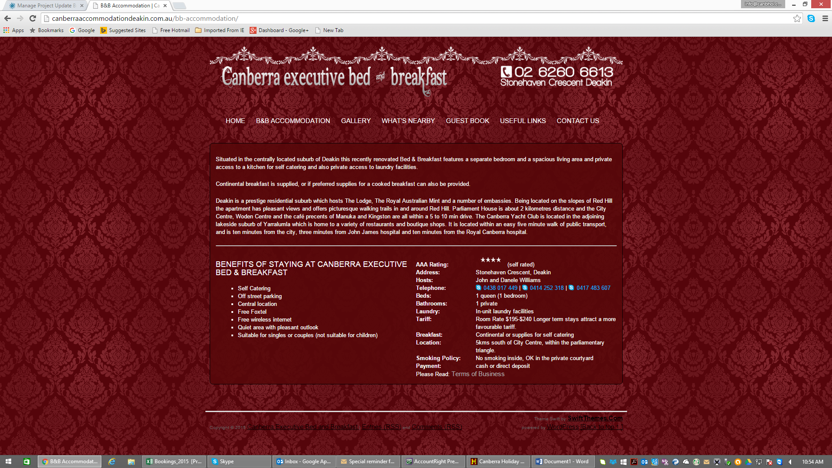

The list below covers just a few of the many attractions Canberra has to offer. The locations of these attractions is shown on a map at the bottom of this page. Browse through the list, or click here to jump straight to the map.

NATIONAL INSTITUTIONS & ATTRACTIONS

AUSTRALIAN INSTITUTE OF SPORT
The Australian Institute of Sport (AIS) is Australia’s premier sports training institute, internationally acknowledged as a world’s best practice model for high performance athlete development.

NATIONAL PORTRAIT GALLERY
The new National Portrait Gallery building, situated on King Edward Terrace, Parkes, Canberra, bounded by the High Court of Australia and the National Gallery of Australia, displays some 400 portraits of people who have shaped Australia and who continue to shape our nation.

NATIONAL GALLERY OF AUSTRALIA
Set on the shores of Lake Burley Griffin, The National Gallery exhibits collections that highlight the talent of Australian and international artists. There is something for everyone, including a lush sculpture garden, children’s exhibits, an extensive gift shop and the gallery’s cafes.

NATIONAL MUSEUM OF AUSTRALIA
Explore Australian history and culture through numerous exhibits, technology and hands-on activities. Wander the exhibition galleries, restaurants, theatres and a resource centre, or check out permanent exhibitions centred around Land, Nation and People. The temporary exhibition gallery hosts travelling blockbuster exhibitions.

AUSTRALIAN WAR MEMORIAL
A must see for any visitor to the ACT. Chock full of memorabilia, personal stories, displays, a sculpture garden, gallery exhibits, research facilities, and function spaces, the AWM provides more than just education – it offers a unique glimpse into the lives of the soldiers (and families) that endure the conflict of war.

PARLIAMENT HOUSE
Parliament House is one of Australia’s most popular attractions. With free guided tours every half hour, the site offers impressive architecture, a stunning art collection, a great cafe and a beautiful landscape of green lawns and white pillars. In addition, be sure to browse among the 4,000 artworks, ranging from historic portrait to contemporary landscape.

BLACK MOUNTAIN TOWER
Rising 195 metres above the summit of Black Mountain, the Tower presents 360 degree views of Canberra and the surrounding rural area. Visitors taking advantage of the two open viewing platforms or the enclosed viewing gallery are presented with striking views of the city by day. From every angle at night the theatrics of the city’s lights under the darkened sky provide a spectacular show of natural beauty and entertainment.

NATIONAL SCIENCE AND TECHNOLOGY CENTRE – QUESTACON
Kids, teens and those young-at-heart will love this interactive science exhibit. With hands-on activities, films, shows and exciting science exhibits, a full motion rollercoaster simulator and even caged lightning and a tornado, Questacon offers exhibits from around Australia and the world.

COCKINGTON GREEN GARDENS
Cockington Green Gardens offers its visitors an experience you will not find anywhere else. Venture into this delightful and fascinating display of meticulously crafted miniature buildings set within beautifully landscaped gardens to make your Canberra visit complete. Created by Doug & Brenda Sarah Cockington Green Gardens is a family owned and operated attraction, with four generations involved in it’s operation over the past 30 years.

NATIONAL DINOSAUR MUSEUM
Starting from humble beginnings in 1993, the museum has grown from just a small collection to housing the largest permanent display of dinosaur and other prehistoric fossil material in Australia. With 23 complete skeletons, and over 300 displays of individual fossils, the museum continues to grow and expand our collection and our depth of information.

KIDCITY
Canberra’s biggest indoor cafe, play and party centre.

KINGSTON MINIATURE RAILWAY
Open to the public on the second Sunday of each month from 12.30pm to 3.30pm and the last Sunday of each month (see the calendar for December) from 10.30 am to 3.30 pm, passengers are taken on a 900 meter journey through the railway museum, usually taking about ten minutes.

OLD BUS DEPOT MARKETS – KINGSTON
Browse over 200 stalls of exceptional quality. Many feature unique handcrafted items made by local and regional artists and craftspeople.

WILDLIFE ATTRACTIONS

NATIONAL BOTANICAL GARDENS
If you love flowers and plants, or simply enjoy the calmness of a beautiful garden, then the Australian National Botanic Gardens is a top spot. With native plants from all parts of Australia, unique rock gardens, eucalyptus lawns and a magnificent rainforest, most garden enthusiasts will be in horticulture heaven. Whether you’re there on an educational trip, or simply to enjoy a quiet garden picnic, you can’t go wrong surrounded by the stunning beauty.

TIDBINBILLA NATURE RESERVE
Tidbinbilla offers outstanding wildlife viewing, the Sanctuary wetlands, bushwalking, great BBQ spots and fun for kids on the Discovery Playground. Come and discover Tidbinbilla and

