Do things differently with us.
Let’s innovate together – come see the future of law.
Dream big.
We push the envelope, and so do you. Let’s innovate together – come see the future of law.
We help make your wildest dreams come true.
We do big picture law. Your business deserves nothing less.
Dreaming is free.

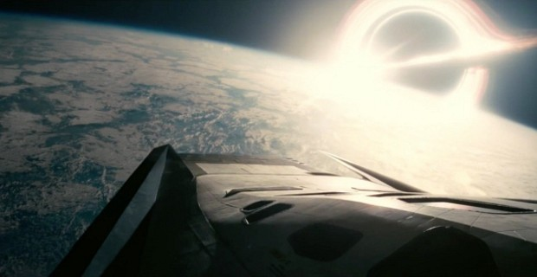
Copyright – DO NOT USE
http://static.srcdn.com/slir/w620-h320-q90-c620:320/wp-content/uploads/Deep-Space-in-Interstellar.jpg
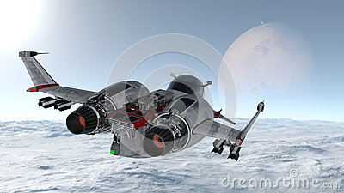
Copyright – DO NOT USE


https://commons.wikimedia.org/wiki/Category:Outer_space#/media/File:Exoplanet_im_All_mit_einer_Sonne.jpg
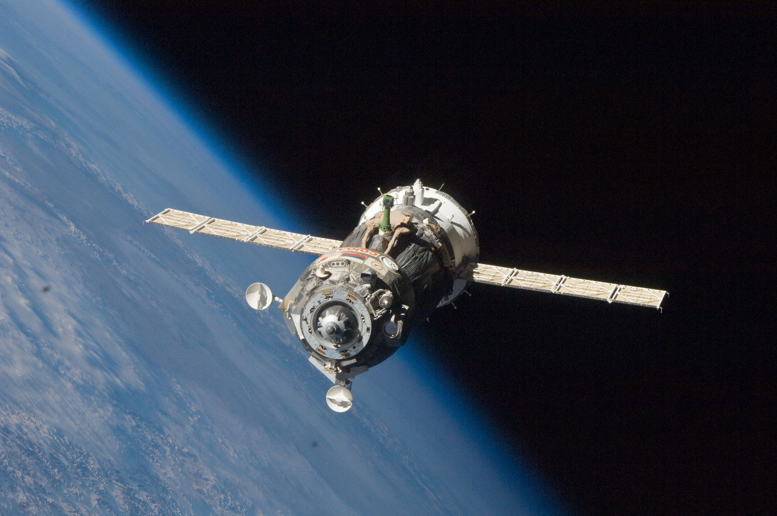
https://upload.wikimedia.org/wikipedia/commons/9/99/Soyuz_TMA-19_spacecraft_departs_the_ISS.jpg
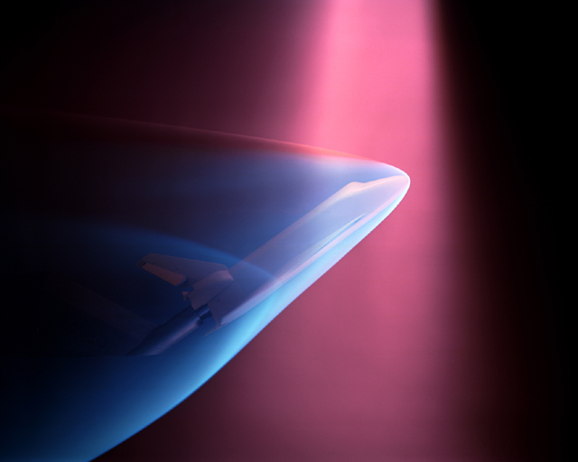
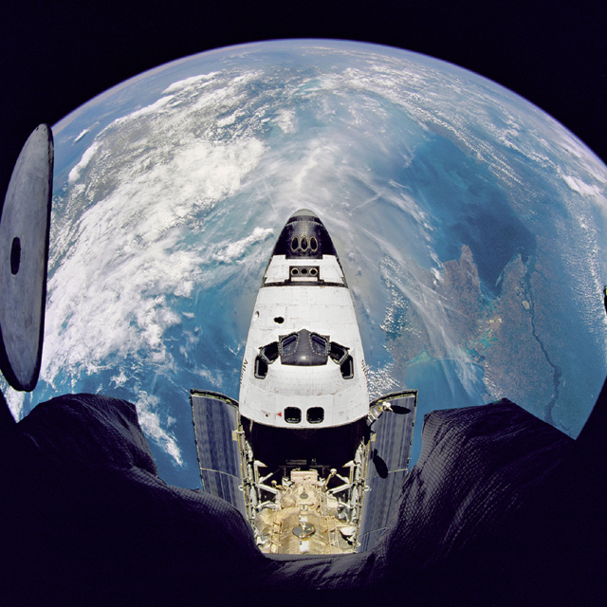http://grin.hq.nasa.gov/IMAGES/SMALL/GPN-2000-001039.jpg
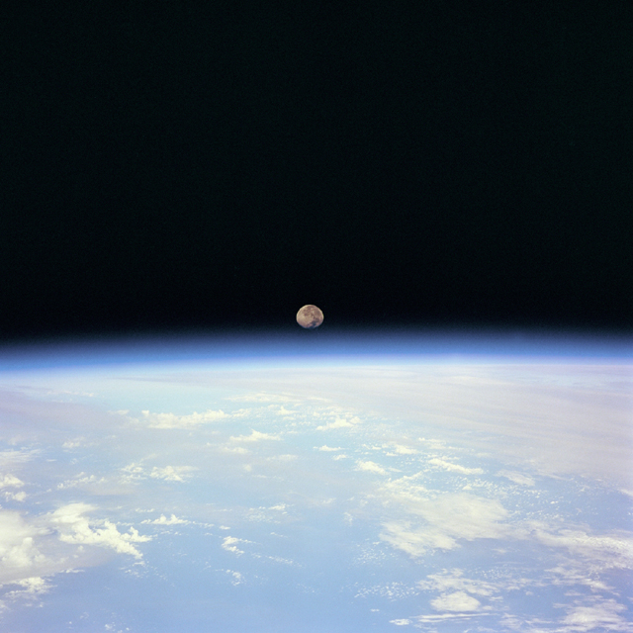

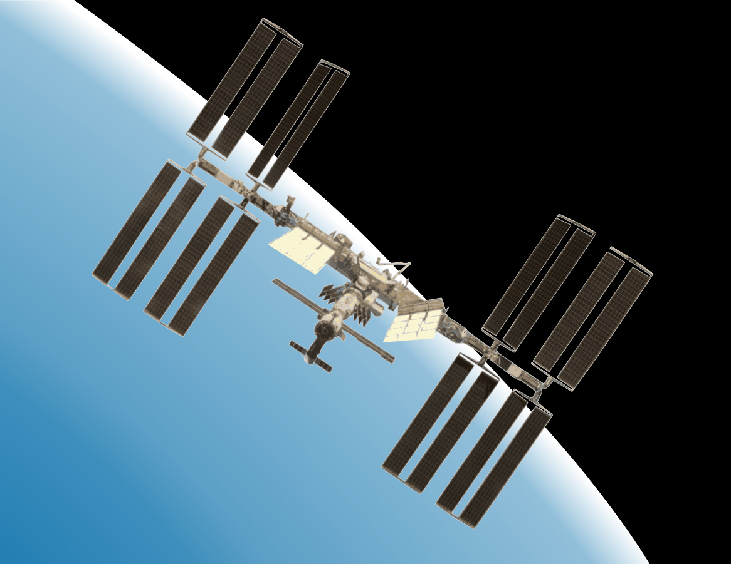
https://openclipart.org/detail/193047/international-space-station-with-earth

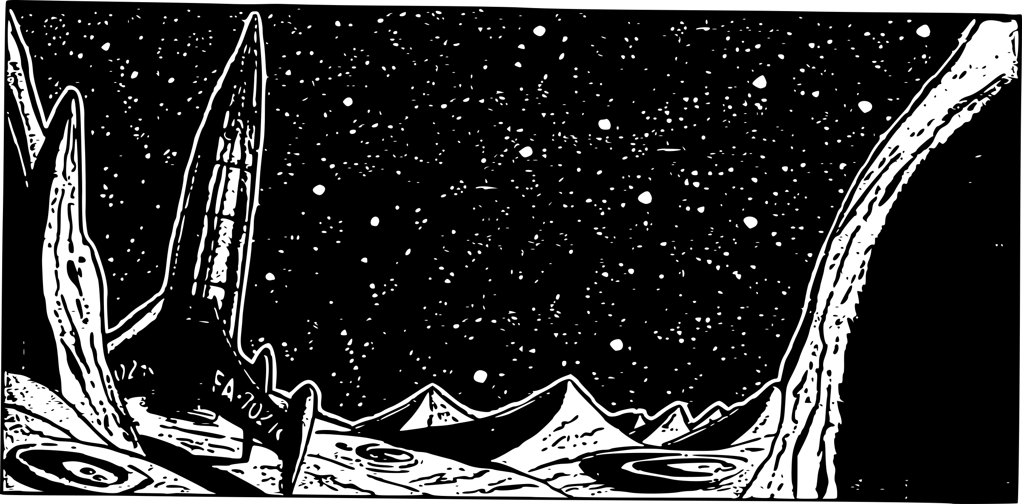
https://openclipart.org/detail/213718/scifi-rocket-retro-futuristic

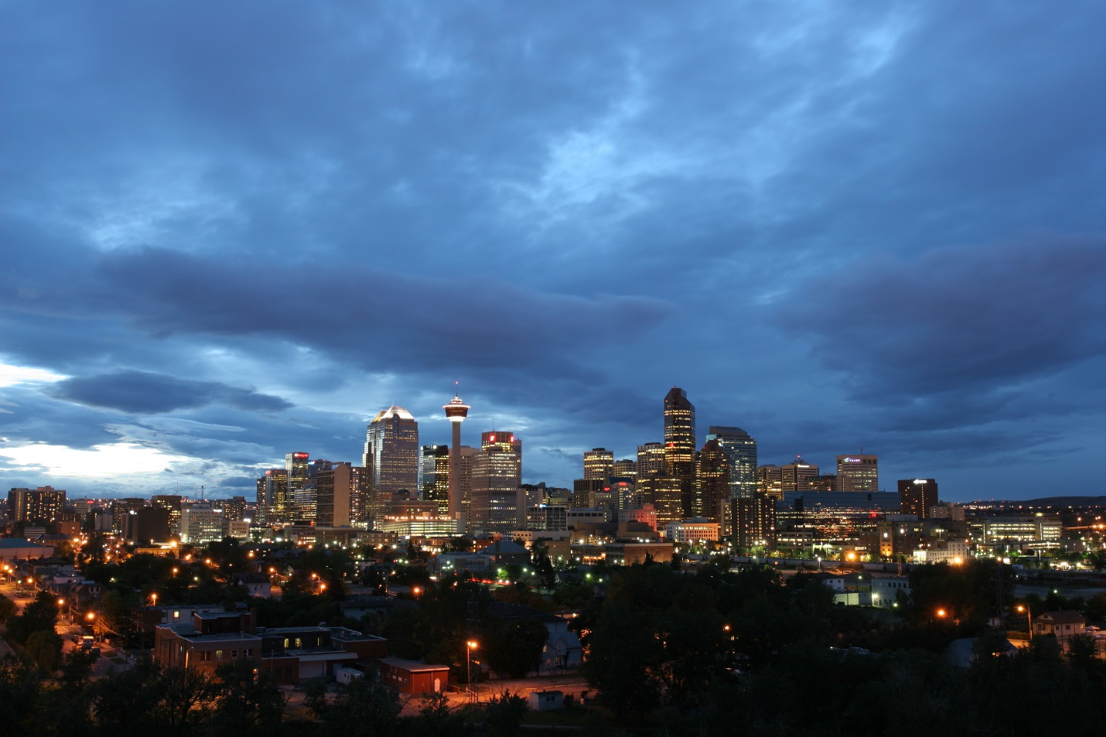
https://upload.wikimedia.org/wikipedia/commons/a/aa/Calgary_skyline_cloudy_2004-08-30.jpg
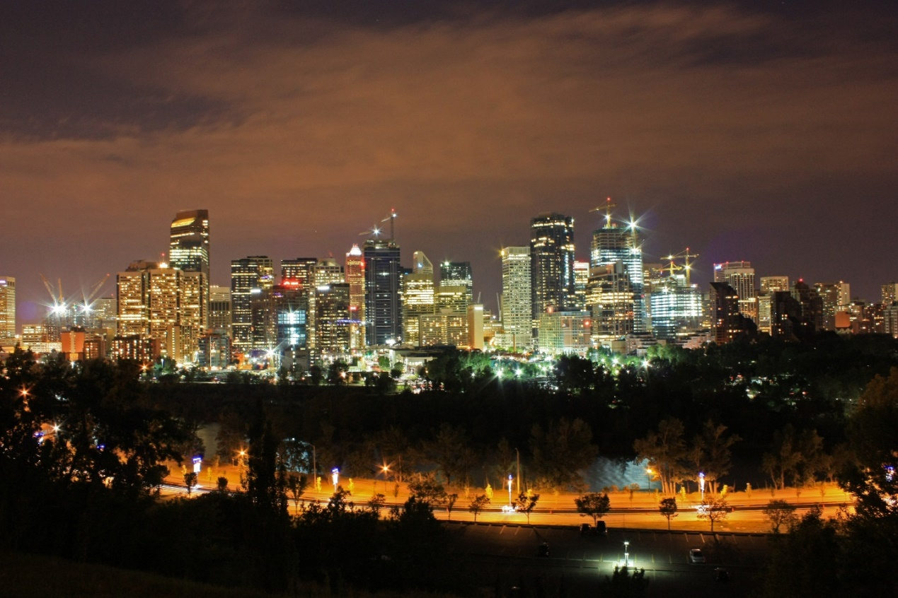
https://upload.wikimedia.org/wikipedia/commons/6/6d/Night_Skyline_007.JPG
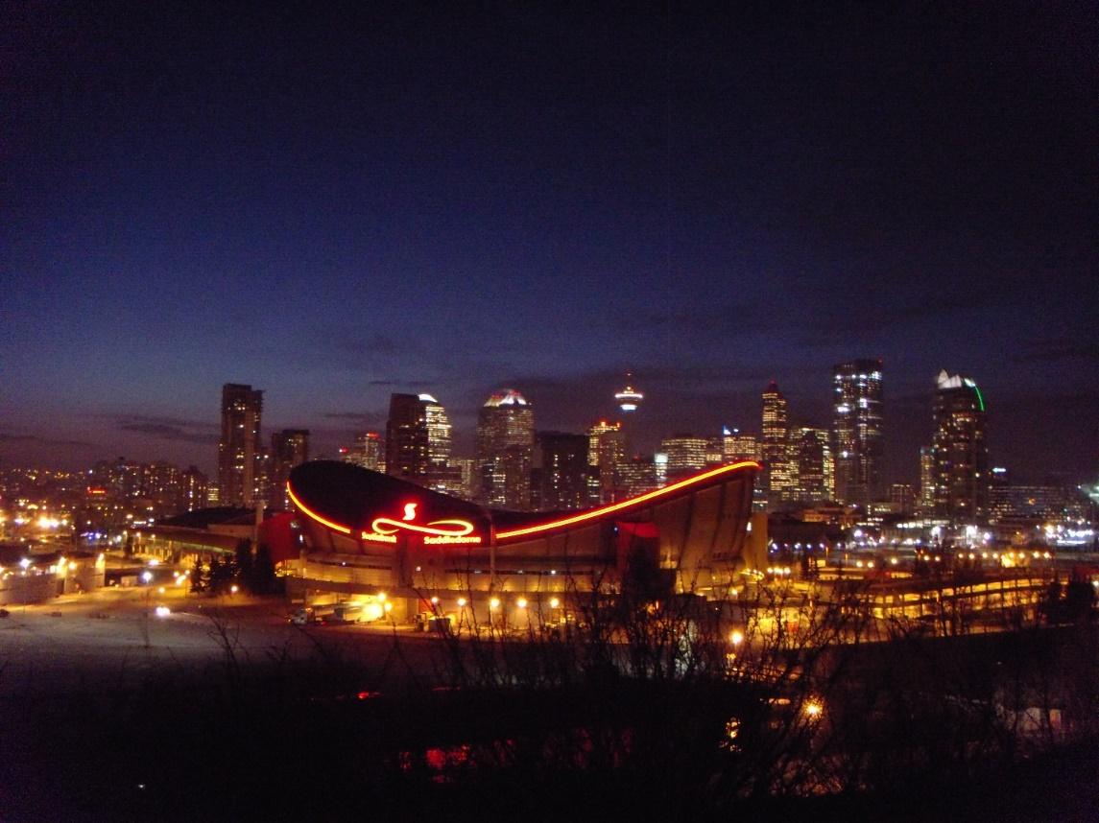
https://upload.wikimedia.org/wikipedia/commons/7/7e/Calgary_skyline.jpg

