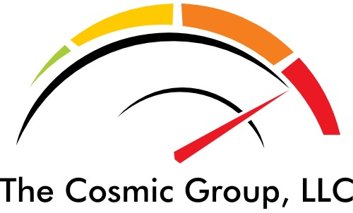
2605 Pacific Avenue
Stockton, CA 95204
209-463-4435

Tax Season Alert

Let the Cosmic Group prepare your 2015 Corporate, Individual and all types of tax returns.

The Cosmic Group is managed by experienced and highly qualified CPAs and Enrolled IRS agents

All new, first time clients will receive a special $50 discount for this tax season

Our office is conveniently located on the Miracle Mile,
next to Starbucks!

Tax Options:
Earned Income Credits
Trusts & Estates
ITIN
990, 1120 & 1040
Rapid refund
IRS Representation
Sales Tax and Payroll Taxes

Other Services Include:
Business Advisory Immigration Consulting Non-profit Audits
Notary Public
Accounting & Bookkeeping
Property Management
Live-Scan fingerprinting

FREE ESTIMATES!

Se Habla Español

