WE MANAGE MULTI-LEVEL APARTMENT BUILDINGS
PILOT manage various high profile apartment buildings. We are responsible for managing contractors to maintain all common area facilities as well as utilities invoicing and routine administrative tasks.
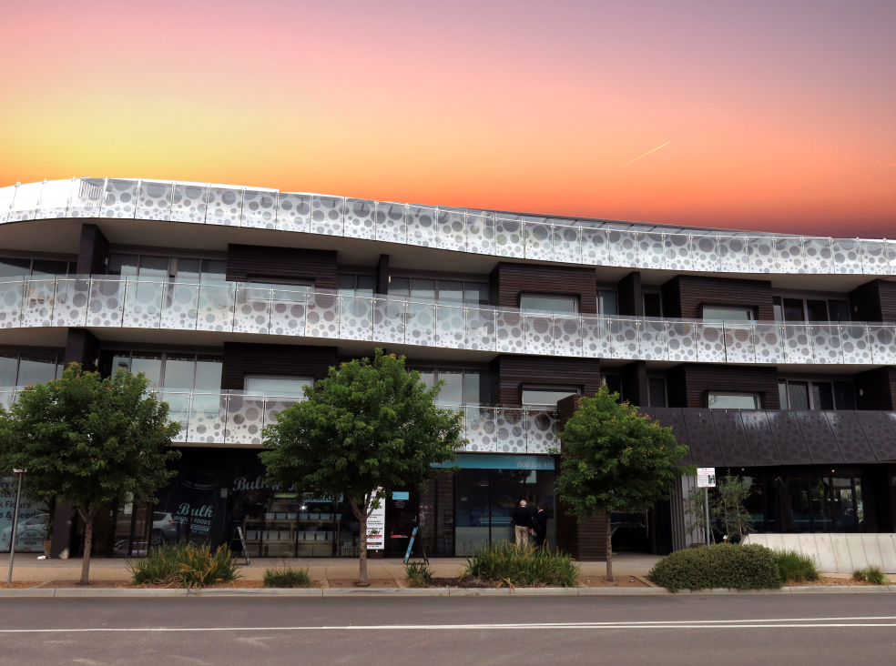 22 Main Street, Mornington

CASE STUDY – MAJOR REPAINTING PROJECT
‘The Convent’, 5 Tanti Avenue Mornington
This property is a historic multi level apartment building close to the beach in Mornington. We assisted our client with a major painting, guttering and partial roofing project including being responsible for all administration. This included review of the tender documents, compliance with the owners corporation decision to proceed with works and on site project progress updates.
The difficulty of this project was compounded by the necessity to work with the neighboring building owners to achieve access to difficult to reach parts of our clients building. The project resulted in a remarkably presentable apartment building.
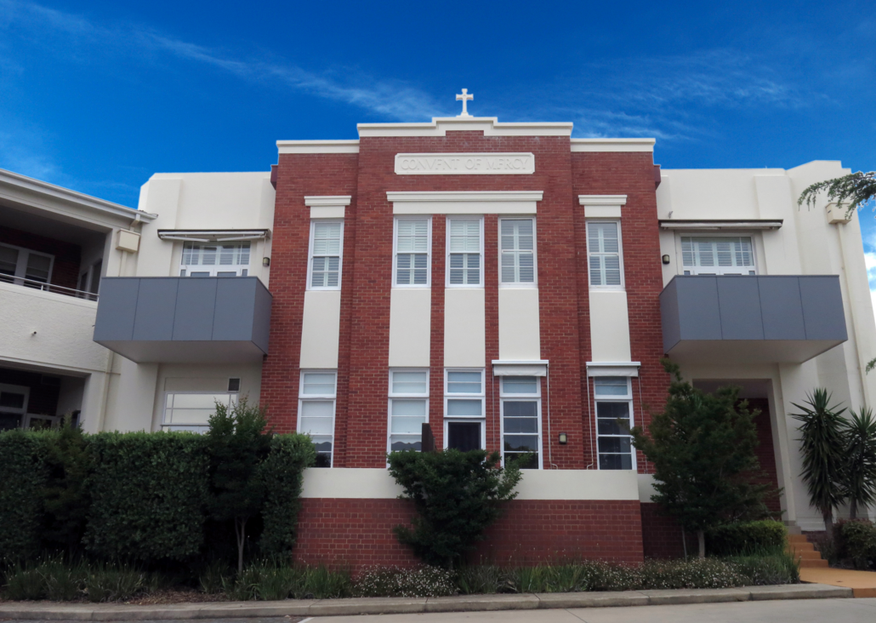
5 Tanti Avenue, Mornington
WE MANAGE COMMERCIAL OFFICES, FACTORIES & SHOPS
Our portfolio includes all kinds of commercial owners corporations including business parks, single/multi-level offices, retail shops and commercial factories.

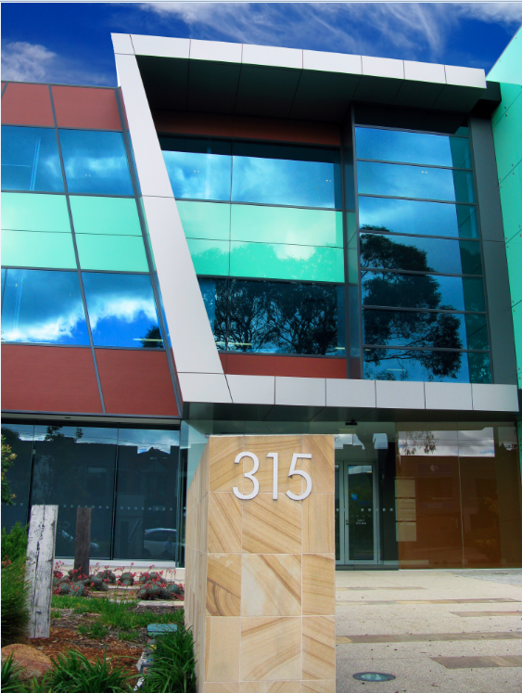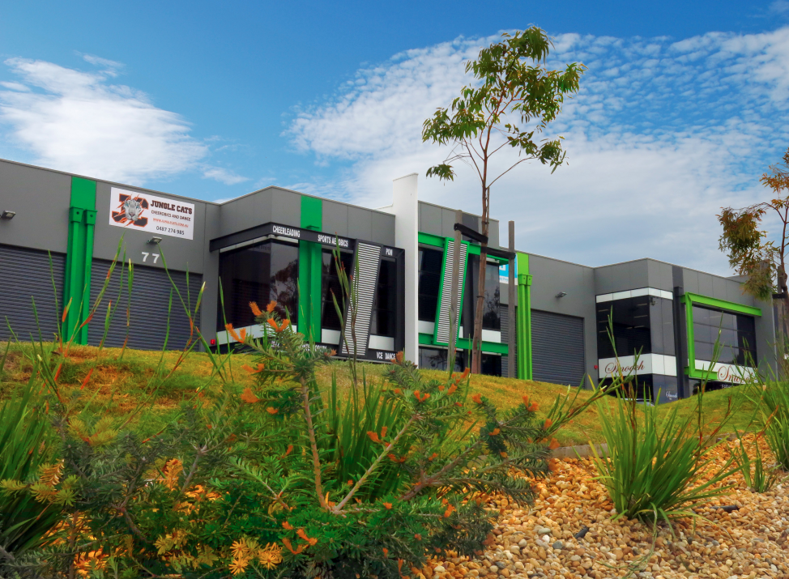
315 Main Street, Mornington 61 Watt Road Mornington

CASE STUDY – DEVELOPMENT CONSULTING
PILOT was selected by the developer of a mixed-use business park before construction commenced to provide owners corporation management advice and ensure a smooth transition on completion.

Some of our duties were:
- Review of the plan of subdivision and landscape plan
- Providing input for special rules
- Budget and fee schedules
- Provision of owners corporation insurance
- Convening the Inaugural Annual General meetings
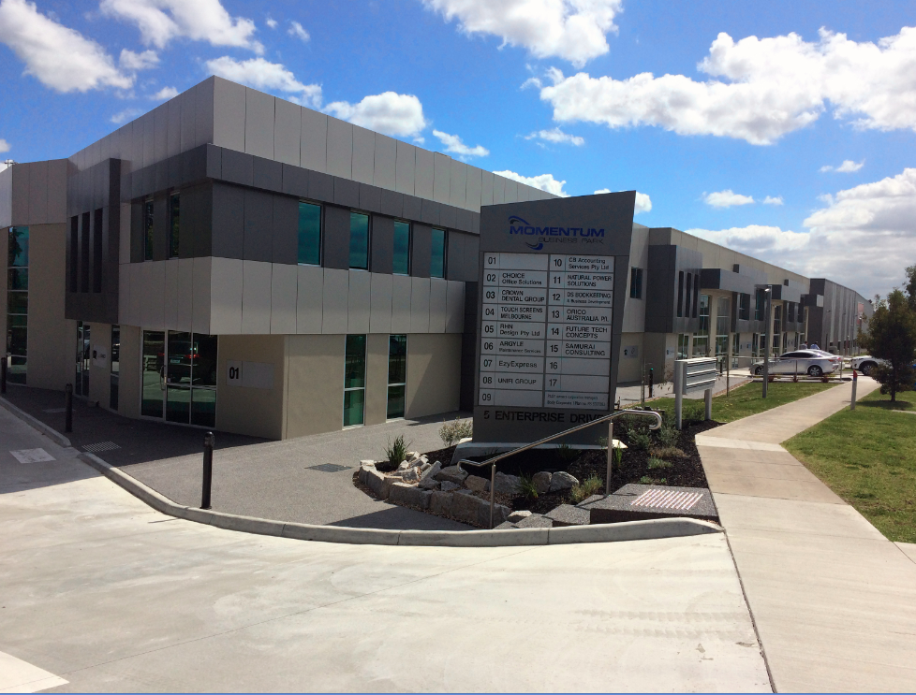 5 Enterprise Drive, Rowville
WE MANAGE RESIDENTIAL COMMUNITIES
PILOT manage an extensive range of residential units including gated townhouse communities. We work with the Committee or independently to ensure all common property is maintained to a high standard.

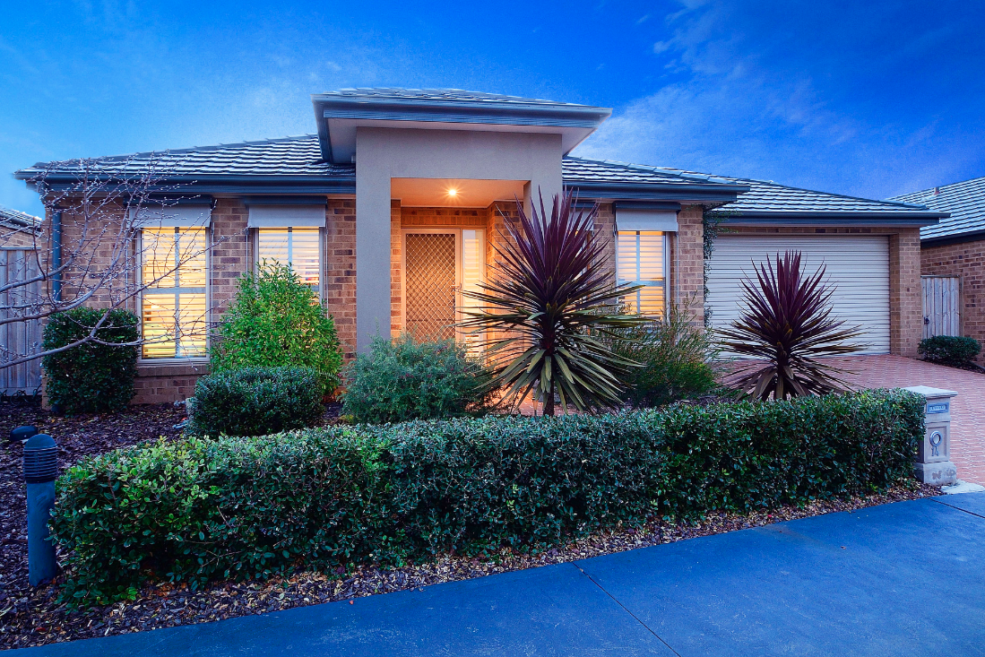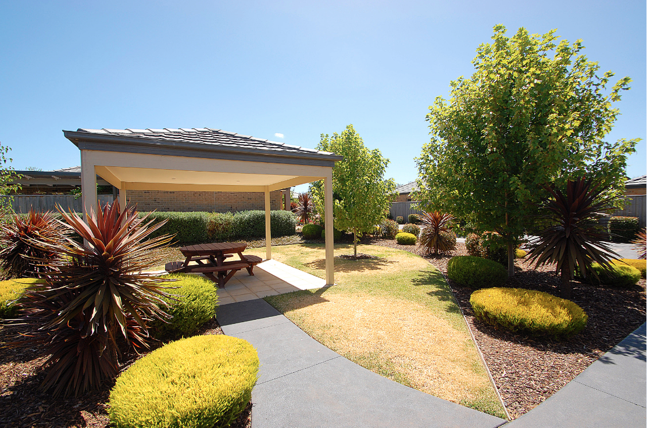

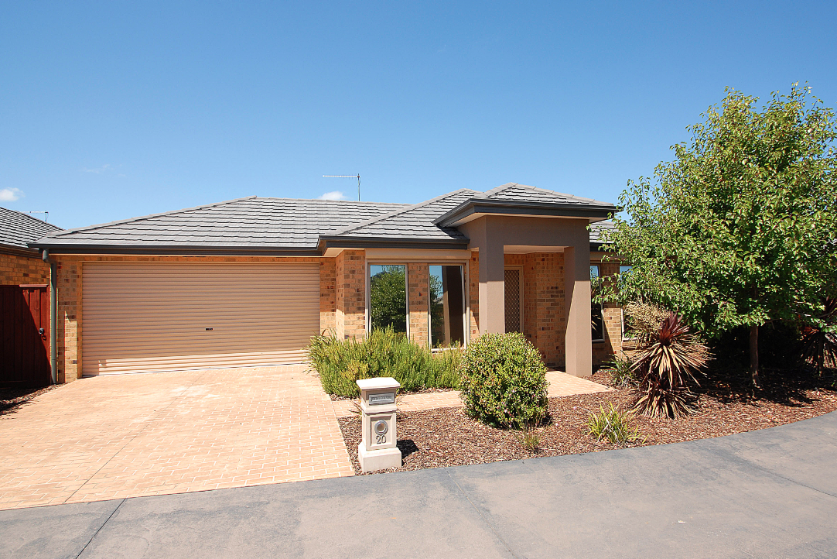
(all images) 194 Bentons Road Mount Martha. Gated community of 24 units

CASE STUDY – TOWNHOUSE COMMUNITY
This property is a seaside townhouse community of 24 units. Prior to commencing construction, PILOT was appointed by the developer to set up the owners corporation including placing competitive insurance and preparing budget and fee schedules.

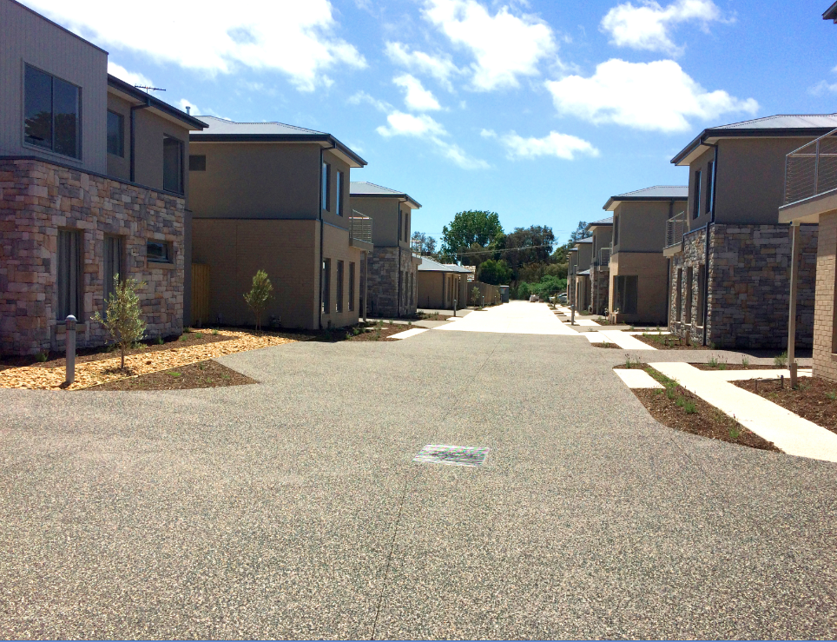
1553 Point Nepean Road, Rosebud

