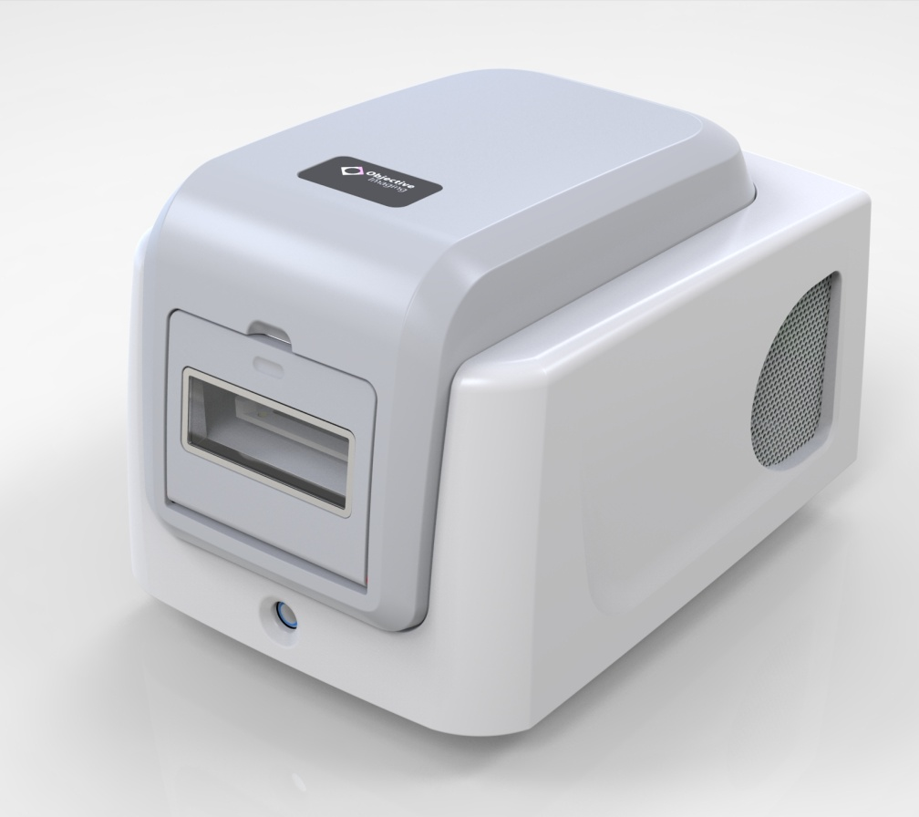


Whole Slide Scanning is now ...

Compact
Simple
Fast
Affordable
www.objectiveimaging.com

