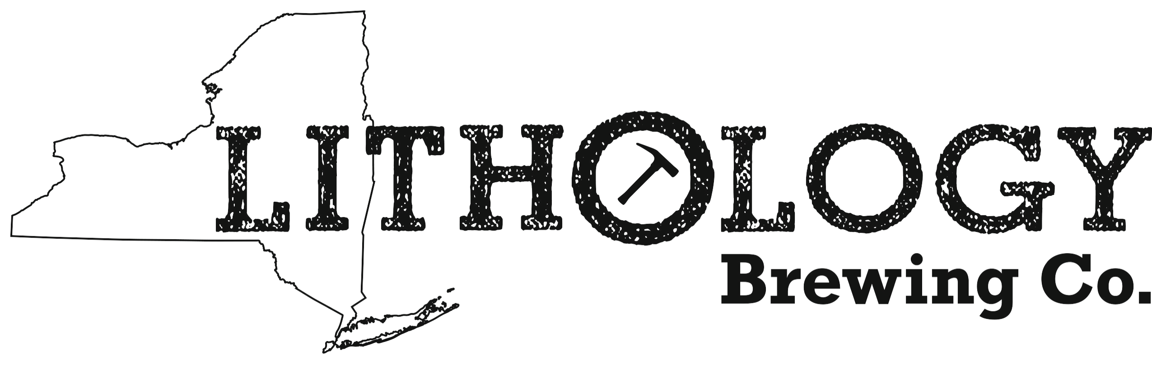 PROJECT BRIEF

Title: Lithology Label Design – Lafayette Farmhouse
Date: Q1 2015
Contacts: Lee Kaplan, Kevin Cain

PROJECT OVERVIEW
Objective:
• Create look & feel for Lithology beer bottle

Description:
• Label design template for 22-oz beer bottle that carries Lithology branding and allows for customization ABV, IBU, SRM, Batch# and Bottle#

Other considerations:
• Lithology artwork per beer type

CREATIVE EXECUTION
Branding:
• Brand personality: Scientific, Cultural with purpose
• Fonts: Road Movie, Rockwell Nexta Rust, Lavenderia
• Colors: Orange (C:2 M:72 Y:100 K:0) & black (C:0 M:0 Y:0 K:100)
• Logo: Provided (Lithologybottlelabel.ai.jpg) (LithologyLogo-Enhanced.psd)

Content:
• Include all government-mandated content, below
Brand name | Lithology Brewing Co.
Class and type designation | Farmhouse Ale  (type of malt beverage, eg, Ale, Lager, Stout, etc)
Name and address | BREWED AND BOTTLED BY LITHOLOGY BREWING CO.  211-A Main Street  Farmingdale, NY 11735
Net contents | 22 fl oz
• All of the above content must be legible, at least 2mm/6 pt font, contrast well with label background, and be placed on front of label*

Alcohol content | ___% ALC/VOL  (alcohol content must be expressed to the nearest 0.1%)
• The above content must be legible, at least 2mm/6 pt font, of the same kind and size of lettering, of equally conspicuous coloring, and can be placed on front, back or side of label*

Government warning | GOVERNMENT WARNING:  (1) According to the Surgeon  General, women should not drink alcoholic beverages during  pregnancy because of the risk of birth defects. (2) Consumption of  alcoholic beverages impairs your ability to drive a car or operate  machinery, and may cause health problems.
• The above content must be legible, at least 2mm/6 pt font, 25 characters at most, contrast well with label background, and can be placed on front, back or side of label*

For more information: http://www.ttb.gov/beer/bam.shtml

*INTERNAL NOTE: Size/style requirements change for 22oz labels.

Design:
• Use Middle of Label for Name, or design

For more information: http://ngmdb.usgs.gov/fgdc_gds/geolsymstd/fgdc-geolsym-sec37.pdf

PRODUCTION
Specs:
• Main label (3.75 in x 4.25 in)
For more information: http://www.grogtag.com/shop-bottle-type or
https://orders.grogtag.com/grogtag/start_with.cgi?tag=live-uploadyourown-grog-full#_ga=1.205875860.620594844.1443011649

Format:
• Working files: .ai, .psd, .indd
• Print-ready file: hi-res .pdf
• Other font, vector, or image files

