LedVation.com website design document (Draft)

- I am looking for an edgy visually stunning website with great content and navigation. If you do not possess these skills do not waste your time or mine.
- I am willing to pay additional $$ if the scope goes beyond this document
- Price paid here must include migration to a hosting service like www.bluehost.com (I will provide credentials to upload final site)
- Supplied vector Logo for website—feel free to make it better if you want
- Supplied digital business card for contact information, please note phone number should be 248-629-0875 not 248-231-2053
- Website should work for all modern browsers and not to use FLASH in any way. The device should be mobile friendly as well.

Sections:
What we do!
LED Innovations provides commercial LED lighting and retrofit services for buildings and users with an average monthly electric bill in excess of $400 per month in the Detroit metro area. Generally we save our customers 30-50% of their total electric monthly bill. We specialize in four key areas which set us apart from the competition.
- Purchasing Power: We deal directly with over 30 LED manufacturers in China. Our bulbs are usually 50% of our competition’s price and usually carry longer warranties. We import direct no middle parties to increase the costs to our clients.
- Rebates: We work with Detroit Edison directly for each job and fill out all necessary paperwork to facilitate the highest possible rebate for your installation. Generally speaking DTE pays for about 70%-120% of the bulb cost for our installations! Generally speaking our clients can get all new LED lighting in their building(s) cheaper than if they replaced
- Labor Rates: When retrofitting or converting to LED’s you can involve us in as little or as much as you want; many sites we act just as consultants and bulb suppliers. If you want us to retrofit your fixtures our rates again are substantially less than the competition.
- Knowledge: LED Technology has changed substantially in the last few years. Ten percent of our business is removing
Savings Calculator!
Please create a dynamic version of the below ROI Calculator. Please use some sort of animation for the values (sliders) HTML5?? and I put in the default values the slider should be set initially to. Would be awesome if the final output was a graph with the breakeven date marked with a vertical line.

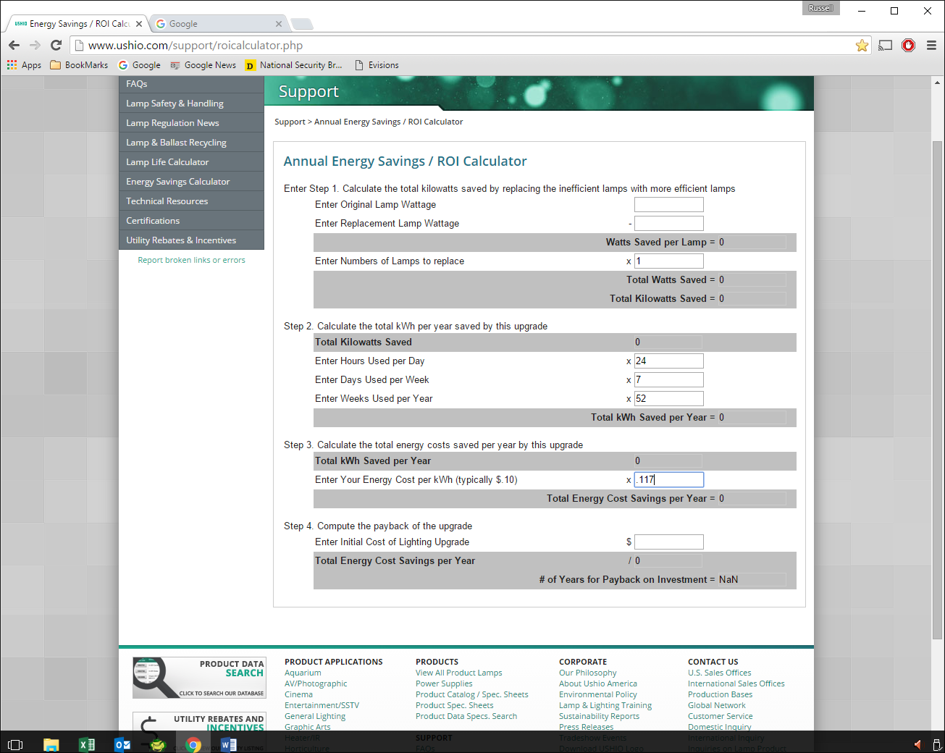

Past Clients!
This section will bring up something like a 8 column spreadsheet with the following values. Not sure of the format of this but I will need to add/delete entries via an administrator password to site (WordPress or something not sure)
- Description of Project/Client
- Image of building or structure
- Total cost of project
- Total DTE rebates
- Picture of Check from DTE
- ROI in Months
- 10 Year Savings from project
- Thumbnail pics of client site

