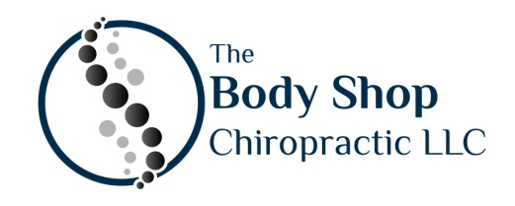
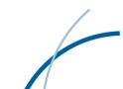
ARC Method
At The Body Shop Chiropractic we focus on correcting postural and arthritic dysfunction with minimally invasive procedures.
The Advanced Restorative Care (ARC) Method is a multidisciplinary approach to correct an array of conditions from degenerative disc disease, arthritis, sciatica, back pain, scoliosis, vertigo, whiplash and many other conditions affecting the whole body.
This unique approach to patient care encompasses personalized physical rehabilitation, trigger point therapy, manual chiropractic adjustments, and orthotics /medical equipment.
4 Components of ARC Method
4

Trigger Point Therapy:
Reduces muscle tightness and adhesions to allow for normal movement and posture.
Chiropractic Adjustments:
Specific movements to break up scar tissue, allowing the joint to move freely
Orthotics /Medical Equipment:
Speeds the correction of postural dysfunction and degeneration by providing the correct physical and nutritional support

Personalized Physical Rehabilitation:
Specific functional examination and exercises are used to identify and correct muscular imbalances.

